
Assessing the impact of wind power on day-ahead electricity prices in France

Margaret Armstrong, Valeriia Iezhova & Alain Galli

Cerna, Mines-Paris, France

Overview

France has lagged behind many of its European neighbours notably Germany & Spain, in introducing wind power. At present, electricity in France is 75% nuclear, 13% hydro-power, 10% fossil-fuel thermal with only 2% from other renewable energy sources. Over the next 15 years, France plans to massively introduce wind power. In addition, other changes will affect the French power generation fleet: the nuclear plants built in the 1970s & 1980s are reaching their planned 40 year lifespan and will require more maintenance (some might be decommissioned); two new nuclear plants have been commissioned and several new gas powered turbines will be constructed to meet the demand in peak and semi-peak periods. The objective of this study is to evaluate the impact that these changes would have on day-ahead electricity prices in a statistical way, by simulating prices 24 hours per day on working days, over the next 10-15 years. By "statistical" we mean that the histograms of the simulated prices should be realistic; we are not attempting to predict prices on particular dates.
The impact of wind power on day-ahead electricity prices has attracted considerable attention since Jensen & Skytte (2003) pointed out that its introduction might lead to a drop in prices because its variable cost is much lower than conventional thermal power plants. Our study builds on empirical work by de Miera et al (2008), Weigt (2009), Sensfuss et al (2008) and Pfluger et al (2009). The first three studies concern the electricity markets in Germany and Spain which have a high penetration of wind power, in contrast to France where it is still very low. Consequently they evaluated its impact on prices over the past few years. In contrast we will focus on its impact in the future. Two common features of the four papers cited are that the demand was considered to be inelastic and that the electricity price is computed using the full merit order, that is, implicitly assuming that all the electricity is traded through the bourse.

Method

Detailed studies of the aggregated offers to buy and sell electricity on the French electricity bourse (Armstrong et al, 2011), showed that demand on the bourse is elastic and that the offers to sell electricity are not a scaled-down version of the overall merit order because only 10% of the electricity consumed in France is traded on the bourse. So it is not appropriate in France to assess the impact of wind power on day-ahead prices in this way. Instead we have developed an innovative method for assessing the effect of major changes in the generation fleet such as the introduction of wind power on day-ahead prices. This approach is based on the method developed by the French TSO for determining the supply-demand balance in the future. We also use the hourly aggregated offers to buy and sell power, from the period Oct 2007-Sept 2008 as reference year.

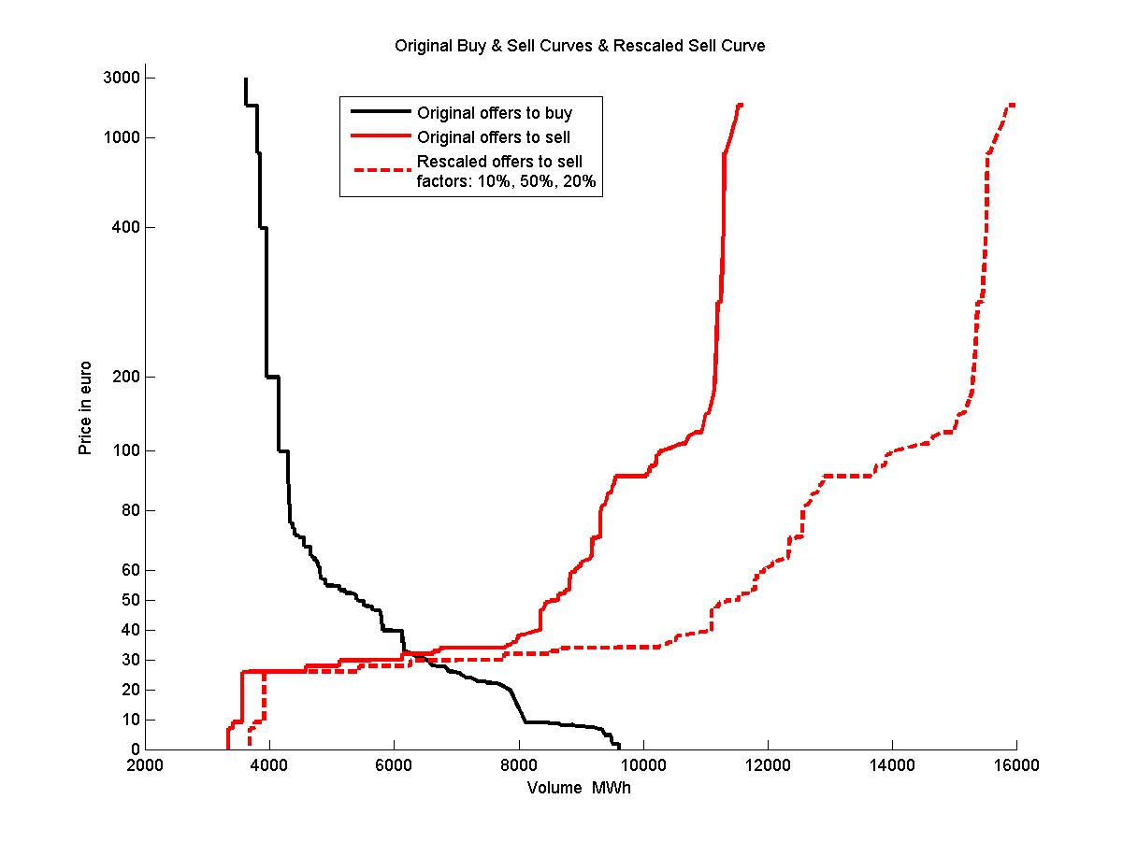
The first step is to split the production fleet into three classes according to marginal cost, with nuclear, run of river and wind power in the lowest one. Then we simulate the production capacity in each class (24 hours per day 365 days per year). The offers to sell electricity on the bourse are rescaled in proportion to the ratio of the simulated production to the actual production in a reference year. The underlying hypothesis is that if 10% of the electricity available in the lowest cost slice was offered on the bourse at a specific time in 2007, then the same proportion would be offered in the future. Similar considerations are applied to the middle & top price generators. See the red curves in Figure 1. Fig 1: Rescaling the volumes in each tranche

The offers to buy were also simulated. The intersection of the curves gives the simulated day-ahead price.
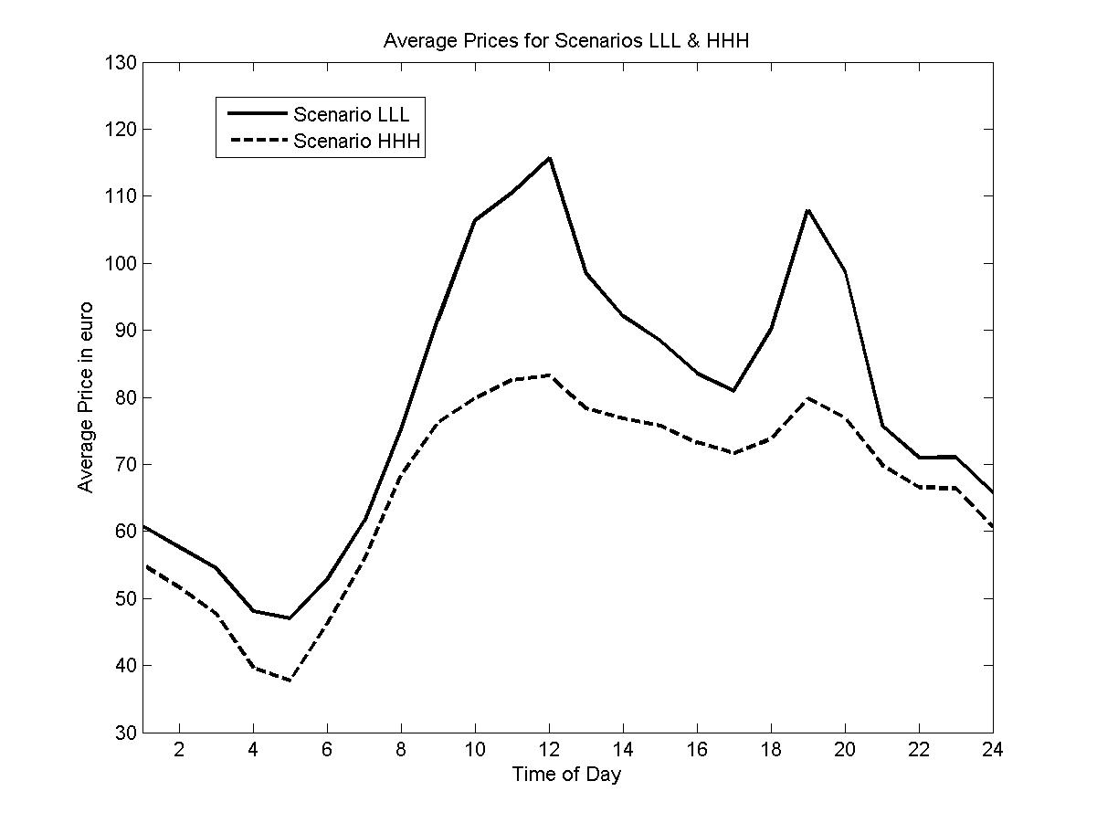
Results & Conclusions

The statistical properties of the simulated day-ahead prices were analysed. Figure 2 shows the average price at different times of day for the most favourable scenario (HHH), as a dotted line and for the least favourable one (LLL) as a solid line for the year 2020. At midday, the average price would be 35 euros higher under the low scenarios for wind, nuclear and thermal power than when the three are high; in the early morning, the difference would still be about 10 euro. Fig2: Average price at different times

References

Armstrong, M., V Iezhova & A Galli (2011) Evaluating the effect of wind power on day-ahead electricity prices in France, Working Paper, Cerna, Mines-ParisTech.
Jensen & Skytte (2003) Simultaneous attainment of energy goals by means of green certificates and emission permits, Energy Policy, 31, 63-71
Pfluger, B., F. Sensfuss and M. Wietschel (2009) Agent-based simulation of the effects of an import of electricity from renewable sources in Northern Africa into the Italian power market, Internat. Energiewirtschaftagung an der TU Wien, 15pp
Saenz de Miera, G, P del Rio Gonzalez & I Vizcaino (2008) Analysing the impact of renewable electricity support schemes on power prices: the case of wind electricity in Spain, Energy Policy 36 (2006) 3345-3359
Sensfuss, F, M. Ragwitz & M Genoese (2008) The merit order effect: A detailed analysis of the price effect of renewable electricity generation on spot market prices in Germany, Energy Policy 36 (2008) 3086-3094
Weigt, H. (2009) Germany's wind energy: The potential for fossil capacity replacement and cost saving, Applied Energy 86 1857-1863

