Overview

Regulated Expansion of Electricity Transmission Networks: the Effect of Fluctuating Wind Generation

Wolf-Peter Schill, DIW Berlin, +49 30 89789-675, wschill@diw.de
Juan Rosellón, DIW Berlin and CIDE, +52 55 57279800-2711, jrosellon@diw.de
Jonas Egerer, TU Dresden, +49 351 463-39771, jonas.egerer@mailbox.tu-dresden.de
Growing shares of fluctuating wind power increase the need to expand existing electricity transmission networks. At the same time, the natural monopoly character of transmission networks requires economic regulation of investments. In this article, we study the effects of different regulatory regimes for transmission expansion with a model-based analysis for central Europe. In contrast to previous studies, we explicitly take into account realistic demand patterns and different cases of fluctuating wind power generation. We are particularly interested in the performance of a new combined merchant-regulatory mechanism. We compare its outcomes to a non-regulatory (merchant) approach, cost-based regulation, a welfare-maximizing benchmark, and a case without expansion.
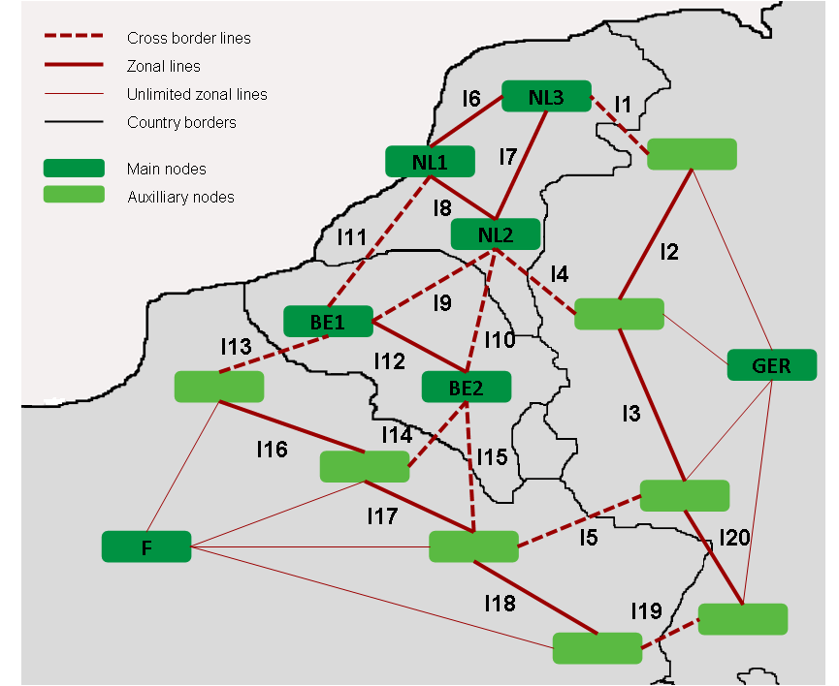
While network expansion removes congestion, smoothes electricity prices and increases overall welfare, it might not be attractive for grid owners who benefit from congestion rents. Thus, economic regulation of investments is required. There are two major approaches. The merchant approach employs the theory based on long-term financial transmission rights (cp. Joskow and Tirole, 2005). The performance-based approach relies on incentive regulatory mechanisms for a transmission company (compare Vogelsang 2001, 2006). Hogan et al. (2010) combine these approaches with the Hogan-Rosellón-Vogelsang (HRV) mechansim. It relies on congestion prices – and therefore on financial transmission rights – as well as on price cap regulation. It has already been tested in model-based analyses for simplified grids in North-western Europe (Rosellón and Weigt 2011) and the Northeast USA (Rosellón et al. 2010). In this paper we expand the HRV model so as to incorporate the peculiarities of large-scale RES systems.
Figure 1: Stylized central European transmission network

Methods
We analyze the different regulatory mechanisms within the engineering-economic Elmod modelling framework (Leuthold et al. 2008). Endogenous model outcomes include the location, extent, and timing of transmission investments, hourly nodal prices, generation patterns, Transco profits, and social welfare. Drawing on a nodal pricing approach, we model real load flows. This allows representing economic externalities of expansion projects caused by loop flows. We apply the model to a stylized central European transmission network, which has been used by Neuhoff et al. (2005) for a seminal model comparison study. It comprises nodes in Germany, France, Belgium and the Netherlands (Figure 1).
On the generation side, we model welfare-maximizing hourly dispatch. As for transmission, we assume that a regulated, monopolistic transmission company (Transco) owns the network. The Transco decides on transmission expansion and collects congestion rents. We combine the welfare-maximizing dispatch problem and the Transco’s profit maximization problem in the MPEC format.
We draw on different cases that vary with respect to wind power fluctuations and demand representation. In a simplified “Static” case, we draw on average yearly demand levels, prices and wind generation. In the more refined “DRes” case, we include an hourly time resolution, which allows representing fluctuating demand in a realistic way. We model 6 characteristic days of the year (weekdays and weekends in three seasons), which results in 144 single hours. We extrapolate to the whole year by weighting the six days with suitable factors. Hourly nodal reference prices and demand levels are derived from the European Energy Exchange and other sources. Finally, we include a “WindRes” case, which extends “DRes” by adding a fluctuating wind generation pattern, which has been derived from historic wind feed-in data for Germany. Taken together, these cases allow separating the effects of demand fluctuations and winding power fluctuations. The model is implemented in GAMS and solved numerically with the commercial solver CONOPT on a high-performance 64bit Linux system.

Results
We compare the welfare outcomes and the extent of network expansion in the different cases. Drawing on realistic demand levels, reference prices, and generation capacities, we show that network extension in central Europe relieves existing congestion and thus increases social welfare. However, this also leads to a large redistribution of social welfare from consumers to producers in France and Germany. Comparing different regulatory approaches, we find that HRV regulation leads to extension and welfare outcomes close to the social optimum. HRV’s welfare outcomes are far superior to the modelled alternatives of cost-based regulation (CostReg) and a merchant-like approach without additional investment incentives (NoReg). This result is robust over all modelled cases. NoReg leads to inferior welfare results because the Transco finds only very small line extensions profitable. Under cost-based regulation, less congested lines are thoroughly expanded, but there are substantial under-investments for the most congested ones. In contrast, the HRV-mechanism provides the Transco with incentives to expand the network such that congestion is relieved.

Conclusions
A methodological conclusion from our work is that the details electricity transmission network modeling matter very much. In particular, analyzing the real-world implications of different regulatory approaches to transmission expansion requires a detailed representation of fluctuating electricity demand. Only then it is possible to achieve robust results on the location and the level of line upgrades, and the related welfare implications, in particular the relation of welfare gains, extension costs and fixed income of the Transco. In contrast, a simplified approach systematically underestimates the need for transmission upgrades. We also find that the effect of fluctuating wind power is of minor importance compared to demand fluctuations. Drawing on a range of sensitivity analyses, we also show that some simplifications are justified in order to maintain acceptable execution time.
As for policy conclusions, we find that we cannot expect a Transco in central Europe to invest optimally in transmission lines without being granted additional incentives. Accordingly, the modelled NoReg approach is not a preferable option. Yet cost-based regulation is an even less promising option, as it does not provide sufficient incentives for the Transco to invest in the most important lines. In addition, cost-based regulation requires the regulator to have substantial information on network congestion. In contrast, HRV regulation leaves extension decisions completely to the profit-maximizing Transco, while at the same time leading to desirable welfare outcomes. Its beneficial welfare properties are very robust against fluctuations of demand and wind feed-in. In the light of future wind integration requirements, HRV regulation may also have favourable characteristics, as it triggers relatively high network extension. It should be noticed that that the benefits of HRV regulation are related to a relatively large fixed tariff part. Yet this distributive issue could be addressed through a proper choice of weight of profits in the welfare criterion, which is subject to future research.

References
Hogan, W., J. Rosellón, and I. Vogelsang (2010), “Toward a Combined Merchant-Regulatory Mechanism for Electricity Transmission Expansion”. Journal of Regulatory Economics, 38(2), 113-143.
Joskow, P. and J. Tirole (2005), “Merchant transmission investment”, Journal of Industrial Economics, 53 (2), 233–64.
Leuthold, F., Weigt, H. and von Hirschhausen, C. (2008): ELMOD - A Model of the European Electricity Market, Working paper EM-00. URL: http://www.tu-dresden.de/wwbwleeg/publications/wp_em_00_ELMOD.pdf, accessed 14 January 2011.
Rosellón, J. and H. Weigt (2011), “A Dynamic Incentive Mechanism for Transmission Expansion in Electricity Networks – Theory, Modeling and Application”. The Energy Journal, Vol. 32, No. 1, 119-148.
Rosellón J., Z. Mislíková, and E. Zenón (2010), “Incentives for Transmission Investment in the PJM Electricity Market: FTRs or Regulation (or both?)”. Utilities Policy, forthcoming.
Vogelsang, I. (2001), “Price regulation for independent transmission companies”. Journal of Regulatory Economics, 20 (2): 141–65.
Vogelsang, I. (2006), “Electricity Transmission Pricing and Performance-Based Regulation”. The Energy Journal, Vol. 27, No. 4.

