Title:

Developing An Energy based Poverty Line for South Africa.

Research Topic:

Based on the notion that “energy poverty” deepens general “human poverty” this research report undertakes to highlight the use of energy poverty measures in the identification of energy poverty rates in South Africa. The energy poverty rates identified are based on 3 pre-determined minimum household energy threshold levels and are applied to the South African Department of Energy’s Socio-Economic Impact of Electrification dataset of 2008/2009. The ultimate objective of the research is to assist policy makers in achieving government’s stated goal or eradicating poverty in South Africa through providing policy makers with robust information on rates of energy deprivation.

Overview of Related Research:
Since 1994, the South African government has identified poverty alleviation as a key policy goal. The most recent growth strategy was the Accelerated and Shared Growth Initiative for South Africa (AsgiSA), formed in 2004 to build on previous economic growth benefits and set a target of 4.5% mean growth over the 2004–2009 period (AsgiSA, 2007). It will also have the task of meeting the government pledged target of halving both unemployment and poverty by 2014. This is consistent with the ‘Johannesburg Plan of Implementation’ (JPOI) adopted at the 2002 Johannesburg World Summit on Sustainable Development (GSSD, 2006). The JPOI was composed to help developing countries face the challenges of sustainable development, namely poverty, inequality and environmental degradation (JPOI Strategy, 2003). It also, “highlights access to energy as central to facilitating poverty eradication” (Vera et al., 2005: 156). An important element of poverty is that of energy poverty, which pervades many if not all elements of poverty. Shelter, food, health, education, security and many other elements of well-being all rely heavily on energy provision (Pauchari and Spreng, 2003, Kemmler and Spreng, 2007).

The IEA in its World Energy Outlook 2009 identified three levels of access to energy services depending on household energy needs and the benefits energy services provide. These are illustrated below and include: level 1- the minimum level of energy access required by households to satisfy basic human needs, level 2- the energy access required by households to improve productivity, and level 3- the level of energy access required by households to satisfy modern society needs.

“Fuel poverty” is a related but distinct concept in which users of energy have access to-but are unable to afford- the energy they require. In terms of quantifying fuel poverty, a common indicator used in country studies is the “energy burden” of households within a region. This is based on the notion that poor households spend a greater proportion of their income on energy than their more wealthy household counterparts. It is calculated as the share of total household income or expenditure devoted to energy. In the literature, the threshold for determining fuel poverty is between 10-15 percent of income spent on domestic energy needs, with 10 percent being the norm (DoE, 2009). Households with energy expenditure’s above this threshold are considered energy poor and are likely to be confronted with difficult choices between meeting energy requirements and spending on competing goods. According to (Aitken, 2007) the energy burden for South African households can amount to between 12-20%. Putting this in perspective, this is the equivalent of a middle income household earning R20,000 a month and spending up to R4,000 a month on acquiring energy services. The DoE (2009) estimates that the incidence of fuel poverty amongst electrified households is highest in the Eastern Cape at 31% with a further 54% spread across KwaZulu-Natal, Limpopo, Mpumalanga and Gauteng. Non-electrified households exhibit a relatively similar pattern, with large energy poverty shares accounted for by households in the Eastern Cape, KwaZulu-Natal and rural areas.

Methods:

The data are drawn from the 2008/2009 Department of Energy (DoE) survey on the socioeconomic impact of electrification, a survey of 3960 households from all nine of South Africa’s provinces. The sample consists of both electrified and non-electrified households in Living Standards Measure (LSM) groups 1 – 3, corresponding to household incomes of less than R1600 per month. Each household was interviewed using a detailed questionnaire. The survey is intended to be an annual longitudinal study, with a pilot survey undertaken in 2007/2008. The sample was drawn on enumerator areas (EAs) and stratified on province, with 50 EAs sampled per province and 9 households per EA. The sample was selected so that two-thirds of households are electrified and the remainder non-electrified. While this ratio is not proportionally representative of households in LSM1 – LSM3, the sample contains weights that are used throughout the analysis to make the results of the estimation nationally representative of the total population of LSM1 – LSM3 households.

In terms of energy data, the survey records spending by the household on the following energy types: paraffin; gas; candles; coal; firewood; solar; electricity; batteries; car batteries; generators; other energy. The dataset also contains an indicator for whether the household receives free basic electricity (FBE). A small proportion of households do not report any expenditure on energy. This may arise if households collect or use their own fuel sources (such as firewood, dung, bagasse, etc). It does not imply that the household did not consume any energy, since the survey records the purchase rather than the use of energy. Thirty-two households do not purchase any energy, but collect their own firewood (however, the survey does not record the quantity of firewood collected). Ten households do not purchase any energy, but receive FBE. The analysis in this study is thus conducted conditional on a household having purchased some form of energy, or received FBE, which restricts the sample to 3893 households.

A single price-to-kWh conversion factor per fuel type is used nationally to convert all energy expenditures by households into energy use figures. (See appendix 1 in this regard.) Where households report that they receive FBE we assume that they consume the full 50kWh per month. Actual (raw) energy quantities/units are then converted into useful energy, using efficiency factors (Winkler, 2006). The energy efficiency factors for cooking have been used for all fuel types except in the case of candles.

We quantify in energy units (namely: kilowatt hours) the amount of useful energy households require in order to meet specific consumption requirements. In determining this amount we are guided by the international literature in the field of energy and poverty studies. For the purposes of this study we stick with three pre-determined annual per capita useful energy access thresholds: These are as follows:
- 667 kWh, which represents the energy equivalent of the United Nation’s $1.25 per person per day (‘$1.25_equiv’) poverty line;
- 1200 kWh, which represents the IEA’s minimum level of energy access required for households to satisfy ‘basic needs’; and
- 2000 kWh, which represents the IEA’s level of energy access for household to satisfy ‘modern needs’.

Note, furthermore that in measuring energy poverty rates in SA, our useful energy measure has been converted into a measure of access-adjusted useful energy, using the methodology developed by Kemmler and Spreng (2007), as was applied to South African data by Vermaak et al (2009). This measure takes into account both the quantity of energy used (useful energy) and the degree of access that households have to modern energy. This is achieved by weighting the energy used by the household according to the accessibility of its source. The greater the accessibility of the energy source, the higher the weighting it receives. Traditional sources therefore receive a weighting of one, transitional sources receive a weighting of two, and modern sources receive a weighing of three. The robustness of this weighting scheme in the South African context is discussed in Vermaak et al (2009). It is this access-adjusted useful energy unit measure that is applied to the DoE data set in quantifying the incidence of energy poverty in SA as it is felt that this is a far more informed tool with which to guide energy and poverty policy in SA.

Results & Conclusions:

The energy burden of households is calculated as households’ energy expenditures as a percentage of total monthly income. The results are shown as a series of tables and GIS maps. An brief example of our results is shown below.

Table 1: Energy expenditure as a percentage of total monthly household income, by province
 | Electrified | Non-Electrified
EC | 20.759 | 23.249
FS | 14.688 | 13.484
GP | 18.254 | 33.795
KZN | 15.627 | 15.603
LP | 11.747 | 15.951
MP | 17.881 | 15.486
NW | 16.120 | 22.552
NC | 11.775 | 11.625
WC | 16.781 | 22.045
Source: own calculations

Gauteng, non-electrified households spent the largest share of their income on energy at just under 34%. Electrified households in the Northern Cape and Limpopo provinces spent the smallest percentage of their total monthly income on energy at just under 12%. GIS Map 1 replicates the data in Table 1 for electrified households.

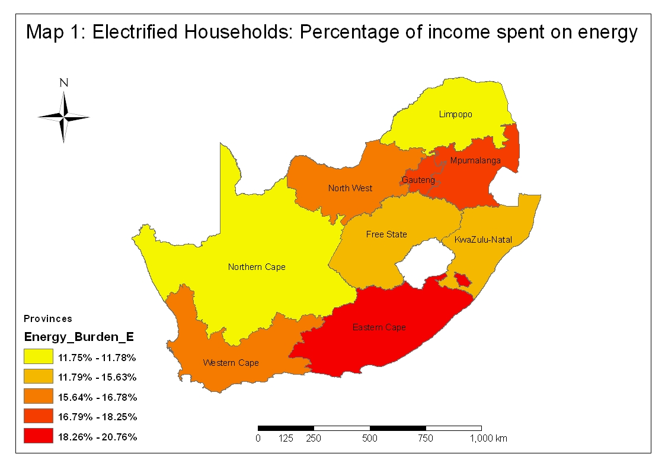

All the maps in this report show increasing percentages as we move from yellow to red indicating increasing fuel poverty.

We employ the preferred energy unit measure of poverty and apply this to the three energy access thresholds identified above. These energy poverty results according to these three energy poverty lines are shown in Table 2.

Table 2: Percentage of households at or below different energy poverty lines, by province.
 | $1.25 equiv  (667kWh) |  | Basic needs  (1200kWh) |  | Modern needs(2000kWh)
 | E | NE | E | NE | E | NE
EC | 0.206 | 0.412 | 0.401 | 0.656 | 0.627 | 0.815
FS | 0.154 | 0.671 | 0.281 | 0.857 | 0.600 | 0.948
GP | 0.061 | 0.275 | 0.205 | 0.533 | 0.497 | 0.762
KZN | 0.098 | 0.697 | 0.355 | 0.802 | 0.567 | 0.886
LP | 0.412 | 0.616 | 0.659 | 0.743 | 0.821 | 0.860
MP | 0.234 | 0.571 | 0.428 | 0.747 | 0.665 | 0.845
NW | 0.173 | 0.528 | 0.319 | 0.725 | 0.577 | 0.824
NC | 0.214 | 0.640 | 0.525 | 0.796 | 0.785 | 0.903
WC | 0.040 | 0.257 | 0.202 | 0.466 | 0.497 | 0.611

As an example, table 2 tells us that 20.6% of electrified households in the Eastern Cape have access to 667kWh or less per month (or 41.2% for non-electrified households). We can see that in each province, and at every poverty line, non-electrified households are more energy poor than electrified households. For most provinces, the differences in poverty rates between electrified and non-electrified households are quite severe. In KZN, for example, less than 10% of electrified households, but almost 70% of non-electrified households, are below the “$1.25-equivalent” poverty line. The first column of results is shown in Map 2 below:

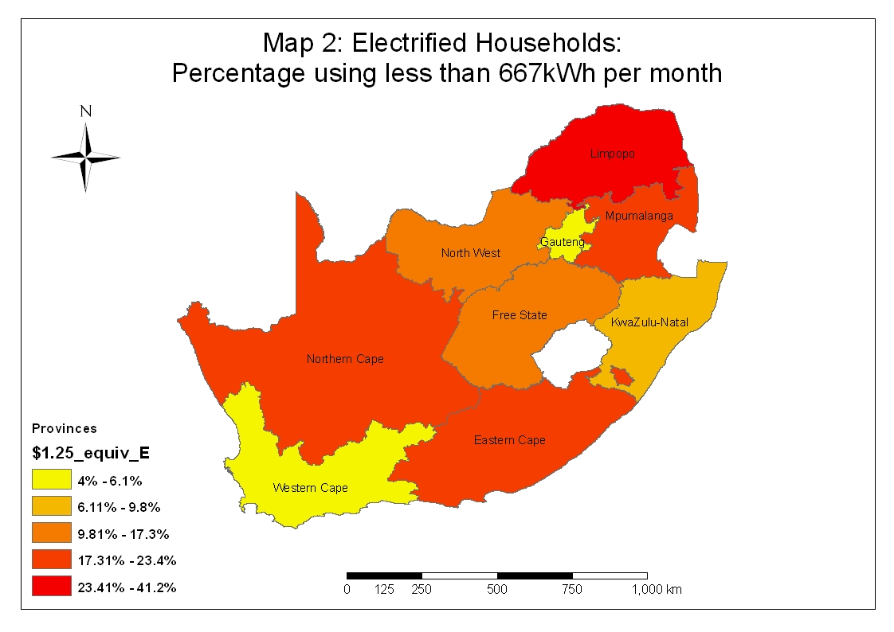

By comparing the energy burden measure (Map 1) with one of the access-adjusted measures (Map 2) we can see the results are very different. We contend that the access-adjusted (energy-unit) measure of poverty is more accurate and a better guide to overall energy policy.

