Do homes that are more energy efficient consume less energy?: A structural equation model of the English residential sector
[Scott Kelly, Cambridge Centre for Climate Change Mitigation Research, 07942 617 428, sjk64@cam.ac.uk]

Overview
Energy consumption from the residential sector is a complex socio-technical problem. To be understood fully it must combine characteristics about the physical properties of the building, the economics of energy and technologies and the behavioural choices made by occupants. This paper presents the first known application of structural equation modelling (SEM) for the explanation of residential energy consumption in England. This powerful statistical technique allows for the calculation of both direct and indirect effects, including the magnitude and statistical significance of these variables to explain residential energy consumption.

Buildings are a significant contributor to greenhouse gas emissions with space heating alone responsible for over half of all end use emissions from UK dwellings. Furthermore, the residential sector has been repeatedly identified by government departments; commercial organisations, non governmental organisations and by academia as having one of the lowest costs and largest impacts for reducing overall CO2 emissions. Still, there remains significant debate about the best strategy for meeting the ambitous CO2 reductions imminently required from the residential sector.

Methods
The model is based solely on publicly available data and comprises information available from two principle datasets: The 1996 English House Condition Survey (EHCS) and the 1996 Fuel and Energy Survey (FES) for England. These two surveys cover all tenure types and involve a physical inspection of the property by certified professionals. Data was prepared for analysis by removing outliers that sat outside five standard deviations of the mean; missing values were replaced using expectation maximisation techniques; sample grossing weights were applied to account for biases created during survey stratification; finally, potentially problematic variables were tested for normality.

Based on substantive prior research a structural equation model was then developed to represent the expected underlying causal relationships likely to explain domestic energy consumption in England. This is represented in pictorial form as a path diagram. The model developed is based on the premise that domestic energy consumption can be explained by several manifest variables. Using such a model it is possible to test a number of hypotheses about the explanatory power and statistical significance between model variables and what their relative effect on residential energy consumption might be. The variables tested included: number of household occupants, household income, floor area, SAP (dwelling efficiency), temperature difference (inside and outside), energy pattern, dwelling energy expenditure, age of head of household, heating degree days, urban/rural, own / rent and the employment status of the heat od the household. Data was then imported into AMOS a well known software package capable of solving structural equation models. Bootstrapping was also conducted to test the uncertainty in the model and accuracy for modelling the population.

The main drivers behind residential energy consumption are found to be the number of household occupants, floor area, household income, dwelling efficiency (SAP), household heating patterns and living room temperature. While the number of occupants living in a dwelling is shown to have the largest magnitude of effect, floor area and household income are also substantial drivers. It is also shown there is strong mediation between causal variables. For instance, household income and the number of occupants living in a dwelling are both strongly mediated by dwelling floor area. In other words, households occupied by more people or have higher incomes tend to live in larger houses and therefore consume more energy. Therefore, homes with a high income indirectly consume more energy because they live in larger homes.

Results
In the multivariate case, SAP explains very little of the variance of residential energy consumption. However, this procedure fails to account for simultaneity bias between energy consumption and SAP. Using SEM its shown that dwelling energy efficiency (SAP), has reciprocal causality with dwelling energy consumption and the magnitude of these two effects are calculable. When nonrecursivity between SAP and energy consumption is allowed for, SAP is shown to have a negative effect on energy consumption but conversely, homes with a propensity to consume more energy also have higher SAP. This confirms the existence of a possible rebound effect but also leads to important implications for policy makers.
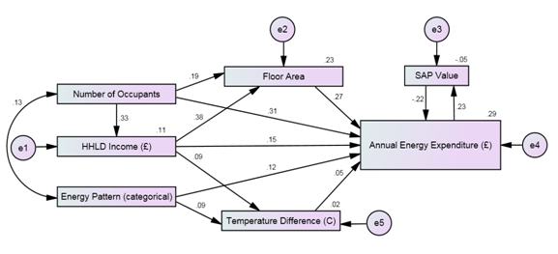
Figure 1: Structural Equation Model of English residential energy consumption

Conclusions
This research shows that homes with a propensity to consume more energy already have relatively higher SAP values which therefore suggests the scope for additional savings through the implementation of energy efficiency technologies may be limited. What is more, this finding implies that homes with a propensity to consume more energy will be more expensive to decarbonise due to the law of diminishing returns. On the other hand, if we focus on homes with a propensity to consume less energy, it can be shown that these homes already have relatively lower SAP rates and are therefore less efficient. However, improving the energy performance of these homes through the implementation of energy efficiency may contribute to the rebound effect acting to increase the average internal temperature rather than decrease energy consumption. These findings suggest the presence of a residential energy efficiency barrier that must be overcome before any real savings from the residential sector can start to accrue. This result may explain why several Government supported projects in the UK aimed at reducing residential energy consumption have not realised their anticipated targets. With this purpose in mind, a dual policy approach may have the most effect. Homes with a propensity to consume more energy should be targeted using behavioural campaigns combined with economic penalties and incentives associated with energy consumption. On the other hand, homes with low SAP values should be targeted for whole home efficiency upgrades in order for these homes to break through the energy efficiency barrier.

References

Please visit this website to download a full list of refences [https://files.me.com/scottjkelly/brhafd]

