WHY DID CO₂ EMISSIONS FROM ROAD PASSENGER VEHICLES IN JAPAN DECREASE? A FACTOR AND POSITIVE ANALYSIS
Okada Akira, Tokyo City University, Phone: +81 45 910 0104, E-mail: okada@tcu.ac.jp

Overview
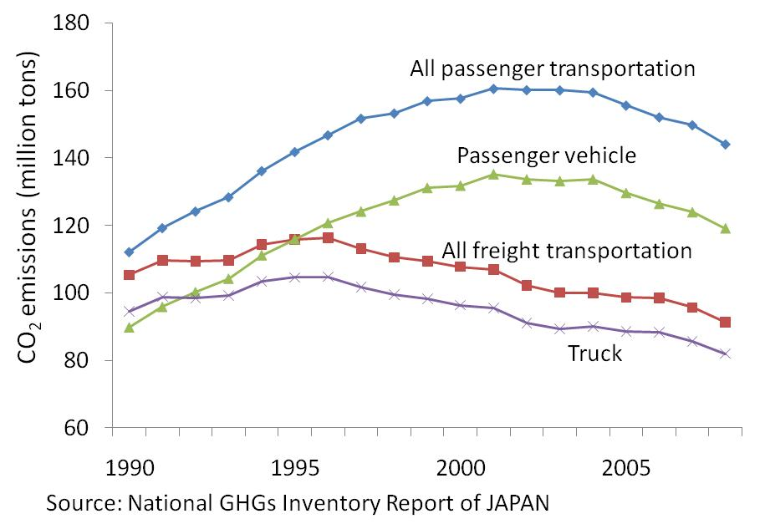
Carbon dioxide (CO₂) emissions from transportation, particularly road transportation, have been increasing worldwide since 1990. The International Energy Agency (IEA; 2010) reports that the transportation sector emitted 6.6 billion tons of CO₂ in 2008. The average annual growth rate of CO₂ emissions globally was 2 percent between 1990 and 2008.
FIGURE 1: Changes in the CO₂ emissions from road transportation in Japan: 1990–2008
However, when examining the greenhouse gas data of the United Nations Framework Convention on Climate Change or those of the IEA, one can find countries whose CO₂ emissions from transportation have already begun decreasing. Such countries include Japan, Germany, France, Portugal, and Austria. CO₂ emissions in Japan peaked in 2001, after which they consistently decreased until 2008. Consequently, the emissions from transportation in Japan had returned to their 1992 level by 2008. Focusing closely on road vehicles in Japan, one can see that the CO₂ emissions from passenger vehicles peaked in 2001 and subsequently decreased from 2002 to 2008 (Figure 1). The CO₂ emissions from trucks peaked in 1996 and decreased until 2008.
Why did CO₂ emissions from transportation, particularly passenger vehicles, in Japan consistently fluctuate? Potential causative factors are changes in fuel efficiency, distance traveled per vehicle, and number of passenger vehicles per 1000 persons. This paper attempts to identify the factors that influenced the growth rate of CO₂ emissions in the last two decades in Japan, and to measure this influence. Moreover, this paper attempts to ascertain the type of variables that are related to these factors. It is assumed that the aforementioned three factors are affected by economic variables, such as income per capita and fuel price. In addition, these factors are also affected by demographic variables, particularly the aging rate—the proportion of people aged 65 and above—because it is known that the travel behavior, car ownership behavior and patterns of the elderly differ from those of the other people as Dargary (2007) mentioned.

Methods
This paper first analyzes the factors affecting the CO₂ emissions from passenger vehicles in Japan. Many research, such as Lakshamanan and Han (1997) and Tmilsina and Shrestha (2010) etc, developed the method of decomposition analysis. However, I apply a decomposition analysis to the data on CO₂ emissions using the technique of Kaya identity. The data comprise statistics collected by the Ministry of Land, Infrastructure, Transport and Tourism (MLIT). It should be noted that here, passenger vehicles include mini cars and light motor vehicles.
The total CO₂ emissions from passenger vehicles in year t (CO2_{t}) can be derived from the total fuel consumption of passenger vehicles in that year. In order to decompose the emissions to the principal factors affecting them, Eq. (1) can be expressed as follows:
$\text{CO}2_{t}=\frac{\text{CO}2_{t}}{E_{t}}⋅\frac{E_{t}}{L_{t}}⋅\frac{L_{t}}{N_{t}}⋅\frac{N_{t}}{{\text{POP}}_{t}}⋅{\text{POP}}_{t}\text{.}$ (1)
where the subscript t denotes the year; E, the energy consumption of passenger cars; L, the kilometric performance of passenger cars; N, the number of passenger cars registered; and POP, the population. The first term in the right-hand side of Eq. (1) is the emission coefficient, the second term indicates the average fuel economy of passenger vehicles, and the third term refers to vehicle kilometers by each car. The fourth term in the right-hand side of Eq. (1) shows the level of car ownership. Here, I replace the four terms in the right-hand side of Eq. (1) with F, FE, K, and V.

Eq. (2) can be derived by differentiating Eq. (1) with respect to t.
$\frac{1}{\text{CO}2_{t}}\frac{\text{dCO}2_{t}}{\text{dt}}=\frac{1}{F_{t}}\frac{{\text{dF}}_{t}}{\text{dt}}+\frac{1}{{\text{FE}}_{t}}\frac{{\text{dFE}}_{t}}{\text{dt}}+\frac{1}{K_{t}}\frac{{\text{dK}}_{t}}{\text{dt}}+\frac{1}{V_{t}}\frac{{\text{dV}}_{t}}{\text{dt}}+\frac{1}{{\text{POP}}_{t}}\frac{{\text{dPOP}}_{t}}{\text{dt}}\text{.}$ (2)
Eq. (2) implies that the growth rate of the CO₂ emissions from passenger vehicles can be given as the summation of the growth rates of F, FE, K, V, and POP. The first term in the right-hand side of Eq. (2) shows the change in the fuel type used by passenger cars. Because almost all passenger cars consumed gasoline in Japan in the past, the first term turns out to be near zero. The growth rate of POP is almost zero because POP did not increase by much in the 1990s, and decreased only from 2006. Thus, it is important to check the terms of FE, K, and V in Eq. (2) to determine the change in the CO₂ emissions from passenger vehicles.
Next, this study empirically investigates the possibility of a relationship among the aforementioned factors, economic variables, and demographic variables, by applying the Environmental Kuznets Curve (EKC) framework through panel data analysis based on Hilton and Levinson (1998). The panel data used in this study are drawn from the MLIT’s statistics and are classified by the area of District Transport Bureaus (DTBs), which work as local branch offices of the MLIT. In order to verify the relationship among these factors and several variables, this study prepares six models, which specify the effect of income per capita, aging rate, and fuel price on these factors. The first three use a panel OLS model for EKC, and the others use a second-order differential equation to estimate EKC in order to alleviate the unit roots issue. The model specifications are as follows:
$$\text{ln}{\left(\frac{E}{L}\right)}_{\text{it}}=β_{0}+β_{1}\text{ln}{\left(\frac{\text{GPDI}}{\text{POP}}\right)}_{\text{it}}+β_{2}\text{ln}{\left(\frac{\text{GPDI}}{\text{POP}}\right)}_{\text{it}}^{2}+β_{3}\text{ln}{\left(\frac{\text{Elder}}{\text{POP}}\right)}_{\text{it}}+β_{4}\text{ln}{\left(\frac{\text{Elder}}{\text{POP}}\right)}_{\text{it}}^{2}+β_{5}\text{ln}{\text{Gas}}_{\text{it}}+ε_{\text{it}},$$
(3)
$$\text{ln}{\left(\frac{L}{N}\right)}_{\text{it}}=β_{0}+β_{1}\text{ln}{\left(\frac{\text{GPDI}}{\text{POP}}\right)}_{\text{it}}+β_{2}\text{ln}{\left(\frac{\text{GPDI}}{\text{POP}}\right)}_{\text{it}}^{2}+β_{3}\text{ln}{\left(\frac{\text{Elder}}{\text{POP}}\right)}_{\text{it}}+β_{4}\text{ln}{\left(\frac{\text{Elder}}{\text{POP}}\right)}_{\text{it}}^{2}+β_{5}\text{ln}{\text{Gas}}_{\text{it}}+ε_{\text{it}},$$
(4)
$$\text{ln}{\left(\frac{N}{\text{POP}}\right)}_{\text{it}}=β_{0}+β_{1}\text{ln}{\left(\frac{\text{GPDI}}{\text{POP}}\right)}_{\text{it}}+β_{2}\text{ln}{\left(\frac{\text{GPDI}}{\text{POP}}\right)}_{\text{it}}^{2}+β_{3}\text{ln}{\left(\frac{\text{Elder}}{\text{POP}}\right)}_{\text{it}}+β_{4}\text{ln}{\left(\frac{\text{Elder}}{\text{POP}}\right)}_{\text{it}}^{2}+β_{5}\text{ln}{\text{Gas}}_{\text{it}}+ε_{\text{it}},$$
(5)
$$Δ^{2}\text{ln}{\left(\frac{E}{L}\right)}_{\text{it}}=β_{1} Δ^{2}\text{ln}{\left(\frac{\text{GPDI}}{\text{POP}}\right)}_{\text{it}}+β_{2} Δ^{2}\text{ln}{\left(\frac{\text{GPDI}}{\text{POP}}\right)}_{\text{it}}^{2}+β_{3} Δ^{2}\text{ln}{\left(\frac{\text{Elder}}{\text{POP}}\right)}_{\text{it}}+β_{4} Δ^{2}\text{ln}{\left(\frac{\text{Elder}}{\text{POP}}\right)}_{\text{it}}^{2}+β_{5} Δ^{2}\text{ln}{\text{Gas}}_{\text{it}}+ε_{\text{it}},$$
(6)
$$Δ^{2}\text{ln}{\left(\frac{L}{N}\right)}_{\text{it}}=β_{1} Δ^{2}\text{ln}{\left(\frac{\text{GPDI}}{\text{POP}}\right)}_{\text{it}}+β_{2} Δ^{2}\text{ln}{\left(\frac{\text{GPDI}}{\text{POP}}\right)}_{\text{it}}^{2}+β_{3} Δ^{2}\text{ln}{\left(\frac{\text{Elder}}{\text{POP}}\right)}_{\text{it}}+β_{4} Δ^{2}\text{ln}{\left(\frac{\text{Elder}}{\text{POP}}\right)}_{\text{it}}^{2}+β_{5} Δ^{2}\text{ln}{\text{Gas}}_{\text{it}}+ε_{\text{it}},$$
(7)
$$Δ^{2}\text{ln}{\left(\frac{N}{\text{POP}}\right)}_{\text{it}}=β_{1} Δ^{2}\text{ln}{\left(\frac{\text{GPDI}}{\text{POP}}\right)}_{\text{it}}+β_{2} Δ^{2}\text{ln}{\left(\frac{\text{GPDI}}{\text{POP}}\right)}_{\text{it}}^{2}+β_{3} Δ^{2}\text{ln}{\left(\frac{\text{Elder}}{\text{POP}}\right)}_{\text{it}}+β_{4} Δ^{2}\text{ln}{\left(\frac{\text{Elder}}{\text{POP}}\right)}_{\text{it}}^{2}+β_{5} Δ^{2}\text{ln}{\text{Gas}}_{\text{it}}+ε_{\text{it}},$$
(8)
where E denotes the energy consumption of passenger cars; L, the kilometric performance of passenger cars; N, the number of passenger cars registered; GPDI, for the DTB’s gross prefectural domestic income; POP, the population; Elder, the number of people aged 65 and above; and Gas, the gasoline price. $ε_{\text{it}}$ is the error term, $Δ^{2}$ is a second-order differential operator, and $β_{0}$–$β_{5}$ are the parameters. The subscript i indicates the DTB number, and the subscript t, the year. In each model, E/L denotes the actual fuel efficiency; L/N, vehicle-kilometers per vehicle; N/POP, the number of vehicles owned per capita; GPDI/POP, the income per capita; and Elder/POP, the aging rate.

As Okada (2010) indicates that there is a quadratic relationship between the CO₂ emissions per capita and the aging rate, thus the proposed hypothesis—“the aging rate and another factor form an inverted U-shape”—yields an expectation with regard to the sign of the parameters Elder/POP and (Elder/POP)²: $β_{3}>0$ and $β_{4}<0$. As each equation also follows the EKC hypothesis, the sign of the parameters GPDI/POP and (GPDI/POP)² are expected as follows: $β_{1}>0$ and $β_{2}<0$. The turning points for each equation can be calculated by $\text{exp}\left(β_{1}/\left(−2β_{2}\right)\right)$ and $\text{exp}\left(β_{3}/\left(−2β_{4}\right)\right)$. Finally, we predict that the estimated parameter of the gas price is negative: $β_{5}<0$.

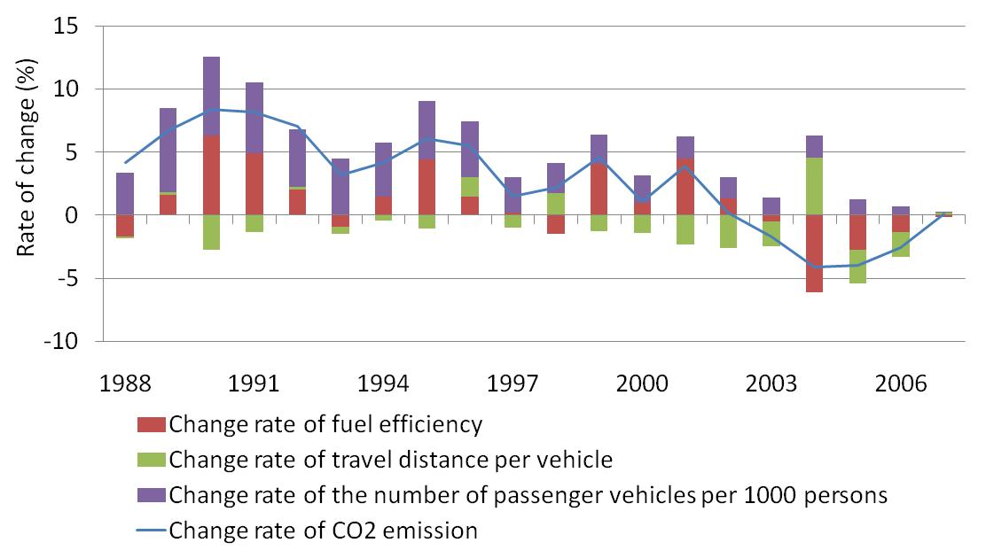
Results
FIGURE 2: Factors behind the change in the CO₂ emissions from passenger vehicles in Japan: 1988–2007
The first analysis indicates that the change in fuel efficiency and in the number of passenger vehicles per 1000 persons contributed to the increase in the CO₂ emissions from passenger vehicles in the 1990s (Figure 2). Between 1991 and 1996, the average growth rate of the two factors was 5.8 percent each year. The CO₂ emissions rapidly increased in the early 1990s because people earned more income in the bubble economy and bought more passenger cars, preferably large passenger cars such as SUVs. The period of deteriorating fuel efficiency happened to coincide with the period of low gasoline prices.
After 2002, the improvements in fuel economy and the decrease in the number of kilometers traveled curbed the growth of CO₂ emissions. The average change rate of the two factors is 2.7 percent from 2002 to 2007. In addition, the change rate of the number of passenger vehicles per 1000 persons stagnated and then declined over time. Unlike in the “before 2001” period, the fuel prices increased continuously and Japan battled a recession after 2002. It is estimated that the latter two phenomena have affected the two factors, which were also affected by the increase in the number of elderly people in Japan because of the increase in the aging rate from 19 percent in 2002 to 22 percent by 2007.
The second analysis reveals that the relationship among the independent valuables and explanatory variables, such as CO₂, income, aging rate, and gas price, varies among models (Table 1). The results of Eqs. (3) and (6) in Table.1 show that there is a positive quadratic relationship between fuel efficiency and income per capita. This also implies that of the increase in income is related to deteriorating fuel efficiency. This result is consistent with the situation in the early 1990s in Japan. On the other hand, the estimated result also shows that there is no relationship between the aging rate and fuel efficiency. The result of Eq. (4) suggests that there exists some relationship between travel distance per vehicle and the explanatory variables. However, the result of Eq. (7) does not support the result of Eq. (4).
The estimation of Eqs. (5) and (8) yields the following two points. First, there is a positive quadratic relationship between the number of cars owned and income per capita. This implies that the increase in income is related to the growth in car ownership. Second, the estimated parameters $β_{3}$ and $β_{4}$accord with the predicted sign; hence, there is an inverse quadratic relationship between the number of passenger vehicles per 1000 people and the aging rate. This implies that the aging rate has a turning point. The turning points as calculated from the estimation results are 12.9 percent and 17 percent. The aging rate of Japan surpassed 17 percent in 2000. As such, the decline in the number of cars owned in Japan is connected to the increase in the aging rate after 2001.
The results of this study reveal that fuel efficiency and travel distance per vehicle do not form any quadratic relationship with the aging rate, one of the demographic factors. However, the number of passenger cars owned forms an inverse quadratic relationship with the aging rate. On the basis of Eq. (1) and the results of the estimation, the CO₂ emissions per capita and the aging rate form an inverse quadratic relationship because there is an inverse relationship between the aging rate and the number of cars owned.
The estimated parameters in this positive analysis imply that there does not exist an EKC relationship among the three factors and income per capita. Only the estimated parameters $β_{1}$ and $β_{2}$ in Eq. (4) are statistically significant and satisfied with the predicted sign for EKC. However, the estimated income level of that peak is JPY 1.24*10¹³⁸, which is equal to US$ 1.46*10¹³⁶. The turning point occurs far beyond the maximum value of income per capita in our data. Thus, the result shows that there is no quadratic relationship between the travel distance per vehicle and income per capita (Richmond and Kaufmann; 2006). Eq. (1) and the results indicate that there is no EKC relationship between the per capita CO₂ emission from passenger vehicles and income per capita in Japan.

Table.1 Estimation Results for Eqs. 3–8
 | Equation 3 | Equation 4 | Equation 5 | Equation 6 | Equation 7 | Equation 8
 | fixed | fixed | fixed | pooled | pooled | pooled
$$β_{0}$$ | 31.11** | 6063.83 | 10.68** | -- | -- | --
GDP/POP | -8.98* | 56.64* | -2.24** | -7.69** | 4.54 | -2.13*
(GPDI/POP)² | 0.79* | -0.09* | 0.21** | 0.67** | -0.39 | 0.20*
Elder/POP | 1.22 | -444.88** | 1.53* | 3.66* | -2.58 | 5.43**
(Elder/POP)² | -0.25 | 9.86** | -0.30** | -0.30 | 0.51 | -0.96**
Gas | -0.05* | -5.50* | 0.00 | 0.02 | 0.05 | -0.00
$${\hat{ρ}}_{1}$$ | 0.97** | 0.25** | 1.36** | -0.89** | -0.95** | -0.18*
$${\hat{ρ}}_{2}$$ | -0.08 | 0.20** | -0.38** | -0.63** | -0.39** | 0.00
$${\hat{ρ}}_{3}$$ |  |  | 0.02 | -0.27*
$${\overline{R}}^{2}$$ | 0.98 | 0.81 | 0.99 | 0.18 | 0.06 | 0.49
D.W. | 1.99 | 2.00 | 1.96 | 1.95 | 2.19 | 1.98
Turning Point  [GDPI/POP]  [Aging rate] | --  -- | 1.24*10¹³⁸  -- | --  12.9% | --  -- | --  -- | --  17.0%
Observations | 165 | 165 | 153 | 129 | 141 | 141
${\hat{ρ}}_{1}$: Coefficient of AR (1), ${\hat{ρ}}_{2}$: Coefficient of AR (2), ${\hat{ρ}}_{3}$: Coefficient of AR (3).
⁺Exceeds the 10 percent threshold, *exceeds the 5 percent threshold, **exceeds the 1 percent threshold.

Conclusions
Through the above analysis, this study verifies four facts. First, the factors affecting the CO₂ emissions from passenger vehicles changed before 2001 and after 2002. Second, these factors are related to the economic and demographic factors such as income, fuel price, and aging rate. Third, a quadratic relationship exists between the change in fuel efficiency and income per capita and between the change in the number of passenger vehicles per 1000 persons and the aging rate, with the turning point being approximately 13 or 17 percent. These results also imply a possible inverse relationship between the proportion of the elderly and the CO₂ emissions per capita from passenger vehicles in an aged society. Therefore, the demographic change is an important consideration in the proposal, choice, and evaluation of the transportation policies for the environment as Liddle (2004) also mentioned. On the other hand, this study does not find an EKC relationship between the three factors and income per capita. This result also reveals no EKC relationship between per capita the CO₂ emissions from passenger vehicles and income per capita.

References
Dargay, J. (2007). The effect of prices and income on car travel in the UK, Transportation Research Part A, 41(10), pp. 949–960.
Hilton, F.G.H. and Levinson, A. (1998). Factoring the Environmental Kuznets Curve: Evidence from Automotive Lead Emissions, Journal of Environmental Economics and Management, 35, pp. 126–141.
International Energy Agency (2010). CO₂ Emissions from Fuel Combustion. 2010 Edition, CD-ROM.
Ministry of Land, Infrastructure, Transport and Tourism. (1988–2008). Annual Report on Motor Vehicle Transport. (In Japanese).
Lakshmanan, T.R. and Han, X. (1997). Factors Underlying Transportation CO₂ Emissions in the U.S.A.: A Decomposition Analysis, Transportation Research D, 2(1), pp. 1–15.
Liddle, B. (2004). Demographic Dynamics and Per Capita Environmental Impact: Using Panel Regressions and Household Decompositions to Examine Population and Transport, Population and Environment, 26(1), 2004, pp. 23–39.
Okada, A. (2010). Does an Increase in the Elderly Population Cause a Decrease in CO₂ Emissions from Road Transportation? A Positive Analysis Using the Environmental Kuznets Curve, 29th USAEE/IAEE North American Conference, Calgary, Alberta, Canada.
Richmond, A.K. and Kaufmann, R.K. (2006). Is There a Turning Point in the Relationship Between Income and Energy Use and/or Carbon Emissions?, Ecological Economics, 56(2), pp. 176–189.
Timilsina, G.R. and Shrestha, A. (2010). Transport Sector CO₂ Emission Growth in Asia: Underlying Factors and Policy Options, Energy Policy, 37(11), pp. 4523–4539.

