Petter Osmundsen
Professor of Petroleum Economics
University of Stavanger

Choice of development concept: platform or subsea?
Implications for the recovery factor
Presentation of research topic
A number of discoveries have a real choice regarding development concept; platform or subsea. The statistics from the Norwegian continental shelf show that fields developed with platforms have a significantly higher recovery rate. The potential for future efforts in increased oil recovery is largely determined by the original development concept. By using case and examples, the paper discusses valuation of the increased flexibility gained by a development solution with platform. It is illustrated that valuation of the different types of flexibility is difficult, which leads to the following questions: do we select development concepts without taking sufficient account of the option values?
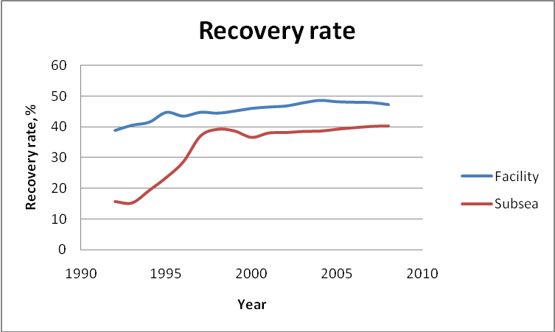
Figure 1. Average recovery rate for platform and subsea fields.
Data source: Norwegian Petroleum Directorate.
Brief overview of related research
Real option theory generates models that enable the pricing of decision flexibility. However, the models are not particularly well suited to analyse the real options associated with the choice of development concept. Partly because these options are complex, partly because they are not independent, and partly because the option models - which have their origins in the pricing of securities – are based on assumptions that are not adequate for concept choice in petroleum developments.
Methods
A simple approach to the issue of development with subsea versus platform is to look at this as a classic choice between spending today versus spending tomorrow. A platform involves higher initial investment, but lower drilling costs and tariffs in the operational phase. The difference in cost structure has an additional effect - which is the main point of this paper - namely that lower drilling costs after the development is carried out also imply a higher recovery rate and thus higher revenues. The article discusses the effect on the recovery rate with cases and examples.
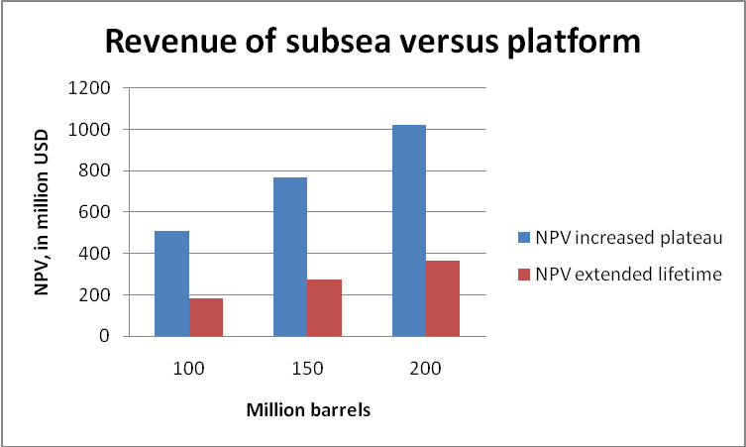
Figure 2: Income Increase for model field, measured in net present value,
in million NOK, of development with subsea versus platform, with a total
production from the model field of 100, 150 and 200 million barrels.
Results and conclusions
To my experience, all of the real option elements are not addressed by the oil companies' existing decision models. To ensure that all real option effects related to the concept choice are addressed, it may therefore be recommended to use simpler methods, such as sensitivity analyses that take into account the differences in operating expenditure and production volumes associated with the concept alternatives.

Department for Industrial Economics, 4036 Stavanger, Norway. E-mail: petter.osmundsen@uis.no, www.uis.no/osmundsen, Downloadable working papers:http://econpapers.repec.org/RAS/pos49.htm
Dixit, A.K. and R.S. Pindyck (2004), Investment under uncertainty, Princeton University Press.
Pilopovic, D. (2007), Energy risk: valuing and managing energy derivatives, McGraw-Hill.

