Overview

lithuanian energy security level Assessment
Juozas Augutis, Vytautas Magnus University, Lithuanian Energy Institute, +370 37 203775, juozas@mail.lei.lt
Ričardas Krikštolaitis, Vytautas Magnus University, Lithuanian Energy Institute, +370 37 401938, ricardas@mail.lei.lt
Linas Martišauskas, Lithuanian Energy Institute, +370 37 401938, linasm@mail.lei.lt
Sigita Pečiulytė, Vytautas Magnus University, +370 37 327898, s.peciulyte@if.vdu.lt
Rolandas Urbonas, Lithuanian Energy Institute, +370 37 401832, rolandas@mail.lei.lt
Prior to 2010 Lithuania was a nuclear power energy producing country. More than 75% of the total Lithuanian electricity production consisted of nuclear power energy. Since the beginning of 2010, both units of Ignalina NPP have been shutdown and the Lithuanian energy system became highly dependent on import of electricity and fossil fuels. Lithuania is isolated from the EU energy systems: there are no electricity interconnections with the Continental Europe and the country is dependent on a single external gas supplier. In addition, Lithuania imports more than a half of the total amount of consumed electricity from neighbouring countries, whereas the remaining part is generated by using fossil fuels supplied by a single source [1].
In this context the issue of Lithuanian energy security, relevant up to now, has become even more important and problematic. As electricity production in the Lithuanian power plant increases gas consumption and, consequently, the dependence on it, it is obvious that this factor in its turn decreases the level of energy security.
In the end of 2010, the Government of the Republic of Lithuania endorsed the National Energy (Energy Independence) Strategy. In this document some strategic initiatives till 2020 were proposed. One of them is to build a liquefied natural gas (LNG) terminal in Klaipeda. The main desired functions of this terminal are the following: to diversify the supply of natural gas so that the country would not be dependent on a single gas supplier; to provide the emergency natural gas reserve function aiming to independently cover the emergency demand for gas; to gain access to the gas spot markes; to establish the preconditions for forming a primary gas market in Lithuania [1]. Another strategic initiative is Lithuanian–Sweden power connection (NordBalt): an electricity line of 700 MW capacity will have been built by the end of 2015. It will enable connecting to the Scandinavian electricity network, trading electricity with the Nordic countries, and accessing cheaper balancing reserves [1].
The Energy Independence Strategy also indicates such energy objects as Lithuanian-Poland power connection of 1000 MW capacity, gas pipeline between Lithuania and Poland, underground gas storage, etc.
The paper presents the investigation of the impact of different kinds of new energy objects (LNG terminal, NordBalt) on the Lithuanian energy security. The system of energy security indicators, covering technical, economical and socio-political aspects is presented. The integral characteristics of these indicators show the level of energy security. The investigation represents the Lithuanian energy security level in 2007 and 2010. In addition, the forecasted energy security level after building the hypothetical LNG terminal and the electricity network between Lithuania and Sweden NordBalt is analysed. The security level of each indicator, each indicator block and total security level are presented as the results. The energy security indicators which increased or decreased in different scenarios are also analysed.

Methods
Security of energy supply is a complex field of scientific research based on modelling of economical processes, analysis of geopolitical situations, network reliability and resistance to disturbance energy analysis, statistical expertise in emergency situations and violations in energy systems, risk analysis, energy supply issues and technical, social, political and other consequences [2,3]. The result of research carried out using the following methods is the estimated level of security of energy supply, analysis of consequences, economic and technical optimisation of security protection and sensitivity analysis.
The basis for the calculation of energy security level is security indicators that are special indexes giving numerical values to important issues for the security of energy sector. The use of indicators enables evaluating both the state of national security of energy supply and separate parts of national energy sector, e.g. transport or nuclear sector. The indicator system is expected to meet certain requirements to be suitable for the assessment of the analysed object. The main characteristics of indicators presented in the paper are science-based, functional, and pragmatic ones. Since the task to assess the security of energy supply is interdisciplinary, the blocks (technical, economical, socio-political and environmental) represent the corresponding fields.
For the assessment of energy security level of Lithuania, 67 indicators were created [2]. All indicators were divided into three blocks: technical, economic or socio-political. In turn, technical and economic blocks were divided into 7 different groups (electricity, gas, oil, coal, nuclear, biofuel, heat), whereas the socio-political block was divided into two groups: geopolitics and sociopolitics.
Each indicator is described by presenting the title, comments, factual and threshold values, pre-critical and critical state values. Each indicator is denoted as X_{ijk}, where i=1,…,n – indicator block number, j=1,…,m – group number in the block, k=1,…,l – indicator number in the group. As the indicators are measured by different units, their values are normalised, e.g. indicator values are transformed in 0-100% scale. Threshold values indicate when the researched system changes to pre-critical and critical states. These values are identified on the basis of technical regulations, normative documents of equipment exploitation and expert assessment [2]. For the assessment of system state, a 15 points scale is used. This scale is divided into three main parts: normal (11-15 points), pre-critical (6-10 points) and critical (1-5 points) states (see Figure 1).

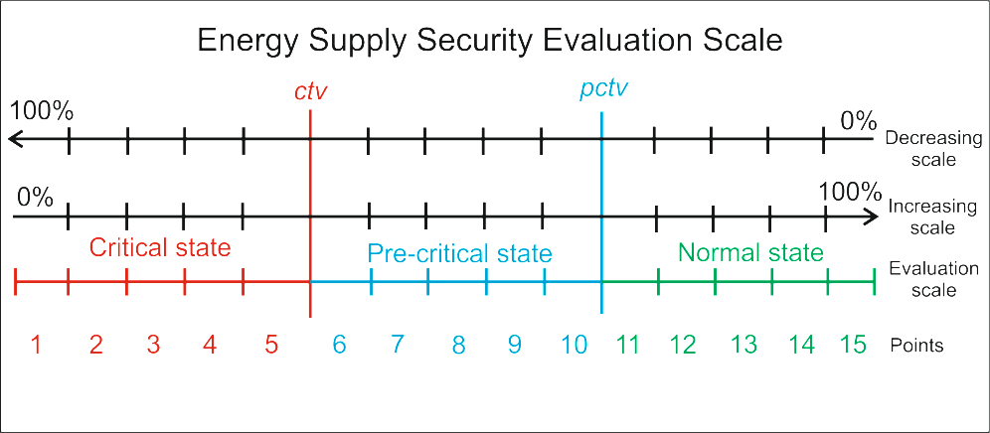

Figure 1: Scale of energy security of supply state assessment.

The evaluation of the state of indicators is based on the direction of each indicator scale which can be increasing or decreasing. In the first case, a higher value of the indicator shows a higher security level, in the second case – a lower security level. If the direction of the indicator scale is decreasing, then the state of indicator is normal, when the value of the indicator is normalized $X_{\text{ijk}}^{n}≤{\text{pctv}}_{\text{ijk}}$; pre-critical, when ${\text{pctv}}_{\text{ijk}}≤X_{\text{ijk}}^{n}≤{\text{ctv}}_{\text{ijk}}$; critical, when $X_{\text{ijk}}^{n}≥{\text{ctv}}_{\text{ijk}}$. If the direction of the indicator scale is increasing, then the state is normal, when $X_{\text{ijk}}^{n}≤{\text{ctv}}_{\text{ijk}}$; pre-critical, when ${\text{ctv}}_{\text{ijk}}≤X_{\text{ijk}}^{n}≤{\text{pctv}}_{\text{ijk}}$; critical, when $X_{\text{ijk}}^{n}≥{\text{pctv}}_{\text{ijk}}$.
Moreover, an important issue is the weights of the indicators, groups and blocks. The weight of each indicator in the block s_{ijk} was determined as equal in a particular block. The group weights s_{ij} in the technical and economic blocks were calculated according to each type of fuel and electricity, as well as heat consumption, calculating the part of relative oil fuel equivalents by thousands of tons in the total energy consumption. The weights of each block s_{i} were attributed equally. The security of energy supply level is evaluated regarding the weights of the indicators and blocks as well as indicator values in points by the expression:
$$B=\sum_{i=1}^{n}{\left(s_{i}\sum_{j=1}^{m}{\left(s_{\text{ij}}\sum_{k=1}^{l}{s_{\text{ijk}}}X_{\text{ijk}}^{p}\right)}\right)},$$
here $X_{\text{ijk}}^{p}$ – the value of the indicator in points which is calculated using the above mentioned inequalities.

Results
To achieve the aim of the work, i.e. to assess the impact of different energy objects on the level of the Lithuanian energy security, the four following scenarios were simulated: 2007 (Ignalina NPP in operation), 2010 (the shutdown of Ignalina NPP), NordBalt (Lithuania–Sweden power connection in operation) and LNG (LNG in Klaipeda in operation). The simulation results are presented in Figure 2 below.

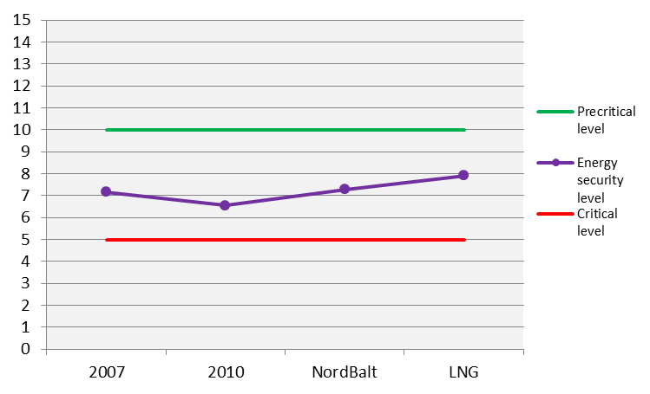
Figure 2: Energy security level.

In order to analyse each scenario separately, all indicators can be divided into three groups: indicators that decrease the security level, indicators that increase the security level and indicators that do not affect it. The first group encompasses 5 indicators: “Ratio of the capacity of the largest supplier of oil and its products to annual consumption” (X₁₃₂), “Ratio of accumulated oil product reserves to average annual consumption” (X₁₃₃), “Average ratio of average heat power units lifetime to their technical resource time” (X₁₇₂), “Ratio of the amount of electricity which can be produced using fuel imported only from one supplier to the total amount of produced electricity” (X₂₁₄) and “Positive societal assessment concerning the development of nuclear power in the country” (X₃₂₅). The calculation results are presented in Figure 3 below.
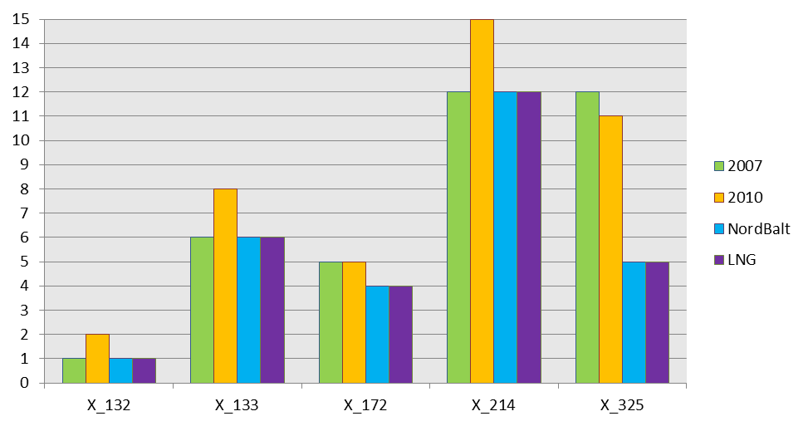
Figure 3: Indicators that decrease the security level.

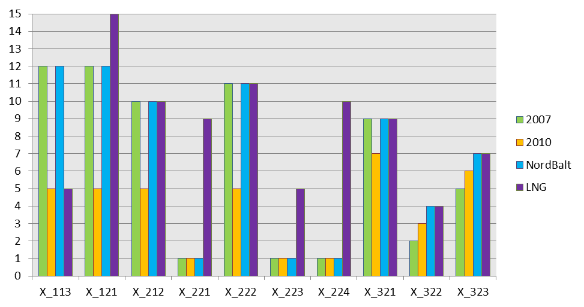
Figure 4: Indicators that increase the security level.

The second group, i.e. the indicators that significantly the increase of the security level, include 10 indicators, namely: “Share of maximum installed part of one technology in the total production of electricity” (X₁₁₃), “Ratio of total gas pipeline capacity to maximum gas consumption” (X₁₂₁), “Ratio of the electricity kWh average cost to open market average electricity kWh cost” (X₂₁₂), “Ratio of gas amount purchased in the gas market to average annual gas consumption” (X₂₂₁), “Ratio of the 1000 cubic meters of gas purchase cost to EU countries average gas purchase cost” (X₂₂₂), “Possibility for consumers to choose a gas supplier” (X₂₂₃), “Possibility for consumers to choose a gas supplier” (X₂₂₄), “Average expenses for energy per inhabitant in comparison with average annual income” (X₃₂₁), “Degree of undertaking the commitment with regard to renewable in the total final consumption” (X₃₂₂), “Degree of following the requirements of Kyoto Protocol regarding the reduction of greenhouse gas emission” (X₃₂₃). The calculation results are presented in figure above (Figure 4). As the LNG scenario suggests, the greatest impact is made by the indicators related to the gas sector. It is natural because the LNG terminal would create the possibilities for developing the gas market and increase the security level.

Conclusions
According to this methodology, the energy security level in 2007 is approximately 7.17 in a fifteen-point system. In comparison to this, the energy security level decreased to 6.55 points in 2010 after the shutdown Ignalina NPP. In case of Lithuania–Sweden power connection (NordBalt), the energy security level increased up to 7.29 points and in case of the LNG, the energy security level rose up to 7.92 points in a fifteen-point system. Nevertheless, in all cases the estimated security level reached a pre-critical energy system level.
In general, it may be noted that the shutdown of Ignalina NPP has had a multifaceted impact on the energy security of Lithuania. The diversity of fuel is an essential element of security and sustainability because dependency on few energy sources increases the risks and reduces the flexibility of the system.
It is natural that a part of energy security indicators decreased after the shutdown of Ignalina NPP. This is, related to the increased gas export and higher prices of electric energy. However, the shutdown of Ignalina NPP has also had some positive effects on the energy security of Lithuania. First of all, the withdrawal of Ignalina NPP from the Lithuanian electricity sector created conditions for the development of the free electricity market and higher numbers of consumers were provided with possibilities to choose electricity producers. Secondly, the competition among other producers of electricity and higher motivation to develop the renewables that emerged after the shutdown of Ignalina NPP can be assessed as another positive factor.

Acknowledgments
This research was funded by a grant (No. ATE-08/2010) from the Research Council of Lithuania.

References
- National Energy (Energy Independence) Strategy. Government of the Republic of Lithuania endorsed the National Energy (Energy Independence) Strategy by Resolution No. 1426 on October 6, 2010.
- Augutis, J.; Krikštolaitis, R.; Pečiulytė, S.; Konstantinavičiūtė, I. 2011. Sustainable development and energy security level after Ignalina NPP shutdown, Technological and Economic Development of Economy 17(1):5-21.
- Correlje A., van der Linde C., 2006, “Energy supply security and geopolitics: A European perspective”, Energy Policy, Vol. 34, Issue 5, pp. 532-543.
- Augutis, J.; Matuzienė, V.; Krikštolaitis, R.; Pečiulytė, S.; Norvaiša, E. (2008). Analysis of security of energy supply assessment methods. Energetika, Vol. 54, No. 4, 1–9.

