THE EFFECT OF CO₂ PRICING ON CONVENTIONAL AND NON-CONVENTIONAL OIL SUPPLY AND DEMAND

Aurélie Méjean, University of Cambridge - CIRED, +33 (0)143947362, am736@cam.ac.uk
Chris Hope, University of Cambridge, +44 (0)122338194, chris.hope@jbs.cam.ac.uk

Overview

This paper introduces a model describing the interaction between conventional and non-conventional oil supply in a Hotelling framework and under CO₂ constraints. The social cost of CO₂ is included in the calculation of the oil rent. A tax on CO₂ emissions associated with fuel use would reduce oil demand and would delay the time when conventional oil is unable to satisfy demand. More precisely, between 87 and 99% of the CO₂ tax is carried into the oil price. Such a tax would delay by 11 years the time when conventional oil production is unable to meet oil demand (mean value). This date is very sensitive to the price elasticity of demand and to the income elasticity of demand, which shows the great potential of demand-side measures to smooth the transition towards low-carbon alternatives.

Methods
A simple probabilistic model for estimating the effect of CO₂ pricing (in this case a CO₂ tax, set at the social cost of CO₂) on oil supply and demand is introduced. The competitive price of oil over time is calculated within a Hotelling framework and is derived from the costs of producing non-conventional oil from Canadian oil sands, a substitute for conventional oil. The model identifies the time of entry of non-conventional oil in the market as the time when conventional oil production alone is unable to match demand. The model describes the behaviour of the oil market under perfect competition, with and without a CO₂ price reflecting its social cost. The social cost of CO₂ emissions associated with the production and use of conventional and synthetic crude oil is included in the model calculations, and this paper investigates the effect of a CO₂ tax set at the social cost of CO₂ on oil prices and demand. Both depletion and technological advances are driving the supply of conventional oil.

The time T when conventional oil production is unable to meet demand is determined by iterating the model until it converges. It is assumed that the competitive price of oil will be equal to the costs of producing synthetic crude oil when that product enters the market at time T. The rent associated with conventional oil at time T is the difference between the competitive price of oil at time T (i.e. the initial costs of producing synthetic crude oil) and the conventional oil production cost. The marginal extraction costs of conventional crude oil are influenced by technological change and depletion. The difference between the competitive price of conventional crude oil and the production cost of oil at T, or the oil rent, is discounted to the present time, and is used to determine the competitive price of oil today. Finally, the Hotelling rent is added to the cost to obtain the competitive price of oil over the whole period. A loop is introduced in the model, as the demand for oil depends on the oil price. The simplified structure of the oil demand and price components of the model is summarised on figure 1.

The model is used to compare the prices and demand obtained after a few iterations in two cases: in the first case prices are calculated with a CO₂ tax on production and fuel end-use, and in the second case prices only include a CO₂ tax on emissions associated with fuel production. The model is set up as follows: a tax is added to the price of oil, which lowers demand through the price elasticity of demand. Lower demand delays the time when conventional oil production only is no longer able to satisfy demand, and thus lowers the oil rent, which reduces the oil price today an drives up demand and extraction. As the model converges, one effect takes over, leading to either higher or lower demand and extraction. It should be noted that the model is designed so that fuel extraction satisfies demand as long as this is physically possible.

A review of the economic and scientific literature is conducted in order to determine the probability distributions associated with each parameter of the model. These probability distributions are used to perform Monte-Carlo simulations. For each run, a sampling method assigns a value to each parameter from the input probability distributions, and the calculations are performed for this particular set of values. When 10,000 runs have been performed, the results are gathered for each output and presented as probability distributions. The uncertainty associated with the validity of the input data is looked at, together with the influence of each parameter on the output.

Results
The results show that a tax on CO₂ emissions associated with fuel use would reduce demand and delay the time when conventional oil supply is unable to satisfy demand. Despite the effect of lower demand, a CO₂ tax on fuel use would reduce demand for oil: between 87% and 99% of the CO₂ tax would be added to the oil price. With a CO₂ tax on fuel production and not on fuel use, conventional oil supply alone is expected to be unable to match oil demand between 2008 and 2021 (90% confidence interval), with a mean value of 2013.

A CO₂ tax on fuel use set at the social cost of CO₂ would delay the time when conventional oil production is unable to meet oil demand from 2013 to 2024 (mean value). With a CO₂ tax on use, the results show a 90% chance that conventional oil supply alone will be unable to meet demand between 2011 and 2050. Figure 2 shows the influence of the main parameters on the date T when conventional supply alone is unable to match demand (the influences show the change in years if one parameter increases by one standard deviation while all other parameters are held constant). The most influential parameter is the price elasticity of demand. The results show that an increase (in absolute values) of one standard deviation, or 0.12 units, of the price elasticity of demand would delay the date when conventional oil production alone is unable to meet demand by over 15 years. Also, a reduction of the income elasticity of demand of 0.2 units would delay that date by about 7 years.

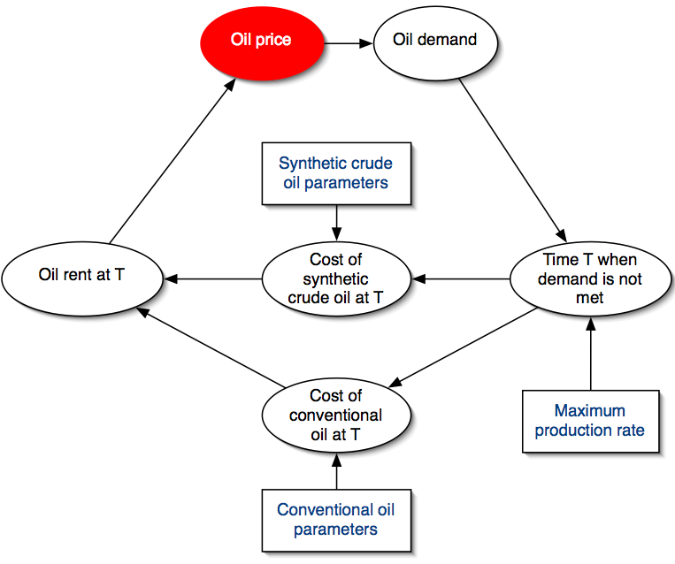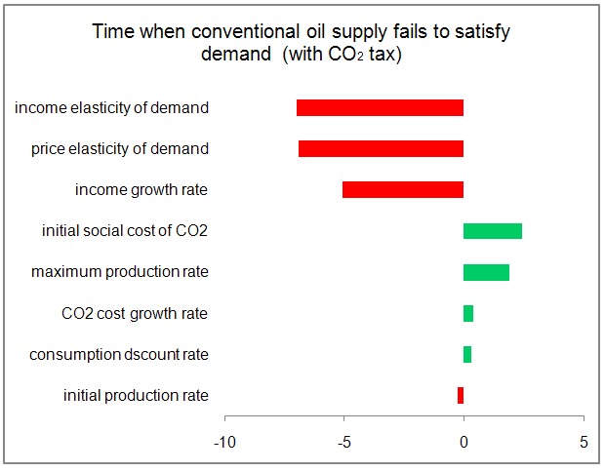
Figure 1: Structure of the model Figure 2: Influences of the main parameters on date T

Conclusions
Despite the effect of the lower demand, a CO₂ tax on fuel use would reduce demand for oil: between 87% and 99% of the CO₂ tax would be added to the oil price. This result informs the debate on the “Green Paradox”. Sinn (2008) argues that reducing demand for oil (and other high carbon fuels) in countries committed to reduce CO₂ emissions would depress the world oil price, which would lead to an increase in oil demand from countries outside of an international agreement to abate CO₂ emissions. This in turn might increase the total level of CO₂ emissions. The result presented here quantifies this effect in the case where the backstop is more carbon-intensive than conventional oil. The result shows that the oil price minus the CO₂ tax on fuel use would fall by 1% to 13% compared to the case without a CO₂ tax. This means that countries that remain outside an international agreement would benefit from slightly lower oil prices than without the tax, as Newbery points out (2010). This effect is thus rather limited. From these results it can be concluded that demand-reducing measures will be largely effective. The results also show that the date when conventional oil is unable to meet demand is very sensitive to the price elasticity of demand and the demand growth rate: these results reveal the great potential of demand-side measures to smooth the transition to low-carbon liquid fuel alternatives.

References
Newbery, D.M., 2010. Oil Shortages, Climate Change and Collective Action. EPRG Working Paper N°1023, University of Cambridge, Cambridge, U.K.

Sinn, H.W., 2008. Public policies against global warming. International Tax and Public Finance 15 (4) 360-394.

