Overview

ESTIMATION OF POWER SUPPLY COST REDUCTION BY INTRODUCTION OF DEMAND RESPONSE PROGRAM IN JAPAN

Masatoshi Takayama, Central Research Institute of Electric Power Industry Socio-economic Research Center,
+81 3-3201-6601, takayama@criepi.denken.or.jp
Masahito Takahashi, Central Research Institute of Electric Power Industry Socio-economic Research Center,
+81 3-3201-6601, m-taka@criepi.denken.or.jp
Yamaguchi Nobuyuki, Central Research Institute of Electric Power Industry Socio-economic Research Center,
+81 3-3201-6601, n-yama@criepi.denken.or.jp
Rikiya Kato, Central Research Institute of Electric Power Industry Socio-economic Research Center,
+81 3-3201-6601, r-kato@criepi.denken.or.jp
Demand Response (DR) is a tariff or program established to motivate changes in electricity use by end-use customers in response to changes in the price of electricity over time or to incentive payments designed to make electricity use lower at times of high market prices or when grid reliability is jeopardized [1].
Since demand grows very slowly in Japan, the country is not expected to experience stringent power supply and demand. However, there is still a need to improve the annual load factor. Reducing fossil fuel expenses is necessary as well. Although the potential of DR in Japan has been studied from the customer side through pilot projects using advanced metering infrastructures (AMI) and customer surveys, the cost-benefit analysis of DR introduction has not yet been performed. The purpose of this study is to estimate the impact of a DR program on the power supply cost of the Japanese power system.

Methods
Using Central Research Institute of Electric Power Industry (CRIEPI)’s long-term power generation system expansion model (OPTIGEN), we estimated the impact of a peak-cutting DR program on the power generation cost of the Japanese power system until 2040, as part of the cost-benefit analysis. The assumed peak-cutting DR program and outline of OPTIGEN are as follows.
(1) Assumed Peak-Cutting DR program
The DR program period was set for three hours between 13h and 16h on the three highest demand days in the summer. During the program introduced period (FY2013-FY2040), it is assumed that we can reduce the demand in L_{T} (peak) × (1–α/100) through the DR program, where L_{T} (peak) is the peak demand in fiscal year (FY) T and α (%) is the peak cutting rate. Figure 1 shows a sample of peak demand cut by assumed DR in FY2040. The figure indicates that the demand in the DR case (α = 1.5%) is smaller than that in the non-DR during the peak-time period(13h-16h).
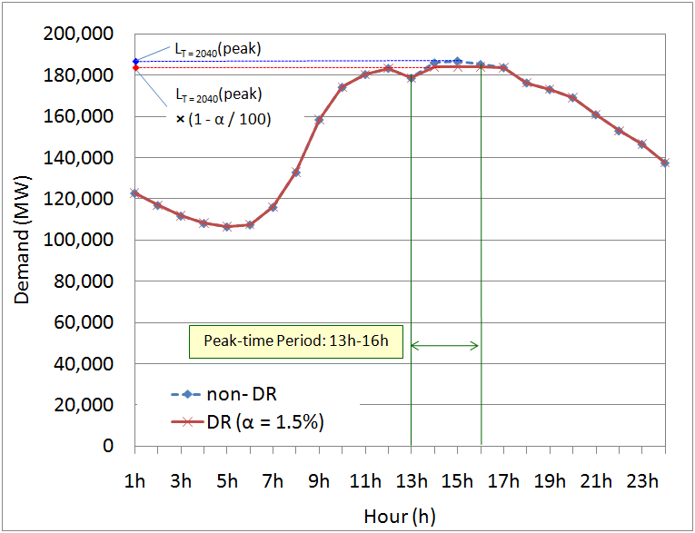
Figure 1: Peak Demand Cut by Assumed DR in FY2040

(2) Outline of OPTIGEN
The model minimizes the long-term power generation cost under given external conditions and finally derives the future power peneretion mix of Japan, where the long-term power generation cost is composed of construction, operation and management, and fuel costs. We considered six kinds of power generation technologies as optimized targets in the model: nuclear power coal-fired thermal power, conventional LNG-fired thermal power, an LNG combined cycle, oil-fired thermal power, and pumping strage hydropower.

Results
According to the results, the averaged unit generation cost during the estimation period was between FY2010 and FY2040; this is the total generation cost divided by the total generaged energy during the period. The averaged unit generation cost and the averaged annual load factor are 6.661 Yen/kWh and 65.4%, repectively, in the non-DR case, as shown in Figure 2. The averaged unit generation cost decreases as the peak cutting rate of DR increases. When the peak demand is cut by 1.0%, the averaged unit generation cost is 6.648 Yen/kWh, which represents a decrease of 0.19% compared to the non-DR case, and the averaged annual load factor is 66.0%, which represents an increase of 0.6% compared to the non-DR case.
Total generation cost also decreases as the peak cutting rate increases, in the same way as the averaged unit generation cost, owing to the reduced construction cost of power plants, as shown in Figure 3. The figure also indicates that avoided cost f the DR program, or the power generation cost saved by reducing 1kW of peak demand, is about 8500 Yen/kW on average. This avoided cost is approximeately equal to the annualized unit construction cost of an conventional LNG-fired thermal power plant.
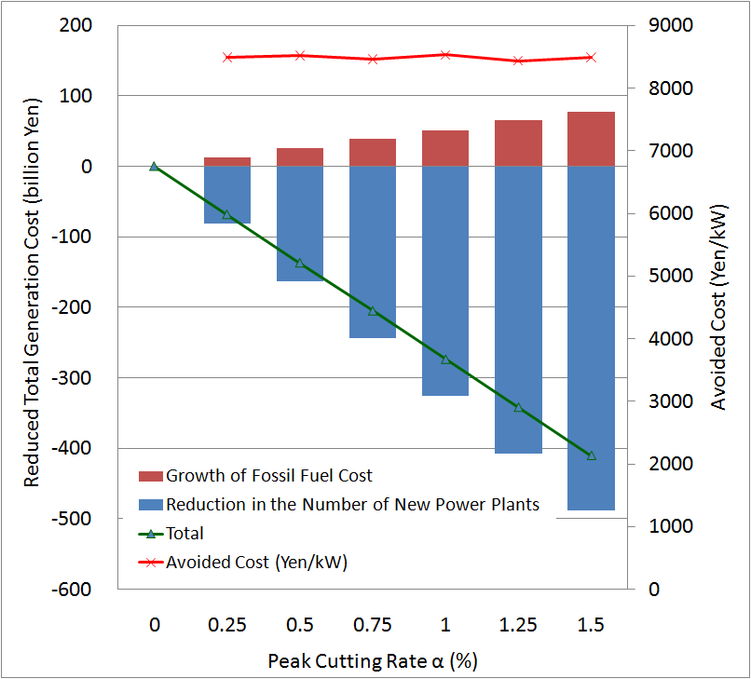
Figure 3: Reduced Total Generation Cost and Avoided Cost
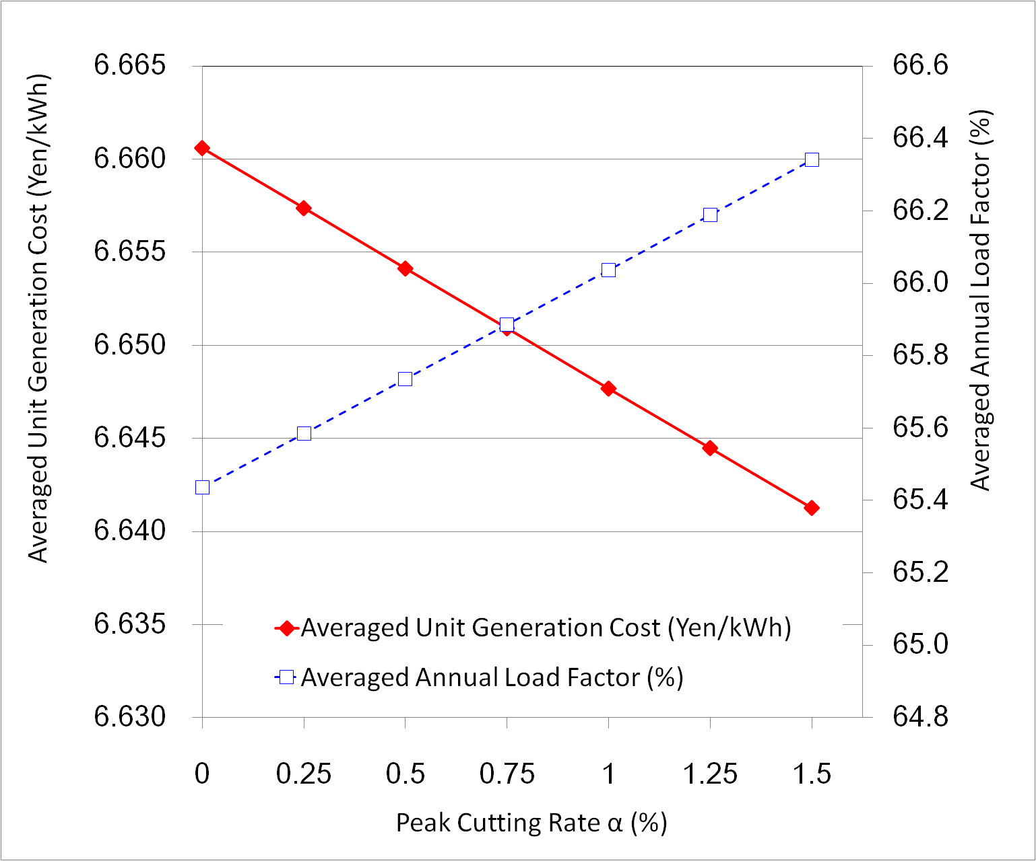Figure 2: Averaged Unit Generation Cost and Averaged Annual Load Factor during the Estimation Period

Conclusions
In the study, using OPTIGEN, we estimated the impact of an assumed peak-cutting DR program on the power generation cost of the Japanese power system as a part of the cost-benefit analysis.
In the future, we should estimate not only the impact of the DR program on the generation cost, but also on the transmission, distribution, and program costs to analyze the social cost-benefit. We would also like to study about the possible applications of DR program other than peak-cutting DR programs.

References
[1] Benefits of Demand Response in Electricity Markets and Recommendations for Achieving Them, Department of Energy, 2006.

