Overview

ENERGY CONSUMPTION TRANSITION AND HUMAN DEVELOPMENT
Qiaosheng Wu, China University of Geosciences, School of Economics and Management, Wuhan, 430074,China,qshwu@cug.edu.cn
Svetlana Maslyuk, Monash University, School of Business and Economics,Churchill,Vic.3842, Australia, Svetlana.Maslyuk@monash.edu.au
Valerie Clulow , Monash University, School of Business and Economics, Churchill, Vic. 3842, Australia, Valerie.Clulow@monash.edu.au
]

Focusing on the high-income OECD countries and selected emerging countries with rapid human development, this paper investigates energy consumption and energy intensity convergence for a panel of 105 countries over the period 1971-2007. Evidence of convergence (or a lack of thereof) implies a specific pattern in the diffusion of energy-related technologies, may help in establishing international environmental targets and forecasting energy consumption and energy intensity, and also contributes on the debate on the existence of the Environmental Kuznets Curve (Le Pen and Sevi, 2010). To date, energy literature (Le Pen and Sevi, 2010; Liddle, 2009; Markandya et al., 2006; Alcantara and Duro, 2004; Nilsson, 1993) mainly focused on convergence in energy intensities, carbon intensities and GHG emissions, leaving the question on convergence in energy consumption open. Until recently the convergence in energy intensities have been examined using mostly descriptive methods such as graphical analysis (Nilsson, 1993) and methods without formal statistical testing (Alcantara and Duro, 2004). No consensus has been reached in the literature in this account. In addition, currently there are very few articles in energy literature, which discuss the relationship between human development (HD) and energy consumption (intensity). These papers (Pasternak, 2000, Dias et al., 2006, Ediger and Tathdil, 2007, and Martınez and Ebenhack, 2008) provide a description of HD indicators and do not model the relationship between HD and energy consumption. In general, researchers agree on significant nonlinear relationship between the HD and energy consumption. However, none of these papers measures the levels of energy consumption which are required by the developing nations to catch up with developed nations to achieve higher HD levels. Our paper makes two important contributions to the literature. First, we examine the energy consumption convergence and energy intensity as well as relative transition paths using Phillips and Sul’s (2007, 2009) nonlinear time-varying factor model. This model incorporates the possibility of transitional heterogeneity and transitional divergence and is robust to the stationarity properties of the series. Second, we estimate the catch-up elasticity of human development to energy consumption (energy intensity) for these countries. This allows to analyze how sensitive is human development to changes in energy consumption (energy intensity). We use 2007 UNDP Human Development Index (our proxy for human development level, hereafter HDI), while energy data (energy consumption per capita, energy intensity, electricity consumption per capita and electricity intensity) is from the International Energy Agency. In addition to using the entire sample, nations have been further divided into three groups: 27 countries in Group A are characterised by high levels of HD and belong to OECD; 5 countries in Group B are emerging nations with high levels of economic growth and medium human development (Brazil, India, Indonesia, China and South Africa) and Group C combines Groups A and B.

Methods

Suppose that $Y_{\text{it}}$is natural logarithm of energy consumption per capita (energy intensity) for a panel of countries i = 1,…, N and t = 1,…,T where N and T are the number of countries and the sample size respectively. $Y_{\text{it}}$can be decomposed into the systematic and transitory components as
$Y_{\text{it}}=a_{\text{it}}+x_{\text{it}}t$ (1)
where $a_{\text{it}}$ and $x_{\text{it}}t$represent systematic components and transitory components respectively. Philipps and Sul (2009) transform (1) in a way that these in the panel are separated:
$Y_{\text{it}}=(\frac{a_{\text{it}}+x_{\text{it}}t}{μ_{t}})μ_{t}=b_{\text{it}}μ_{\text{it}}$ (2)
where $b_{\text{it}}$or the individual transition factor explicitly measures the share of the common trend $μ_{\text{it}}$that country $i$ energy consumption experiences. $b_{\text{it}}$measures the transition path of an economy to the common steady-state energy consumption path as determined by$μ_{t}$. This specification enables testing for convergence by examining whether the transition factors $b_{\text{it}}$converge to a constant, $b$ by taking ratios instead of differences and thus eliminating the common growth component. To do so, Philipps and Sul (2009) define the relative transition parameter, $h_{\text{it}}$,as
$h_{\text{it}}=\frac{Y_{\text{it}}}{N^{−1}\sum{Y_{\text{it}}}}=\frac{b_{\text{it}}}{N^{−1}\sum{b_{\text{it}}}}$ (3)
which measures the individual transition factors for country $i$ relative to the cross-section average energy consumption. Since the “relative transition path” $h_{\text{it}}$traces out an individual trajectory of energy consumption for each country relative to the average, it can be used to assess whether or not the divergence from $μ_{t}$is transitory or permanent. The catch-up elasticity of HDI to energy consumption which is necessary for the Group A and B nations to reach the value of the human development of the top HDI nation in 2007 (Norway), is calculated based on the estimation of the two non-liner models:

The natural logarithm model: $Y=a+\text{bx}+c\text{ln}(x)$ (4)
The square root model: $Y=a+\text{bx}+{\text{cx}}^{\frac{1}{2}}$ (5)
where Y is the HDI and x is the energy consumption (intensity) expressed as fractions. Based on the estimates, the elasticity is calculated as derivative of Y with respect to x.

Results
According to Phillips and Sul (2007, 2009), under the assumption of convergence, the relative transition path tends to unity for all countries in the panel. Figure 1 shows relative energy consumption path for selected countries.
(USA, Japan, UK)  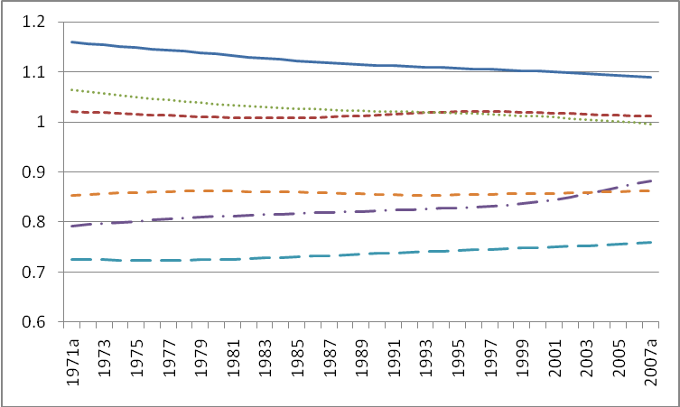  (Brazil, China, India)  Figure 1: Examples of relative transition paths of selected countries (1971-2007) | We found that these paths are quite different for developed and developing countries and do not converge to the same steady state. For high-income OECD countries(Group A), the relative transition paths of energy intensity do not tend to unity, but in energy consumption per capita, there is a clear tendency for these countries to converge. In contrast, for Group B both energy consumption and intensity tend to converge.
For countries in Group A, the catch-up elasticity diminshes both with the increase of x and with the increase of Y. With the increase of x, the elasticity decreases fast at early human development stage, and slows down at later stages. Elasticity decreases to zero when per capita energy consumption fraction reaches about 80% of the Norway’s level. For countries in Group B, catch-up elasticity decreases faster with the increase of x than the increase of Y at early human development stages and more slowly at late development stages. Here, elasticity decreases to zero when its per capita energy consumption fraction reaches about 25% of the Norway’s level.

Conclusions

This paper provides some insight on the energy consumption and energy intensity paths which are required for developing nations to catch-up with the developed based on a convergence tests introduced by Pillips and Sul (2007, 2009). The results indicate a big gap between developed countries and developing countries in both HDI and energy variables. Developing and developed countries seem not to converge to the same steady state. Similar to Le Pen and Sevi (2010), our results show that international development targets should be developed utilizing the non-convergence paradigm. Also, since energy consumption paths and the value of catch-up elasticity between Groups A and B is different to achieve improvements in the human development, any nation should not only rely on the increase in energy or electricty consumption, because it will work only in the short term, but work on improvements in its energy efficiency.

References
Alcántara, V., and Duro, J.A. (2004). “Inequality of Energy Intensities across OECD Countries,” Energy Policy, 32, 1257-1260.
Dias, R. A., Cristiano R. M., and Balestieri, J. A. P. (2006). “The Limits of Human Development and the Use of Energy and Natural Resources,” Energy Policy, 34, 1026–1031.
Ediger, V. S., and Huseyin, T. (2007). “Energy as an Indicator of Human Development: A Statistical Approach”, Journal of Energy and Development, 31, 213-232.
Le Pen, Y., and Sevi, B. (2010). On the Non-convergence of Energy Intensities: Evidence from a Pair-wise Econometric Approach,” Ecological Economics, 69, 641-650.
Liddle, B. (2009). “Electricity Intensity Convergence in IEA/OECD Countries: Aggregate and Sectoral Analysis,” Energy Policy, 37, 1470-1478.
Markanya, A., Pedroso-Galinato, S., and Streimikiene D. (2006). “Energy Intensity in Transition Economies: is there a Convergence towards the EU Average?,” Energy Economics, 28, 121-145.
Martınez, D. M., and Ebenhack, B. W. (2008). “Understanding the Role of Energy Consumption in Human Development through the Use of Saturation Phenomena”, Energy Policy, 36, 1430–1435.
Nilsson, L. (1993). “Energy Intensity in 31 Industrial and developing countries 1950-1988,” Energy, 309-322.
Pasternak, A. D. (2000). “Global Energy Futures and Human Development: a Framework for Analysis,” US Department of Energy Report UCRL-ID- 140773, Lawrence Livermore National Laboratory, Livermore, CA.
Pillips P.C.B., and Sul, D.(2009). “Economic Transition and Growth,” Journal of Applied Econometrics, 24, 1153-1185.
Pillips P.C.B., and Sul, D.(2007). “Transition Modelling and Econometric Convergence Tests,” Econometrica, 75, 1771-1855.
United Nations Development Programme, Human Development Reports for 1990-2008, New York.

