SUSTAINABLE ENERGY POLICIES ASSESSMENT FOR SPAIN IN 2030

Álvaro López-Peña, BP Chair on Energy and Sustainability, +34915422800, alvaro.lopezpena@iit.upcomillas.es

Pedro Linares, BP Chair on Energy and Sustainability, +34915422800, pedro.linares@upcomillas.es

Ignacio Pérez-Arriaga, BP Chair on Energy and Sustainability, +34915422800, ipa@mit.edu

Presentation of research topic
The Spanish energy system is confronted with great sustainability challenges, as it is the case with most OECD countries. According to recent research, one of the main reasons for this is the evolution of the Spanish economy during the previous years to the present crisis, where construction gained a big importance in Spanish output while at the same time allowed GDP per capita to approximate the European average levels. This has made energy consumption grow significantly, especially from the (now richer) households that demand more energy and transportation services. In addition, the reliance of Spanish economy on other low added-value and high energy consumption sectors, such as tourism, has made energy intensity grow during the 1990s and first years of the 21st century (Mendiluce, Pérez-Arriaga, and Ocaña 2010). Today’s Spanish energy sector is largely dependent on imported primary energy sources (oil, gas, coal and enriched nuclear fuel): 88% primary energy dependence in 2008 according to (BP Chair on Energy and Sustainability, 2010). This seems to contribute as well to the Spanish large trade deficit (10% of GDP in 2008). The economic growth would have made the environmental impacts of the Spanish energy sector grow considerably: +50% in the equivalent CO₂ emissions of the energy sector with respect to the 1990 levels (Ministerio De Medio Ambiente Y Medio Rural Y Marino 2010). In addition, projections for the future of the Spanish energy system point at growing primary energy consumption with high reliance on imported fossil fuels which, in turn, would tend to be more expensive as global energy demand grows faster than supply (International Energy Agency 2010). For a more detailed diagnosis, see (BP Chair on Energy and Sustainability, 2010).
Energy policies pursuing greater sustainability, while complementing markets, are required (Pérez-Arriaga and Linares 2008). Policy analysis tools are needed for evaluating them. The aim of this paper is to present a sustainable energy policies analysis tool and some of its results when applied to the Spanish case in the 2030 horizon.

Related research
Some related research on Spanish sustainable energy policy assessment is (Linares, Santos, and Pérez-Arriaga 2008), (Labriet et al. 2010) or (Ministerio De Industria Turismo y Comercio 2007). On a broader geographical scope, some references are (Criqui, Mima, and Viguier 1999), (Syri et al. 2001) or (Das, Rossetti Di Valdalbero, and Virdis 2007). For a good review on modelling techniques for sustainable energy policymaking, see (Boulanger and Bréchet 2005).

Methods
The developed tool consists on a static linear programming (LP) optimization model that satisfies energy services demand for a given year, while maximising the several dimensions of sustainability (economic, social and environmental) of the resulting energy sector, measured in economic terms. The energy sector is characterised as a set of processes comprising primary energy imports/exports, production of indigenous primary energy, energy transformations, final energy imports/exports, final energy distribution, and final energy consumption. That is, an structure inspired in the Sankey diagram of the Spanish energy sector introduced in (BP Chair on Energy and Sustainability, 2010) and generalised in a similar way as the Reference Energy System concept in the TIMES modelling paradigm. The energy demand sectors are modelled with a Linear Expenditure System-based approach, and investments in energy efficiency are possible as well. Reliability constraints are considered in the electricity sector when evaluating intermittent generation investments.
The economic and environmental sustainability of the resulting energy flow is evaluated in economic terms. For this, direct economic costs (energy importation, mining, transformation and distribution), revenues (energy exportation), lost utility of unsatisfied demand and economic and environmental externalities valued in monetary terms are considered. Social sustainability is not considered yet. This is the objective function to be optimized, where the decision variables are the capacities of the different processes, the investments in energy efficiency and the flows in the energy system. Policies are represented by restrictions on these decision variables. This LP modelling approach, with low complexity, allows us to quantify and easily understand the major trade-offs that exist in trying to achieve the predefined objectives. In addition, the results can be represented and easily understood through intuitive Sankey diagrams. This methodology’s main contribution is the transparency and easy understanding of the results and involved policy trade-offs, while at the same time providing a sound framework for quantifying and maximising energy sustainability. With this model, several policies proposed by the Spanish government and other relevant agents in the Spanish energy sector will be evaluated.

Results and conclusions
The model has been tested initially (as a sort of calibration) to produce the optimal energy system for 2008 under different policy assumptions, considering the actually observed energy demands (no substitution possibilities) and installed capacities. As an example, a restriction on total carbon emissions is set. In the figure, the resulting Sankey diagrams without (left) and with (right) the constraint are shown, where its results upon coal-fired electricity generation can be seen. The marginal abatement cost of carbon emissions in this case is over 200 €/ton.
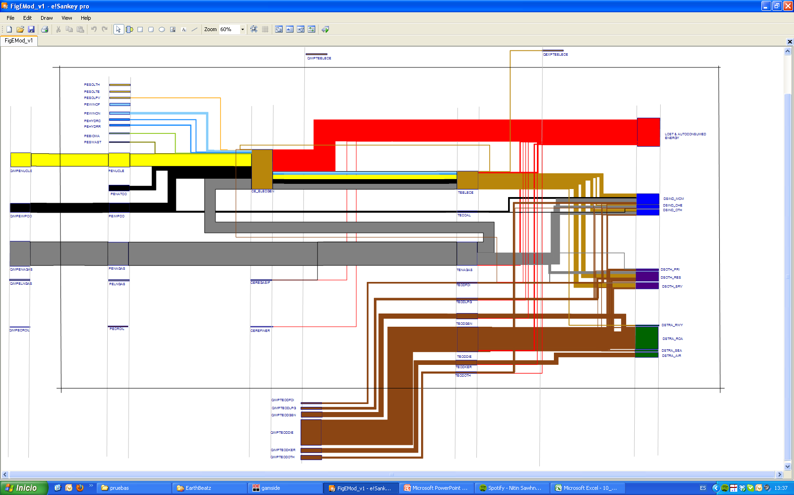 | 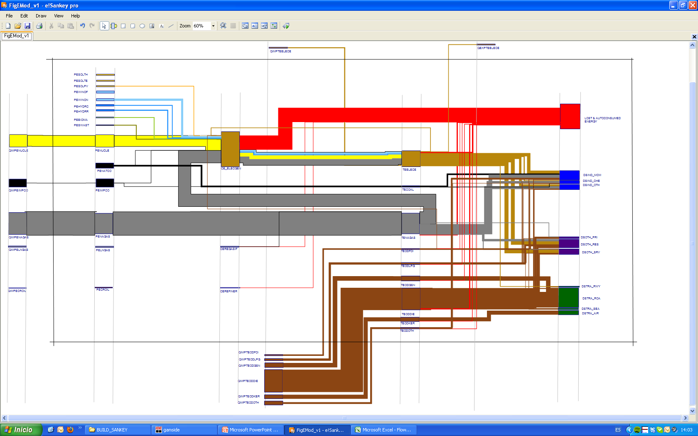
Some preliminary conclusions can be obtained: with fixed installed capacities and no energy efficiency nor substitution possibilities, marginal abatement costs of carbon emissions are quite high. This result is reasonable as the system does not have many degrees of freedom for reducing emissions. In the full paper, these possibilities (investment in capacity or energy efficiency as well as substitution) will be explored, as well as other policies in the medium and long term.

References
Boulanger, Paul-Marie, and Thierry Bréchet. 2005. “Models for policy-making in sustainable development: The state of the art and perspectives for research.” Ecological Economics 55:337-350. http://linkinghub.elsevier.com/retrieve/pii/S0921800905003198.
BP Chair on Energy and Sustainability. 2010. Observatorio de Energía y Sostenibilidad en España 2009. Madrid http://www.upcomillas.es/catedras/bp/Documentos/Actividades/Observatorio/Febrero2010/InformeObservatorio2009Act.pdf.
Criqui, Patrick, Silvana Mima, and Laurent Viguier. 1999. “Marginal abatement costs of CO2 emission reductions , geographical flexibility and concrete ceilings: an assessment using the POLES model.” Energy Policy 27:585-601. http://linkinghub.elsevier.com/retrieve/pii/S0301421599000518.
Das, Anjana, Domenico Rossetti Di Valdalbero, and Maria R. Virdis. 2007. “ACROPOLIS: An example of international collaboration in the field of energy modelling to support greenhouse gases mitigation policies.” Energy Policy 35:763-771. http://linkinghub.elsevier.com/retrieve/pii/S0301421506001133.
International Energy Agency. 2010. World Energy Outlook 2010. Paris.
Labriet, Maryse, Helena Cabal, Yolanda Lechón, George Giannakidis, and Amit Kanudia. 2010. “The implementation of the EU renewable directive in Spain. Strategies and challenges.” Energy Policy 38:2272-2281. http://linkinghub.elsevier.com/retrieve/pii/S0301421509009537.
Linares, Pedro, F. Javier Santos, and Ignacio Pérez-Arriaga. 2008. “Scenarios for the evolution of the Spanish electricity sector: Is it on the right path towards sustainability?” Energy Policy 36:4057-4068. http://linkinghub.elsevier.com/retrieve/pii/S0301421508003054.
Mendiluce, María, Ignacio Pérez-Arriaga, and Carlos Ocaña. 2010. “Comparison of the evolution of energy intensity in Spain and in the EU15. Why is Spain different?” Energy Policy 38:639-645. http://linkinghub.elsevier.com/retrieve/pii/S0301421509005886.
Ministerio De Industria Turismo y Comercio. 2007. Estudio de Prospectiva Energética en España en el Horizonte 2030. Madrid.
Ministerio De Medio Ambiente Y Medio Rural Y Marino. 2010. Inventario de emisiones de gases de efecto invernadero de España años 1990-2008. Madrid.
Pérez-Arriaga, Ignacio, and Pedro Linares. 2008. “Markets vs. regulation: A role for indicative energy planning.” The Energy Journal 29:149–164. http://www.iit.upcomillas.es/pedrol/documents/ej08.pdf.
Syri, Sanna et al. 2001. “Low-CO2 energy pathways and regional air pollution in Europe.” Energy Policy 29:871-884. http://dx.doi.org/10.1016/S0301-4215(01)00022-2.

The diagram layout and used colour scheme is the same one as in the Sankey diagrams in (BP Chair on Energy and Sustainability, 2010)

