Overview
Exploring the homeowner’s decision in favor of a residential heating system - A discrete choice analysis for GERMANY
Christian Michelsen, RWTH Aachen University, Phone: +49 241 80 49 836, E-mail: cmichelsen@eonerc.rwth-aachen.de
Reinhard Madlener, RWTH Aachen University, Phone: +49 241 80 49 820, E-mail: rmadlener@eonerc.rwth-aachen.de
Residential heating accounts for more than 75% of the energy demand of German households and is mainly based on the fossil fuels oil and natural gas. Hence, there is a strong link to global warming, energy supply security, and (increasing) energy prices. Meanwhile, there are huge technical and economic potentials for energy and CO₂ savings. Consequently, one of the main aims of the long-term energy plan (Energiekonzept) of the German government is to reduce the primary energy demand of the residential building stock by 80% until 2050. Among other actions, the installation of residential heating systems (RHS) based on renewable energy sources is one measure. However, this implies targeting a heterogeneous group of homeowners. These actors have differences e.g. with respect to their financial possibilities, characteristics of the home or preferences regarding certain RHS-specific attributes.
In this research, we analyze the influence of such variables on the homeowners’ decision in favor of a RHS. To this end, we apply a discrete choice model on survey data. Research that applies a discrete-continuous choice framework on the determinants of residential energy behavior, such as appliance choice was carried out by e.g. Dubin and McFadden (1984), Liao and Chang (2002), Mansur et al. (2008) or Vaage (2000). An example for the choice of space heating types of German households is Braun (2010). However, all these studies are based on appliance ownership data and mostly exclude behavioral aspects, while only few studies exist up to now that use data on the individual adoption decision (e.g. Achtnicht, 2010). Therefore, our research makes a significant theoretical and empirical contribution towards a better understanding of the adoption of energy technologies such as RHS at the level of the individual decision-maker.

Methods
In a first step, we developed and implemented a questionnaire for a mail survey in Germany in order to obtain data on the homeowners’ adoption decision in favor of a RHS. A theoretical framework proposed by Michelsen and Madlener (2010) guided the development of the questionnaire. Logistic support for carrying out the survey was provided by the German Federal Office of Economics and Export Control (BAFA). We mailed the questionnaires to 5000 randomly selected homeowners who had received a BAFA capital grant for installing a new RHS between 01/2009 and 08/2010. The overall response rate was 59.7% (N=2985). In a second step, we designed a discrete choice model (multinominal logit, MNL) in order to calculate the probability that a homeowner chooses a specific RHS out of a choice set of four alternatives (gas- and oil-fired condensing boiler with solar thermal support (Gas-ST, Oil-ST), heat pump (HP), and wood pellet-fired boiler (HP)). In our MNL model, there are four categories of independent variables, including socio-demographic characteristics, characteristics of the home, spatial characteristics, and preferences of the homeowners regarding RHS-specific attributes. Gas-ST is used as the reference technology to normalize the MNL model.

Results
Figure 1 shows the impact of variables on the probability to adopt either the residential heating system Oil-ST, HP or WP instead of Gas-ST for the full sample including both owners of existing and newly built homes. Overall, the size of the home (SizeHome) and a location in the South of Germany (South) positively influence the likelihood to adopt an alternative RHS other than Gas-ST. If regulations exist that restrict the choice of certain RHS (RegulatoryConstraints), the likelihood not to adopt one of the alternative RHS increases. Preferences about RHS-specific attributes play a minor role when it comes to the adoption of the system Oil-ST. Spatial or home characteristics have a higher influence on the probability for Oil-ST. In contrast, preferences significantly influence the probability to adopt the system HP. In particular, considerations related to the independence from politically motivated energy supply crises (SupplyPolitics) influence the likelihood for HP. Both preferences about RHS-specific attributes and characteristics of the home have an impact on the probability to choose the system WP. Expectedly, the availability of financial support (ImpactGrant), such as capital grants, has a positive impact on the decision in favor of the system WP. Moreover, we show that the drivers to adopt a certain RHS also vary between different groups. For example, the decision of owners of newly built homes is more influenced by preferences about RHS-specific attributes and home characteristics than socio-demographic characteristics. In contrast, socio-demographic and home characteristics are important variables shaping the decision of owners of an existing home in favor of a RHS.
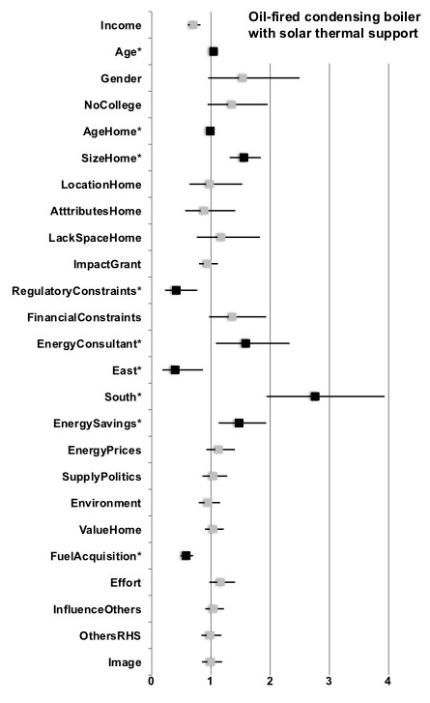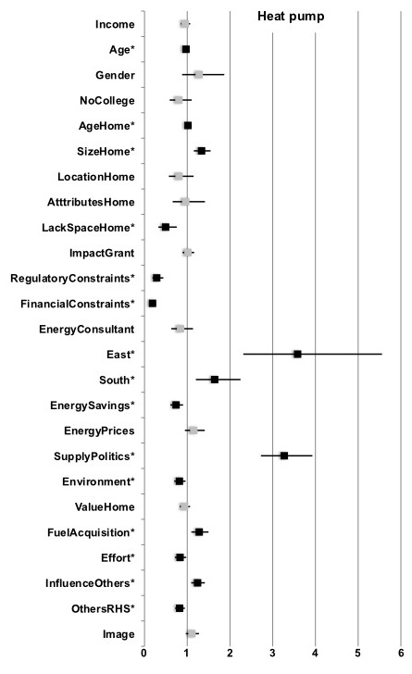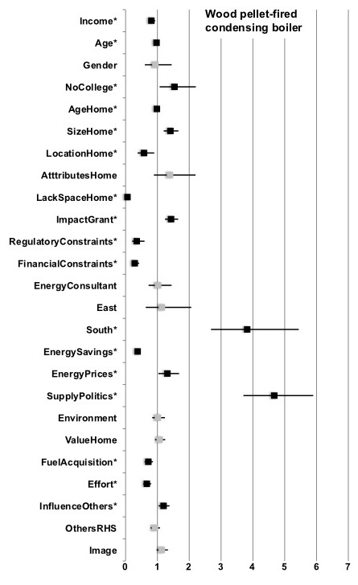
Fig 1: MNL regression results presented in odds ratios, with upper and lower limits for the RHS Oil-ST, HP and WP (reference group: Gas-ST; 5% level of significance marked with * and black ink; if > 1: higher probability to adopt alternative RHS instead of Gas-ST, if < 1: higher probability to adopt Gas-ST instead of alternative RHS)

Conclusions
Our research shows that there are different drivers behind the decision in favor of a certain RHS. Besides characteristics of the home and spatial characteristics, preferences regarding RHS-specific attributes are significant drivers behind the homeowners’ adoption decision. The importance of key drivers also differs across RHS and groups of homeowners, respectively. This implies that the decision in favor of a certain RHS is a rather complex process. Our findings have important implications for understanding the likely future diffusion of RHS, the design of policy measures for the residential building sector, and marketing strategies of companies.

References
Achtnicht, M. (2010), Do Environmental Benefits Matter? A Choice Experiment Among House Owners in Germany, FCN Working Paper No. 27/2010, Institute for Future Energy Consumer Needs and Behavior, RWTH Aachen University (also published as ZEW Discussion Paper 10-094).
Braun, F. (2010), Determinants of households’ space heating type: A discrete choice analysis for German households, Energy Policy, 38, 5493-5503.
Dubin, J., McFadden, D. (1984), An econometric analysis of residential electric appliance holdings and consumption, Econometrica, 52 (2), 345-362.
Liao, H.-C., Chang, T.-F. (2002), Space-heating and water-heating energy demands of the aged in the US, Energy Economics, 24 (3), 267-284.
Mansur, K., Mendelsohn, R., Morrison, W. (2008), Climate change adaptation: a study of fuel choice and consumption in the US energy sector, Journal of Environmental Economics and Management, 55 (2), 175-193.
Michelsen, C. and Madlener R. (2010), Integrated Theoretical Framework for a Homeowner's Decision in Favor of an Innovative Residential Heating System, FCN Working Paper No. 2/2010, Institute for Future Energy Consumer Needs and Behavior, RWTH Aachen University.
Vaage, K. (2000), Heating technology and energy use: a discrete continuous choice approach to Norwegian household energy demand, Energy Economics, 22 (6), 649-666.

