AN INPUT-OUTPUT ANALYSIS OF THE INDIRECT ENERGY DEMAND FOR AND THE VALUE OF GOODS AND SERVICES OF AUSTRIAN HOUSEHOLDS

Michael Hartner, Energy Economics Group, Vienna University of Technology ++43 1588101 370 379, hartner@eeg.tuwien.ac.at
Reinhard Haas, Energy Economics Group, Vienna University of Technology ++43 1588101 370 352, haas@eeg.tuwien.ac.at

Overview
The main driver for the production of goods and services (in fact for all economic activity) is the demand for goods and services of consumers. If there was no demand for a certain good or service it would not be produced in the long run. For the majority of production processes some kind of commercial energy input is needed. So we can conclude that consumption is also the main driver for energy needs.
In other words, by consuming goods and services one also consumes (embedded) energy. Theoretically the whole demand for energy can be traced back to the demand for goods and services. (see Haas et al. 2008)
However most statistics relate energy demand to different industry sectors or distinguish between industry, services, agriculture and households. Energy use from a private consumption perspective is only provided for direct energy services like electricity, heat or petrol. In this research we want to shed light on total energy use, which includes direct and embedded energy from a private consumption perspective. The embedded energy of products is derived from economic data linked with energy statistics using Input-Output analysis.
Data like that can provide consumers with information on their personal energy use to enable them to adopt their behaviour towards sustainability. Furthermore such a perspective allows to estimate price effects of energy carriers on final goods and services and may also help to establish environemtally orientated tax regimes.

Method
Equation (1) shows one way to describe embedded energy:
Total embedded energy of product x_{j} [J]
............ Energy intensity of sector producing product x_{i} [J/kg, J/m³, J/€….] (1)
Quantity of product x_{i} needed to produce product x_{j} [kg, m³, €….]
The fact that each product includes numerous intermate products and considering the great heterogenity of todays goods and services general statements are hard to derive. However the method of Input-Output analyses allows to assess embedded energy of aggregated groups of products.
Recently this method has been used to assess the carbon footprint of economies. (see Rueda-Cantuche(2011), Kratena(2010)). We use a two region approach (Austria and the rest of the world) as described in Kratena(2010 p.10f) to include the effects of imports. Instead of linking the technology matrices with CO₂ intensities we include energy data for different energy carriers. The input output table and energy data for the Austrian economy is provided by Statistic Austria and lists 57 sectors. For the estimation of the rest of the world (ROW) we will use a consolidated EU-27 table which is provided by Eurostat.

The basic formulation to calculate embedded energy for a two-region approach is the following:
(2)
E_{d} ,E_{f} ……vector of energy intensities of each sector of the domestic economy and ROW [J/€]
A_{d} , A_{f} …. input coefficient matrices of intermediate goods for domestic economy and ROW [-]
A_{m}…. input coefficient matrix of imported intermediate goods to the domestic economy [-]
I……. identity matrix [-]
Y_{d} …. demand vector of domestic economy for domestic goods[€]
Y_{m} …. demand vector of domestic economy for imported final goods[€]

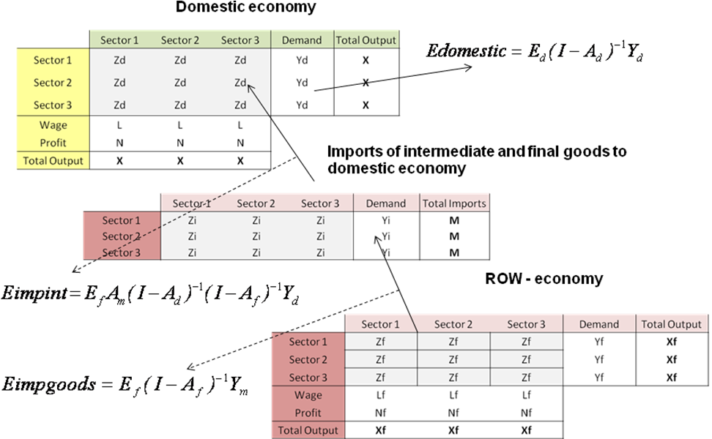
Fig. 1 illustrates the IO-model and identifies the composition of the embedded energy for goods and services of each sector. One part is domestic demand for domestic goods which involves two effects labelled as Edomestic and Eimpint. The first arises from production activities within the economy to satisfy demand for domestic goods while the latter calculates the effects of imported intermediate goods needed to produce domestic goods. Finally Eimpgoods specifies the embedded energy of imported final goods from ROW to the domestic country.

Results and conclusions
Here we will show some preliminary results only for domestic production and consumption as the energy data to implement ROW still has to be adopted for the model inputs. However we can see that the model allows to investigate the composition of embedded energy for the given aggregated product groups split up in various energy carriers. The following figures show the total amount of embedded electricity (Edomestic-fig. 2), the composition of embedded electricity of the Austrian hotel and restaurant service sector (fig. 3) both for private consumption in 2006. Fig. 4 illustrates the electricity intensity for the consumption of goods and services in kWh per 10€ consumption of each product group.
Fig.2: Embedded electricity of the consumption of products in 2006 | Fig.3: Composition of embedded electricity for the consumption of services from hotels and restaurants
Fig.4: Electricity intensity of domestically produced products 2006 (without imports of intermediate goods)

References
HAAS, R., NAKICENOVIC, N., AJANOVIC A., FABER T., KRANZL L., MUELLER A., RESCH G (2008).: “Towards sustainability of energy systems: a primer on how to promote the concept of energy services to identify necessary trends and policies”, Energy Policy, 36, 11/2008, 4012-4021
RUEDA-CANTUCHE, J. M. (2011) "Comparison of the European Carbon Footprint (2000-2006) from three different perspectives within a multi-regional framework: new empirical evidences" in V. Costantini, M. Mazzanti and A. Montini (eds), Hybrid Economic-Environmental Accounts, Routledge Studies in Ecological Economics, Oxford, UK.
KRATENA K., MEYER I. (2010) “CO2 Emissions Embodied in Austrian International Trade”, FIW Research Reports 2009/10 N°02

Here the effects of exports from the domestic economy on the rest of the world is ignored. This simplifies the involved calculations. Note that this can only be applied to small economies like Austria.

