The relationship between spot and contract gas prices
[Frank Asche, University of Stavanger, (47) 51 83 22 86, frank.asche@uis.no]
[Atle Oglend, University of Stavanger, (47) 51 83 22 47, atle.oglend@uis.no]
[Petter Osmundsen, University of Stavanger, (47) 51 83 15 86, Petter.Osmundsen@uis.no]

Overview
During the last decade, we have observed several important changes in the natural gas trade in Europe. Although long term contracts still dominate, in recent years several types of spot markets have developed. Financial derivatives trading have emerged in several gas markets in the UK as well as in continental Europe. This development commenced when the UK gas market was deregulated in the early 1990s, after British Gas was privatized in 1986, and has been followed up with a gradual opening of gas markets in some continental European countries.
After the deregulation, gas in the UK is primarily traded in the Over The Counter market. The National Balancing Point (NBP) gives the reference price for many forward transactions and for the International Petroleum Exchange futures contracts. The Interconnector - a pipeline connecting the UK market to Continental Europe - became operational in 1998, and brought to the UK the European price of gas which is closely linked to oil products. Spot and derivative trading has also increased in continental Europe. Zeebrugge (ZEE) in Belgium is the arrival point for the Interconnector, where a sport market developed after the opening of the Interconnector. Forward contracts with delivery in this market have been actively traded since 2003. The Title Transfer Facility (TTF) hub in the Netherlands is one of the most recently developed gas hubs in Europe. This hub, operational since 2003, is rapidly maturing into an important trading point for gas market participants in Northwest Europe. Due to such market developments, price relationships between energy products might have changed, giving rise to potential structural changes price determinations process. In particular, it is of interest to investigate whether there are independent price determination processes for gas in different markets.
The UK market is been investigated in several studies (Asche, Osmundsen and Sandsmark; Panagiotidis and Rutledge). These studies indicate that the UK energy market is highly integrated, as natural gas, oil and electricity has a common price determination process. This is true in the years 1995-1998 when the UK market was separate, as well as after the Interconnector became operational in 1998, and provided a physical link between the UK and the continental markets. Asche, Osmundsen and Sandsmark (2006) also indicate that the oil price is leading the other prices, providing another potential link to gas prices in continental Europe, as the oil price and the prices of several oil derivatives are the main elements in the pricing formulas in the contracts (Asche, Osmundsen and Tveteras). The fact that different European gas markets seems to be integrated (Asche, Osmundsen and Tveteras; Silverstofs et al,) lends credibility to such a hypothesis.
In this paper we will investigate several hypotheses with respect to the degree of integration of the European gas market. In particular, we are interested in the link between the gas price and the oil price. The price series are shown in Figure 1. It is evident that until 2005, the relationships between all the price series were very close. This support the earlier literature that indicates that natural gas markets in Europe are highly integrated, and that they are integrated with the oil market. During the winter and spring in 2005 there is one strong deviation by the NBP gas prices, as there is a clear indication of peak load pricing. However, by the summer, the old relationship seems to be re-established. At the end of 2006, the spot gas prices declines relatively to the oil price. From then on, gas prices still seem to follow the oil price up the peak at the end of 2008 and down again, although the relationship is not as close. When the volatility in the oil price increase early in 2006, it is also interesting to note how clearly the contract gas price is lagging. The lag is about three months, the most common delay in most of the gas contracts (Asche, Osmundsen and Tveteras).
This suggest the possibility that the relationship between the oil and gas price may be characherized by two different regimes. Moreover, as the conditions for the regime shifts can change between periods and years, for instance due to different temperature profiles, it is important that structural changes are endogenous. To test this hypothesis, we apply the regime shifting model of Hamilton (1989).

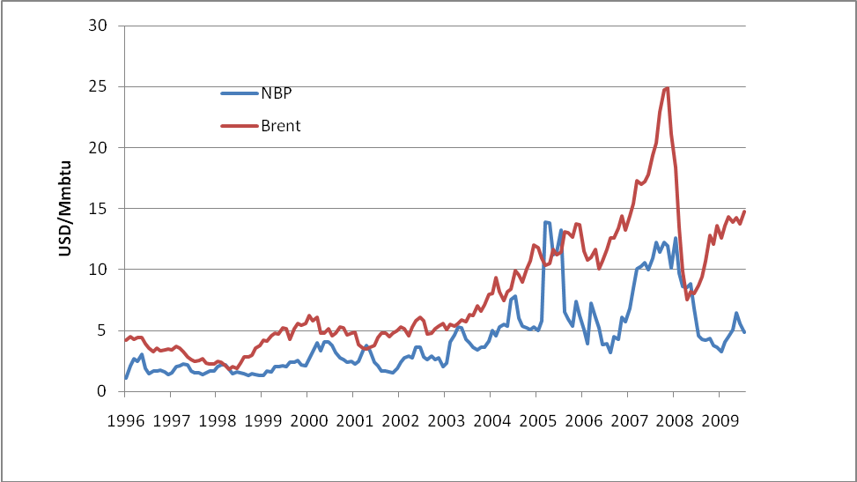
Figure 1. Oil and gas price

Hamilton’s (1989) specification is a two state regime shift model to relative prices in order to account for possible non-linearity and structural changes in the series. Accounting for regime shifts we find that the price of oil relative to gas has increased over the years. We identify two regimes: onemore persistent regime where NBP gas is relatively cheaper than Brent oil; and a significantly more volatile, less persistent regime where NBP gas is more expensive. We find that part of this last regime is related to the seasonal component in the price of NBP gas, with a higher probability of being in this regime in winter when gas is more expensive.

References
Asche, F., P. Osmundsen and M. Sandsmark. 2006. The UK Market for Natural Gas, Oil and Electricity. Are the
prices decoupled? The Energy Journal 27: 27-40.
Asche, F., P. Osmundsen and R. Tveterås. 2002. European Market Integration for Gas? Volume Flexibility and Political Risk. Energy Economics 24: 249-265.
Hamilton, J. D. 1989. A New Approach to the Economic Analysis of Nonstationary Time Series and the Business
Cycle. Econometrica 57(2):357-384.
Panagiotidis, T. and E. Rutledge. 2007. Oil and gas markets in the UK: Evidence from a cointegrating approach.
Energy Economics 29: 329-347.
Silverstov, B., G. L'Hegaret, A. Neumann and C. von Hirschhaussen. 2005. International Market Integration for Natural Gas? A Cointegration Analysis of Prices in Europe, North America and Japan. Energy Economics 27: 603-615.

