OPTIMAL GAS STORAGE INVESTMENTS IN THE EUROPEAN GAS MARKET – A STOCHASTIC MODELING APPROACH
Stefan Lochner
Institute of Energy Economics at the
University of Cologne (EWI)
Tel: +49-221-27729-303
Stefan.Lochner @uni-koeln.de

Overview
The European Union’s rising import dependency on natural gas requires additional investments in import infrastructure and natural gas storages. The efficient amount of investments is thereby a relevant question to (potential) investors and regulators. Recent large-scale studies by regulators [1] or transmission system operators [2] focused on investments in the natural monopoly of the gas network. Gas storage investments were at the focus of some albeit limited academic literature on the subject in the past, which usually derived a “demand” for gas storage by looking at estimated (potential) fluctuations in supply and demand and what amount of storage volume is required to match the two [3, 4]. However, when aiming to identify the optimal infrastructure set-up, further research is required to better capture the economics of storing gas in the context of its long-run costs relative to those of alternative options to balance supply and demand. From a theoretical perspective there is no demand for gas storage but a requirement of flexibility. And this may also be provided through demand side management or the flexibility of supply and transport infrastructures. Both may be difficult for a number of reasons, but strong seasonal variations in LNG imports in some European countries already demonstrate that seasonal production flexibility can also be imported. Hence, investment and operating costs of the various options, which may vary across Europe, need to be considered to determine the optimal level of storage investments.

Methods
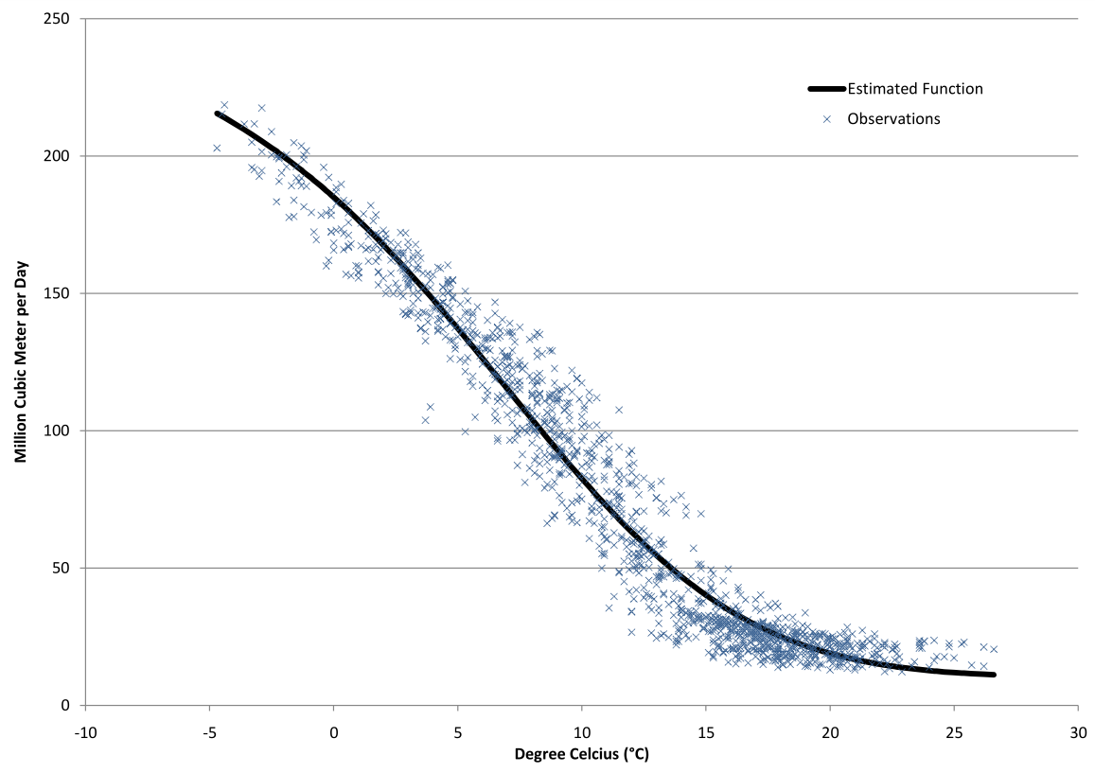
To do so and to capture the spatial characteristics of gas infrastructure and the stochastic elements of gas markets, we develop and apply a stochastic dispatch and investment model of the European gas market (which is an extension of an earlier dispatch model by Lochner [5]). As a stochastic linear program, the model minimizes the cost of gas supply in the European gas market taking border prices from outside the continent as given and optimizing dispatch of and infrastructure investments in LNG terminals, pipelines and storages within Europe. Thereby, the model takes all relevant options of providing flexibility into account and would only expand existing storage capacity (we start with the existing 2010 infrastructure) at each location if that is the cost optimal decision. With respect to spatial granularity, we model the European gas infrastructure in a high level of detail with the underlying model database containing more than 900 pipelines, all existing gas storages and LNG terminals, and potential investments sites (or expansions of existing locations) for storages (more than 100) and LNG terminals (25). Temporally, we model three representative days per months and stochastic scenario for 2015, 2020 and 2025. Demand stochasticity (gas demand by households is highly depend on temperatures) is captured by five demand scenarios which are included via a Bender’s decomposition algorithm (with the investments decisions as complicating variables). The scenarios are derived from modeling temperatures (as an AR process), estimating temperature-demand curves (from historic data, see figure above for GRTgaz market area in France as an example) and Monte-Carlo simulations to obtain demand distribution functions for individual countries. General supply and demand assumptions are based on IEA [6] and EC [7] projections.

Results
The results from the simulations yield an insight into the efficient storage investments in the European gas market under the given assumptions. Similar to other studies, we generally find that there is room for additional efficient storage investments in Europe. However, our results also show that the results differ significantly between regions and countries. This is also true for the trade-off between investments in the different flexibility provision options. While the declining European production does not allow for greatly substituting storages by expanding production capacities and pipelines, increasing physical market integration is found to be a cost efficient way to provide additional flexibility in some countries. This is due to the uneven distribution of storage working gas volumes (WGV) across Europe - e.g. Germany’s WGV equals 21 % of its demand, in Belgium this figure is only 3 %. Hence, investment in pipelines can actually allow ‘exporting’ flexibility from Germany to Belgium to some extent which decreases the need for investment in WGV in Belgium. With respect to LNG, the model endogenously expands some terminal locations significantly. While this is also happening to import increasing volumes of natural gas, LNG deliveries to the terminals show a structural pattern indicating their capability to provide flexibility. Especially in (unusually) cold winters, obtaining additional LNG – even at high LNG spot prices – is more cost-effective than precautionary storing plenty of gas for an unlikely worst case. Regarding the types of storages built, these are mainly smaller but more flexible salt caverns. The new investments are also largely in countries with low storage endowments as of 2010 and where the load-duration curve is rather steep.

Conclusions
The analysis is the first one to investigate efficient storage investments in the context of the existing infrastructure, interdependencies between storages and the pipeline grid, and with the explicit (model-endogenous) incorporation of the costs of storages relative to those of other flexibility options. Results show that investments in additional storage may be necessary. However, coordination with pipeline and LNG investments reduces such requirements and strengthens the case for coordinating infrastructure investments.

References
- EWI (2010). Model-based Analysis of Infrastructure Projects and Market Integration in Europe with Special Focus on Security of Supply Scenarios. Cologne, Germany. URL: http://www.ewi.uni-koeln.de/ERGEG-Study.303.0.html (11/03/2011).
- ENTSOG (2011). ENTSOG Ten-Year Network Development Plan 2011-2020, Brussels.
- De Joode, J. and Ö. Özdemir (2009). Developments on the northwest European market for seasonal gas storage – Historical analysis and future projection. ECN-E--09-065.
- Höffler, F. and M. Kübler (2007): Demand for storage of natural gas in northwest Europe: Trends 2005-2030. Energy Policy 35, pp. 5206-5219.
- Lochner, S. (2011): Identification of congestion and valuation of transport infrastructures in the European natural gas market. Energy 36, doi:10.1016/j.energy.2011.01.040
- IEA (2010). World Energy Outlook 2010. International Energy Agency, Paris.
- Capros, P., L. Mantzos, N. Tasios, A. DeVita and N. Kouvaritakis (2010). Energy Trends to 2030 — Update 2009. Institute of Communication and Computer Systems of the National Technical University of Athens. Publication of the European Commission DG ENER.

