[What drives states to support renewable energy?]
[Steffen Jenner, The University of Tuebingen, +49-7071-2972927, Steffen.Jenner@uni-tuebingen.de]
[Gabriel Chan, Harvard University]
[Rolf Frankenberger, The University of Tuebingen]
[Mathias Gabel, The University of Tuebingen]

Overview
Why do states support electricity generation from renewable energy sources (RES-E)? Lyon/ Yin (2010), Chandler (2009) and Alavalapati/ Huang (2007) have answered this question for the existence of renewable portfolio standards (RPS) in the U.S. states. This article supplements their work by testing the core hypotheses on the EU27 sample between 1990 and 2010. Furthermore, we ask why the majority of EU states relies on feed-in-tariffs (FIT). The study conducts logistic time series cross-section regression analyses that run on a hazard model.

Methods

The study applies a hazard model to the question why states support RES-E. Thus, we are working with a quantitative approach that is known from labor market studies and other research that bases on duration data.

On the base of the hazard model, different logistic regressions are run. Their dependent variable is a binary code distinguishing between regulation c(t) = 1 and non-regulation c(t) = 0 of a country c in the year t. The independent variables are metrics derived from other studies, such as Lyon/ Yin (2010), Chandler (2009) and Alavalapati/ Huang (2007).

Results

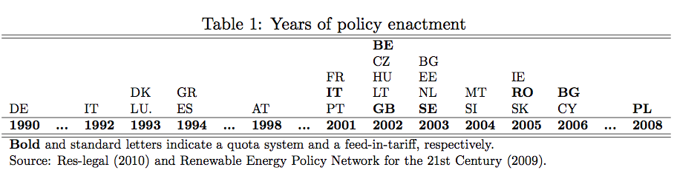

One of the full model runs:

Conclusions
Our EU27 study provides evidence in support of the U.S. studies mentioned above.

(a) The existence of a solar energy association increase the probability of a state to adopt regulation. (b) Solar radiation, (c) unemployment, and (d) proportional electoral systems also increase the probability. (e)

The existence of nuclear societies and (f) market concentration decrease the probability of transition.

Interestingly, the nuclear society indicator as well as the market concentration indicator turn positive if we exclude the FIT cases. We suggest that utilities favor quotas over FITs because the latter can challenge their grip on the production side.

Finally, (g) the EU impact that has been neglected by far too many studies dominated the analysis. This is good news for EU enthusiasts since binding agreements uphold their legal power obviously.

References

Alavalapati, J. R., Huang, M.-Y., Carter, D. R., Langholtz, M. H., 2007. Is the choice of renewable portfolio standards random? Energy Policy 35 (11), 5571 - 5575.

Chandler, J., 2009. Trendy solutions: Why do states adopt Sustainable Energy Portfolio Standards?” Energy Policy 37 (8), 3274 – 3281.

Lyon, T. P., Yin, H., 2010. Why do states adopt renewable portfolio standards? An empirical investigation. Energy Journal 31 (3), 133 - 157.

