Deconstructing the ‘Rosenfeld Curve’: Why is per capita
residential energy consumption in California so low?
[Anant Sudarshan, Stanford University, +16508044436, anants@stanford.edu]

Overview

Over the last three decades, California has implemented a variety of regulatory and legislative measures aimed at reducing the demand for energy, through encouraging more efﬁcient consumption.These programs have attracted widespread interest because state electricity consumption per capita has stayed relatively steady since 1970, in contrast to a national trend of steady growth. The difference between state and national electricity intensities has grown famous as the Rosenfeld Effect, with a graph of this comparison well known as the Rosenfeld Curve. The name comes from the head of California’s Energy Commission, Dr Art Rosenfeld, and is the nomenclature is testament to the close link often claimed between this observed outcome and the effectiveness of state energy efficiency policies.

In this paper I examine the determinants of residential energy consumption with a view to determining the fraction of the state-nation difference in electricity consumption intensity that might reasonably be attributed to policy. I present an econometric model of household demand for energy and estimate that policy and price effects can explain only about 20 percent of the state nation difference in consumption intensities. Additionally, the model suggests that split incentive considerations may have resulted in inefﬁciently high energy consumption in rented dwellings and that program interventions may have been particularly effective in reducing the energy needed for heating and cooling end uses.
Overall the paper sheds new light on the reasons why California has done so well on comparisons of energy intensity with other parts of the world, as well as highlight the role played by appliance distribution, prices, climate and demographics. This work contributes to a better understanding of the true potential for mitigation of energy demand growth via efficiency programs, including building and appliance standards.

Methods

The paper uses household level microdata on energy consumption and household characteristics from the Residential Energy Consumption Survey, a nationwide sample survey conducted by the Energy Information Administration. RECS data from 1993 through till 2005 is used to estimate a household energy demand model, simultaneously modelling the use of both electricity and heating fuels and accounting for observable and unobservable heterogeneity in demand. The demand system is estimated conditional on appliance ownership and households of different types in California are compared to their counterparts in the rest of the country.
Econometric estimation is carried out using a Markov Chain Monte Carlo sampler to evaluate the posterior distributions of a Bayesian linear hierarchical model.

Results

The key results are that over 80 percent of the difference between California and United States per capita residential electricity consumption can be explained without recourse to program interventions – in particular as a consequence of differences in climate, demographic differences, prices, appliance distributions, urbanization, fuel choices. About 17 percent of the gap may owe to state efficiency programs. The largest differences are found in houses with high electric heating and cooling loads, indicating that programs affecting HVAC demand such as building standards may have played a large role. I also find limited evidence suggesting that split incentive concerns may be present in the US market. Figure 1 summarizes my conclusions for electricity demand.

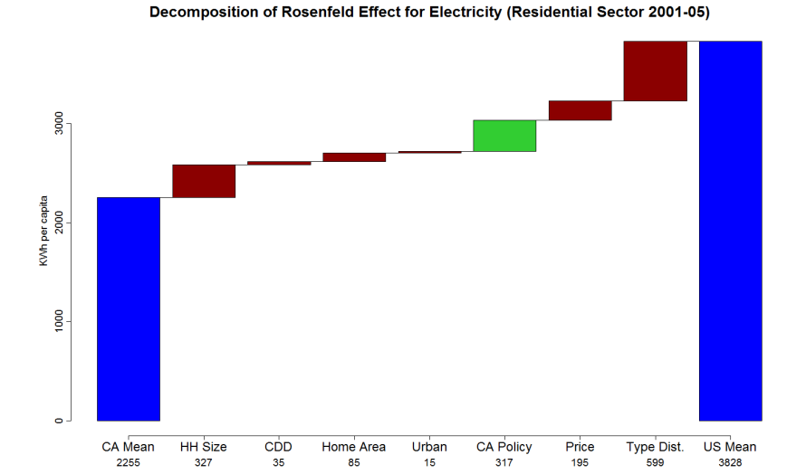

Conclusions

The average reductions in electricity consumption that we may attribute to non-price policy impact is very limited at about 317 KWh per capita annually or approximately 20 percent of the overall difference between the state and the rest of the nation. This is still a signiﬁcant reduction of course but it suggests a very different story than a comparison of electricity intensities by themselves. The potential impact of similar policies - such as strong building standards and incentives to improve air-conditioner efﬁciency - might be much greater in geographies that have more extreme climates. Part of the motivation for this analysis has been to make the point that while indices such as energy intensities (and more sophisticated versions derived from decomposition methods) can provide a great deal of insight, they also hide as much as they reveal. In particular, we need to be careful when we identify seemingly spectacular success stories screened on the basis of a single aggregate statistic.

References
[Format: single space, 10 point font Times New Roman]

