Performance assessment of air conditioning system assisted by photovoltaic cold thermal storage
Kashif Irshad, Interdisciplinary Research Centre in Renewable Energy and Power Systems, King Fahd University of Petroleum & Minerals, Dhahran (31261), Saudi Arabia
Researcher at K.A.CARE Energy Research & Innovation Centre at Dhahran, Saudi Arabia
+966138601184, kashif.irshad@kfupm.edu.sa
Firoz Khan, Interdisciplinary Research Centre in Renewable Energy and Power Systems, King Fahd University of Petroleum & Minerals, Dhahran (31261), Saudi Arabia, +966138607019 , firoz.khan@kfupm.edu.sa
Md. Hasan Zahir, Interdisciplinary Research Centre in Renewable Energy and Power Systems, King Fahd University of Petroleum & Minerals, Dhahran (31261), Saudi Arabia, +966542856377, hzahir@kfupm.edu.sa
Amjad Ali, Interdisciplinary Research Centre in Renewable Energy and Power Systems, King Fahd University of Petroleum & Minerals, Dhahran (31261), Saudi Arabia, +966531082131, amjad.ali@kfupm.edu.sa

Overview
In this paper, a concept for using solar-powered phase change material (PCM) cold thermal storage to boost the cooling performance of an air conditioner in Dhahran, Saudi Arabia, is given. The thermal performance of a novel porous Ca₂⁺⁻doped MgCO₃ matrix with PEG as the functional phase is evaluated by reducing the air temperature entering the evaporating coil. Instead of using the energy-intensive AC compressor, the system utilizes the cold PCM that was stored during off-peak hours. It reduces cooling expenses and carbon emissions by using just 5% of the power normally required. This system is totally powered by solar photovoltaics, which reduces energy consumption, carbon emissions, and operational expenses for customers.

Methods
The photovoltaic powered PCM thermal storage system coupled with the air conditioning system consists of a solar PV system, refrigeration system, PCM thermal storage system, and traditional air conditioning system. The working diagram of the system is shown in Figure 1. The system is directly coupled with the existing AC units. PV panels installed over the system, receive solar energy from the sun and convert it into direct current (DC), producing electrical energy during daytime. This DC can be converted into an alternating current (AC) by using an inverter or use directly to run the refrigerator system as shown in Figure 1.
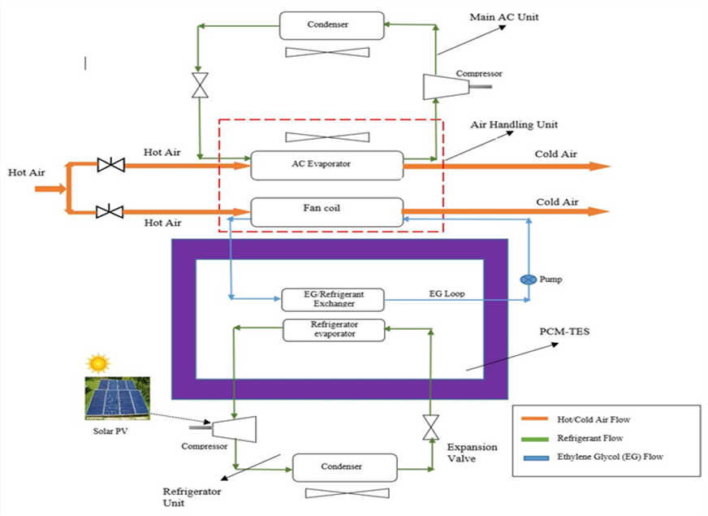
Figure 1: Working principle of photovoltaic powered PCM thermal storage system coupled with the air conditioning system
The battery bank will also be installed to maintain stability in energy supply during the operation. The refrigerator coil will be immersed in the PCM solution stored in the additional TES tank. The novel porous Ca²⁺⁻doped MgCO₃ matrix and PEG as the functional phase is used as a PCM. PEG/CaMgCO₃ composites PCM used in the system because of it high thermal enthalpies, stability and operational temperature range as compared to traditional shape stabilized PCMs. The secondary refrigerant from refrigerator circulates through the copper coils absorb heat from the PCM store in the insulated tank and solidifies it. This phase is known as the charging phase. When all the PCM unit becomes solidified, the condensing unit then switches off. The stored solidified PCM remaining in its position until cooling energy is needed. During daytime when the ambient temperature rises, the existing AC unit must do extra work to cool the buildings, and hence power consumption increases. During this time, the solidified PCM comes into play and rather than supplying cooling through the compressor of AC units, solidified PCM start melting to absorb the energy of hot refrigerant and supply cool refrigerant in the additional cooling coil. The coil and refrigeration system is designed for maximum exchange of energy at all sorts of ambient and indoor temperature. As the system is physically isolated from existing compressor units, its operation can be controlled independently.

Results
The performance of photovoltaic powered PCM thermal storage system coupled with the air conditioning system were carried under six different conditions as present in Figure 1. Type A to Type C conditions represent outlet air temperature under variable input air temperatures which were 33 °C, 34 °C and 35 °C. Type D to Type F conditions represent outlet air temperature under variable input air flow rate which were 900 CFM, 750 CFM and 500 CFM.

Figure 1. A: Variation of outlet air temperature under variable input air temperature condition; B: Variation of outlet air temperature under variable air flow rate conditions

The influence of air flow rate and entrance air temperature on exit air temperature over the course of a day was noted in Figures 1 A and B. A greater heat load is the result of an increase in input air temperature or air flow rate. The propagation of heat accelerates the melting of PCMs. Therefore, the rate of heat transfer will decrease. Consequently, the output air temperature increases as the input air temperature rises. In addition, the output air temperature curve in Figure 1 B rises as air velocity increases, resulting in a maximum increase in discharge air temperature. More results will be presented in full conference paper.

Conclusions
Using an experimental approach based on the effective heat capacity technique, the effectiveness of a photovoltaic-powered PCM thermal storage system paired with an air conditioning system is investigated. Calculations of the effects of the input air temperature and air flow rate on the system's performance are based on the system's melting period throughout the day. Higher intake air temperature and air flow rate raise the output air temperature and the amount of heat absorbed by the PCMs, respectively, while also accelerating the rate of heat transfer and decreasing charging time.

