Saudi Arabia Net-Zero emissions by 2060: Transformation of the electricity sector

Puneet Kamboj, King Abdullah Petroleum Studies and Research Center, +966112903168, puneet.kamboj@kapsarc.org
Mohamad Hejazi, King Abdullah Petroleum Studies and Research Center, mohamad.hejazi@kapsarc.org
Khalid Alhadhrami, King Abdullah Petroleum Studies and Research Center, khalid.hadharami@kapsarc.org
Gokul Iyer, Pacific Northwest National Laboratory, gokul.iyer@pnnl.gov
Page Kyle, Pacific Northwest National Laboratory, pkyle@pnnl.gov
Silvia Regina Santos Da Silva, Geoge Mason University, ssantosd@gmu.edu

Overview

In the lead of COP 26, Saudi Arabia announced achieving net-zero emissions by 2060 under the umbrella of the Saudi Green Initiative. To achieve this target, the share of electricity in the final energy mix of the Kingdom will have to increase irrespective of the pathway chosen. The fuel mix of Saudi Arabia’s electricity generation comprises conventional fuels (oil and natural gas) and a negligible share of renewable energy. Hence, decarbonizing the electricity generation mix of Saudi Arabia is of utmost importance and will require a complete transformation from the current fuel mix. This study explores various electricity generation technology options relevant to the Kingdom, including carbon capture for achieving net-zero emissions by 2060. We also look at the required investment for each technology option in the long term.

Methods

For this study, we use a modified version of the Global Change Analysis Model (GCAM v6.0), where we have separated the Kingdom of Saudi Arabia (KSA) as a separate energy-economy region, i.e., GCAM–KSA includes 33 energy-economy regions (32 original regions plus KSA). Our scenarios are built on the emission scenarios developed by Ou et al. (2021). More specifically, we focus on two emission scenarios that reflect alternative pathways of climate policy regimes and their associated global GHG emissions. The reference scenario (green line in Figure 1) reflects a no climate policies world (i.e., a counterfactual scenario). The NZE-2060 scenario (red line in Figure 1) assumes that KSA will achieve carbon neutrality in 2060. For the rest of the world, we assume that the remaining 32 regions will achieve their updated NDCs by 2030, their NZE pledges if announced by their target year. For regions without NZE pledges, an annual rate of improvement in CO2 emissions per unit of GDP is assumed to be in line with a 2 °C world. In the case of the Kingdom, we show that an NZE-2060 scenario requires deploying various technology options for the power sector, such as solar, wind, geothermal, nuclear, and gas, with carbon capture.

Results

Our initial results show that by 2060 more electricity generation will be required in the net-zero scenario compared to the reference. Saudi Arabia’s power sector will completely transform with a diversified fuel mix to reach net-zero emissions by 2060. Along with a significant share of renewable energy sources, electricity generation by natural gas with carbon capture will be the most critical technology. Nuclear electricity generation will also find its way into the fuel mix and play a vital role in the Kingdom's decarbonization of the power sector.

Figure 1 (LHS) Electricity generation in the Kingdom of Saudi Arabia for a reference and a net-zero scenario; (RHS) the absolute fuel-wise generation difference in the net-zero scenario w.r.t. the reference scenario

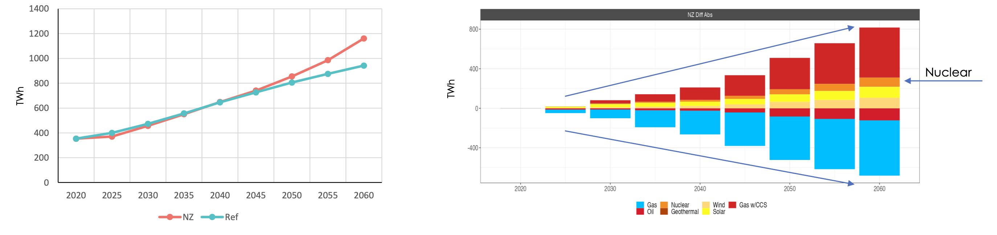

Conclusions
Our initial key takeaway is that in addition to electricity generation through solar and wind, gas generation with carbon capture will be the critical technology for Saudi Arabia to reach net-zero emissions from the power sector. Also, nuclear generation will find its way into the fuel mix for electricity generation.

References
Ou et al., 2021. Can updated climate pledges limit warming well below 2°C? SCIENCE, 374, 6568, 693-695, DOI: 10.1126/science.abl8976.

