Regulations and Contract Design in Multi-Agent District Heating and Cooling SystemS
Maximilian Hoffmann, RWTH Aachen University, +49 176 52867077, maximilian.hoffmann@rwth-aachen.de
Frieder Borggrefe, Chair for Energy System Economics, RWTH Aachen University, frieder.borggrefe@eonerc.rwth-aachen.de
Aaron Praktiknjo, Chair for Energy System Economics, RWTH Aachen University, apraktiknjo@eonerc.rwth-aachen.de

Overview
Bidirectional low-temperature district heating and cooling of the 5th generation (5GDHC) belongs to the latest trends within the heat transition. In these networks, distributed heat pumps and compression chillers are used to obtain the demanded temperature levels locally, whereas the network’s temperature remains at a level of 5-40°C [Wirtz et al. (2020)]. Therefore, 5GDHC net-works are characterized by a high efficiency and low heat losses as well as by high shares of renewable energy sources [Wirtz et al. (2019)].
This work focuses on the assessment of business models from both a provider and consumer perspective using the currently planned residential district of Hassel, Germany, as a case study.

Methods
This work extents classical optimization-based energy system models to account for individual consumer behavior and the contractually governed interaction between consumers and energy providers. Different contract structures with respect to costs and profits of consumers and energy providers, as well as their deviation from an overall social welfare optimum, are investigated. Furthermore, this work also considers legal regulations and federal funding options such as price ceiling, CO2 taxation and subsidization of investments into climate-friendly technologies, which are frequently analysed in the literature [Schütz et al. (2017), Pinto et al. (2020), Pina et al. (2021)]. In contrast to the sate-of-the-art approaches, however, this work analyzes their impact on individual decision-making, total system costs and resulting CO2 emissions for both, central-planner and multi-agent optimization models.
In particular, an energy system optimization model for the whole district is formulated and subsequently split into several consumer and a provider model in order to circumvent the solving of a computationally intractable bilevel model [Dempe et al. (2015)]. At the interface, an energy contract, i.e. concise energy prices are assumed. For these predefined energy prices, the consumer models are run yielding their energy demands depending on the assumed price constellation. Then both, the prices and the demands are fed into the energy provider model. This analysis is preformed for 1681 different price constellations applied to 51 different consumers and one provider. Afterwards, the results of the respective contracting model are benchmarked against the central planner model of the whole district which defines the social-welfare optimum and is solved using cutting-edge time series aggregation techniques for maintaining computational feasibility [Hoffmann et al. (2022)].
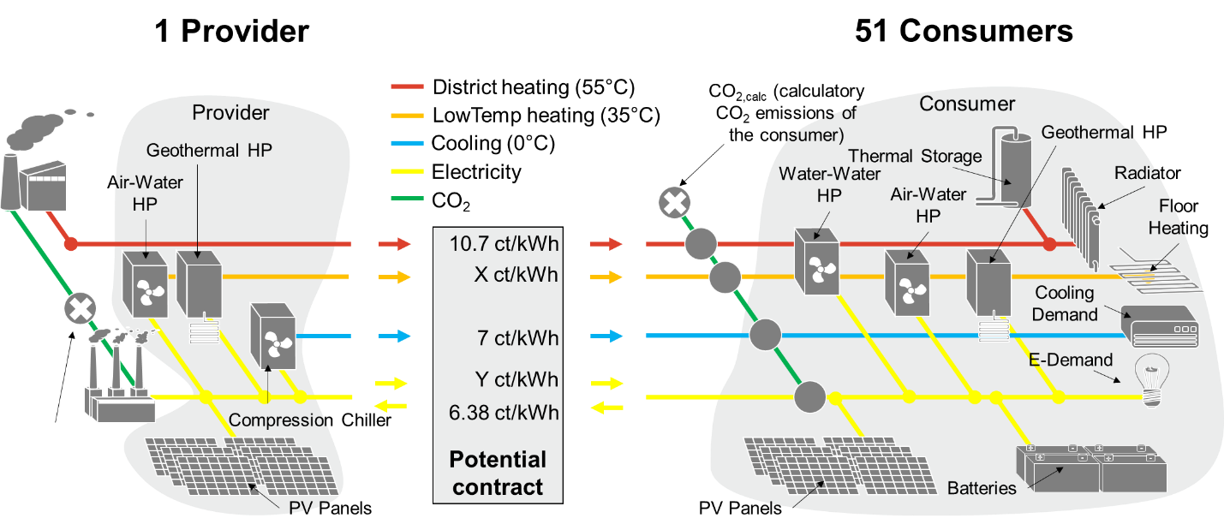
Figure 1: Decomposition of the Optimization Model into a Provider and 51 Consumer Models Interacting by a Fixed Contract
In a second step, different regulation schemes are imposed on the consumers and the district system operator. These regulations comprise subsidies for energy efficient technologies such as heat pumps on the one hand and carbon taxes on the other hand, that a imposed on either the consumers, the energy provider or both of them. Then, the sensitivities for different price constellations between energy consumers and the energy provider are re-run and the impact of the regulations on the individual behaviour of the market participants as well as on the central-planner model are investigated.

Results
The results comprise approximately 400.000 single (sub-)system optimizations and show a distinctly sensitive reaction of consumers on changing prices or regulation schemes if they have a large number of system options such as installing photovoltaic panels on their own. Interestingly, the demand for different energy sources such as low-temperature heat and electricity my suddenly change for slight price changes as the consumers may be incentivized to move to an economically more convenient alternative. This, in turn, leads to sudden tipping points in energy demands which, in turn, may lead to strong deviations from a social-welfare optimum of up to 18% of total annualized costs, i.e. non-aligned incentives may result in a system layout and energy consumption behvaior that is 18% more expensive than predicted by a central-planner model.
For the regulations, a similar impact can be observed. Here, poorly defined regulations may have little impact on the overall behaviour. Especially CO₂ taxation alone prove to be not very effective and drove costs without setting the incentives to invest into carbon neutral technologies. In contrast to that, carrot-and-stick combinations of subsidies for carbon neutral technologies and CO₂ taxes on the other hand prove to be very effective with respect to multiple criteria, among which are CO₂ reduction, little impact onto the overall social welfare and system costs and the individual costs of the system stakeholders.

Conclusions
The results imply, that in district systems, contractually governed constant energy prices may set wrong incentives for energy consumers and providers. Furthermore, these contracts always lead to more or less suboptimal deviations from the macro-economic optimum and similar phenomena can be observed for additional regulations.
In this context, CO2 taxes for the energy consumers and subsidies for climate-friendly technologies have been proven to be a preferable regulation scheme, whereby, however, a price ceiling for the provider’s energy prices should be introduced in order to avoid a shift of the energy consumers towards less climate-friendly supply options. This implies that well-designed and financially balanced regulation schemes should include subsidization on the one, but taxation of deviating behavior or price ceiling on the other hand. Lastly, this work illustrates that, at times of rising energy prices, more efficient, but slightly more expensive technologies should be favored in the medium term.

References
1. Dempe, S., V. Kalashnikov, G. A. Pérez-Valdés and N. Kalashnykova (2015). Bilevel Programming Problems: Theory, Algorithms and Applications to Energy Networks. Heidelberg, Springer Berlin, DOI: https://doi.org/10.1007/978-3-662-45827-3.
2. Hoffmann, M., L. Kotzur and D. Stolten (2022). "The Pareto-optimal temporal aggregation of energy system models." Applied Energy 315: 119029, DOI: https://doi.org/10.1016/j.apenergy.2022.119029.
3. Pina, E. A., M. A. Lozano and L. M. Serra (2021). "Assessing the influence of legal constraints on the integration of renewable energy technologies in polygeneration systems for buildings." Renewable and Sustainable Energy Reviews 149: 111382, DOI: https://doi.org/10.1016/j.rser.2021.111382.
4. Pinto, E. S., L. M. Serra and A. Lázaro (2020). "Optimization of the design of polygeneration systems for the residential sector under different self-consumption regulations." International Journal of Energy Research 44(14): 11248-11273, DOI: https://doi.org/10.1002/er.5738.
5. Schütz, T., M. H. Schraven, S. Remy, J. Granacher, D. Kemetmüller, M. Fuchs and D. Müller (2017). "Optimal design of energy conversion units for residential buildings considering German market conditions." Energy 139: 895-915, DOI: https://doi.org/10.1016/j.energy.2017.08.024.
6. Wirtz, M., L. Kivilip, P. Remmen and D. Müller (2019). "Bidirectional low temperature networks in urban districts: A novel design methodology based on mathematical optimization." Journal of Physics: Conference Series 1343(1): 012111, DOI: 10.1088/1742-6596/1343/1/012111.
7. Wirtz, M., L. Kivilip, P. Remmen and D. Müller (2020). "5th Generation District Heating: A novel design approach based on mathematical optimization." Applied Energy 260: 114158, DOI: https://doi.org/10.1016/j.apenergy.2019.114158.

