Geospatial agent-based modelling of household long-term energy transition in the MEA region using high-resolution gridded data and the MUSE-RASA model
[Diego Moya, Imperial College London and Technical University of Ambato, 593 032 8849687, da.moyua@uta.edu.ed]
[Sara Giarola, Imperial College London and Polytechnic University of Milan, +44 7721 490582, s.giarola10@imperial.ac.uk]
[Adam Hawkes, Imperial College London, +44 (0)20 7594 9300, a.hawkes@imperial.ac.uk]

Overview
The Residential Sector (RS) is a sector where most of the Neoclassical Economic Theory principles about the human dimension representation may fail. The RS is responsible for consumption and management of energy in residential buildings [1] and contain electricity, heat and cold suppliers [2]. The RS might account for 25% and up to 40% of the total energy consumption of a nation. This share depends on a range of heterogeneous and diversity factors such as the socioeconomic dimension of consumers, wheather conditions and cultural characteristics that evolve in space and time [3]. Most importantly, heating (space heating and water heating) and cooling (space cooling) can consume up to 80% of all the residential energy and depends on human behavious, social structures and income levels [4]. And related global greenhouse gas emissions represent 17% of global emissions [5]. Thus, the assessment of the the human dimension, consideting other theory fundamentals for the sustainable transition of this sector is key to meet mid-century net-zero emission targets.

Methods
To overcome the limitations of the representative homogenous hyper-rational agent in traditional models based on Neoclasical economics, the representation of the human dimension in climate-energy-economy models requires the use of empirical, historical, and analytical data from other schools of economic thought. The framework presented here is based on assumptions from Anwar Shaikh’s Theory of Real Competition. Geospatial big data analytics (combination of Geographical Information Systems, GIS, and Big Data Analytics) and agent-based modelling (ABM) tools present a potential opportunity to introduce realism, as Shaikh states, in the analysis by representing the complexities of agent’s heterogeneous shaping structures and diverse shaping attributes.

This article presents the framework of the novel MUSE (ModUlar energy system Simulation Environment), ResidentiAl Spatially-resolved and temporal-explicit Agents (RASA): MUSE-RASA model, a Geospatial Agent-Based Modelling Framework based on Shaikh’s Theory of Real Competition. This enhanced model has been applied to assess the long-term transition of the Climate-energy-economy system with a focus on the residential sector globally with a particular focus on the MEA region (Kuwait, Lebanon, Oman, Qatar, Saudi Arabia, Syria, United Arab Emirates, Yemen, Bahrain, Islamic Republic of Iran, Iraq, Jordan) and its impact on reaching the mid-century NZE target.

The MUSE-RASA framework uses geospatial big data analytics to capture realism into the modelling approach. To do this, spatial agents have been defined by the characterisation and parametrisation of five components. These agent components are heterogeneity, diversity, evolution, decision-making and exogenous constraints. These components capture the human dimension in models to overcome one of the limitations in the assessment of long-term transitions. Traditional models have limited their consideration of the human dimension to the perfectionist theoretical notion of a representative homogenous agent with infinite perfect foresight and hyper-rational expectations.

Figure 1 illustrates the interactions of the five components of the MUSE-RASA model to abstract the real world into a micro-environment and a macro-environment of the simulation process. This simulation produces global metrics that serve to analyse the transition and to design policy recommendations. The MUSE-RASA modelling approach improves on traditional models by representing the complexities of agent’s heterogeneous structures, diversity and evolving attributes to introduce more realism into the analysis when considering empirical, historical, and analytical evidence, which is in line with post-Keynesian and Marxist economic theory foundations (Heterodox schools of economic thought). The MUSE-RASA model is therefore a more realistic IAM that integrates GIS-based and ABM approaches for the global assessment of the residential sector transition, considering heterogeneous and diverse agents that evolve in space and time under a range of endogenous and exogenous constraints.

Results
Results are presented for a single representative hyper rational agent in Figure 2 and for eleven socioeconomic agents in Figure 3. These results illustrate the difference between considering hyper rational representative agents and when considering the actual characteristics of consumers towards the net zero emission target in the region under study.

Conclusions
Results show the relevance of representing agent disaggregation capturing a range of attributes when assessing the long-term sustainable transition of the residential sector in the MEA region. The agent heterogeneity, diversity, evolution, decision-making process, and exogenous constraints have been captured to define eleven agents. For each agent in the region, five outputs of the MUSE-RASA model have been produced: service demand with a focus on space heating, heating supply by technologies, fuel and electricity consumption, emissions, and transition costs. Recommendations for energy policy design can be described with reference to four aspects: household budget limitations, quantification of the total demand, carbon tax schemes and heat density restriction. Considering these aspects in policy design will introduce realism in the evidence base, thus supporting most robust policy design and suprasing neoclassical-based model assumptions.

Figures:
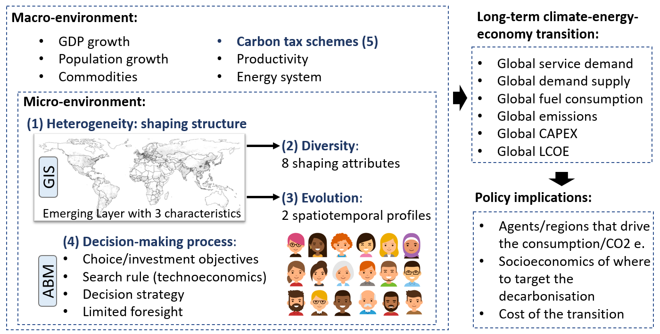
Figure 1: Abstracting from the real world to the MUSE-RASA model, outcomes, and implications. The five components of the geospatial Agent-Based Modelling Framework are identified in the micro- and macro-environment of the MUSE-RASA model. The model outcomes and policy implications are also illustrated in the MUSE-RASA environment.

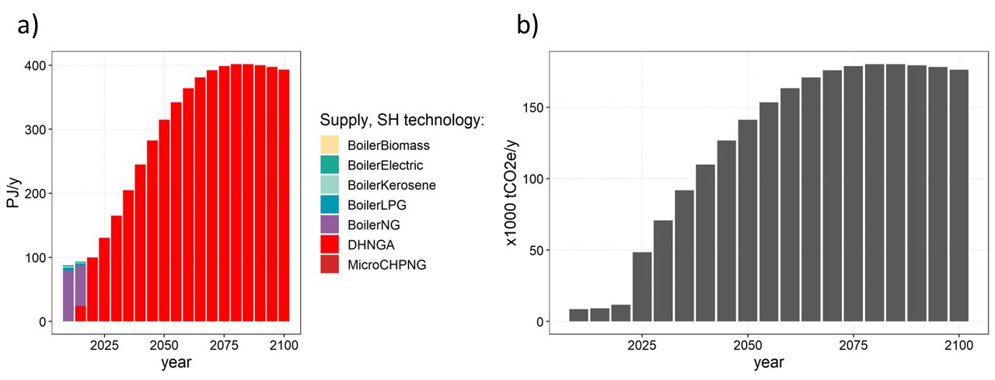
Figure 2: Modelling of the supply of space heating services in the MEA region during winter and cooler periods. These results are based on the hyper rational assumption of a representative agent for the whole region. a) Region-wide supply in the long-term; b) Region-wide of emissions in the long-term until the end of the century.

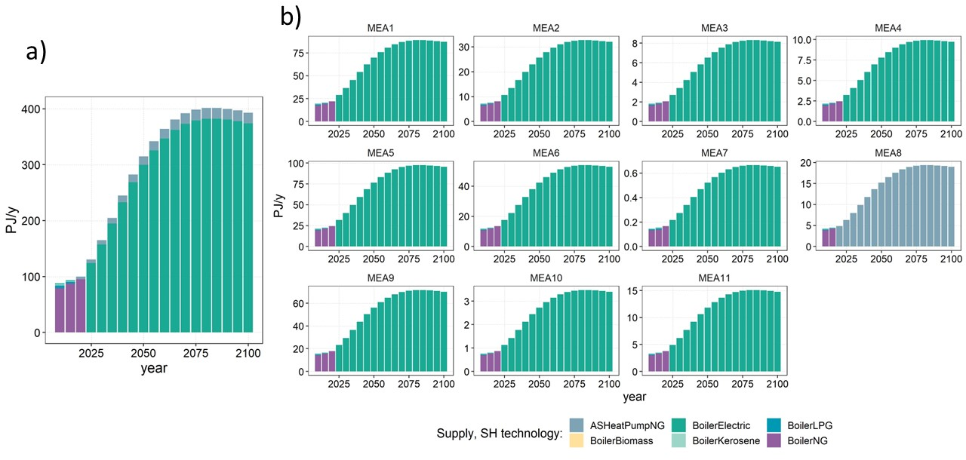
Figure 3: Modelling of the supply of space heating services in the MEA region during winter and cooler periods under a GIS-ABM approach. These results are based on eleven socioeconomic agents for the whole region.

References
[1] V. S. K. V. Harish and A. Kumar, "A review on modeling and simulation of building energy systems," Renewable and Sustainable Energy Reviews, vol. 56, no. Supplement C, pp. 1272-1292, 2016/04/01/ 2016, doi: https://doi.org/10.1016/j.rser.2015.12.040.
[2] F. Bünning, R. Sangi, and D. Müller, "A Modelica library for the agent-based control of building energy systems," Applied Energy, vol. 193, no. Supplement C, pp. 52-59, 2017/05/01/ 2017, doi: https://doi.org/10.1016/j.apenergy.2017.01.053.
[3] J. Ma and J. C. P. Cheng, "Estimation of the building energy use intensity in the urban scale by integrating GIS and big data technology," Applied Energy, vol. 183, no. Supplement C, pp. 182-192, 2016/12/01/ 2016, doi: https://doi.org/10.1016/j.apenergy.2016.08.079.
[4] P.-H. Li, I. Keppo, and N. Strachan, "Incorporating homeowners' preferences of heating technologies in the UK TIMES model," Energy, vol. 148, pp. 716-727, 2018/04/01/ 2018, doi: https://doi.org/10.1016/j.energy.2018.01.150.
[5] IEA. "Greenhouse Gas Emissions from Energy: Overview " https://www.iea.org/reports/greenhouse-gas-emissions-from-energy-overview (accessed 25 Dec, 2021).

