Paper Abstract
for IAEE Meeting, February 2022
In Kingdom of Saudi Arabia

Why Invest in Hydrogen?
A Sustainable Path Forward

With appendix and selected exhibits

John Ballantine, PhD, Senior Lecturer
Brandeis University

Mohammed AlMehdar, PhD Candidate
Brandeis University

September 9, 2022

Most energy scenarios paint a significant yet declining role for fossil fuel producers as we transition to a greener and possibly 1.5 - 2-degree COP 26 world (Paltsev, Ansari & Holtz, table 1). Of course, getting there by 2050 requires a huge – many trillions of dollars – investment in our energy infrastructure, particularly following the Ukraine war with the dramatic shift in Europe / Germany from Russian gas to LNG and sustainable sources. (Rystad, IEA). Global energy producers are fully aware of the uncertainties and climate pressures surrounding investment in our energy transitions. The question is how fast, how much investment, and how to finance?

Needless to say, meeting our disparate energy needs as we transition towards a net zero world while making reasonable returns is particularly challenging for oil & gas producers, utilities, and burgeoning energy ventures. One bullish set of transition outlined by IEA, Rystad, the Hydrogen Council (table 2) describes an increasing role of green and blue hydrogen / ammonia (with carbon capture) in our industrial economies.

Table 2: Possible Hydrogen Supply: Demand Mix
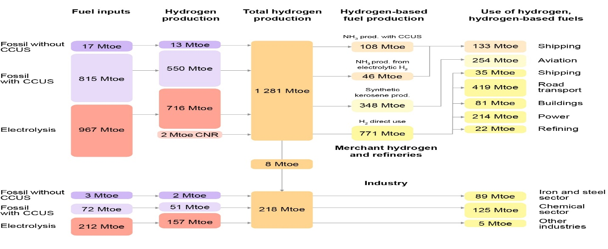
Figure 2 IEA Future of Hydrogen from 3

How Will Energy Suppliers Invest: Today’s fossil fuel world which provides over 80% of energy supply is roughly divided into three stylized sets of producers with vastly different operating objectives, costs, resources (reserves), and management goals – Independent producers (IOCs), OPEC and National Producers (NOCs) + 1 (Russia), and shale producers.

Each of these disparate group of producers, or agents, invests and produces with very different patterns that result in boom-bust investment cycles and varying degrees of production / supply flexibility. Given the shifts in our energy markets oil prices have been extremely volatile and hard to predict over the past fifty years (IEA, scenarios; VAR, Killian, Hamilton, et. al). Consequently, making long-term thirty-year investments where there is a tremendous commitment of capital, people, and uncertain returns is extremely challenging. The war in Ukraine, climate crisis, shale revolution, demand shift to Asia, and political upheavals are part our complex energy history (IEA, Yergin, The Prize, The Quest)

Is Hydrogen a Sustainable Opportunity? One of the critical questions is how will energy agents, with tremendous capital, engineering and technical expertise invest over the coming decades? What role will they play in our transition to a cleaner and more sustainable world economy.? And how might the dynamics of energy markets change? Are we stuck with boom-bust cycles, price volatility, and uncertain returns.

Today it appears that OPEC (Saudi Arabia) and some NOCs like Statoil are making significant investments in hydrogen / ammonia in their efforts to transform / anticipate our industrial economies. Middle Eastern (and North Sea) producers have access to abundance of low-cost gas, strong cash flows, carbon capture research / technology, and longer-term survival strategies. (figures 2 &3) Of course, the NOCs do not reveal the size, scale, economics, or technical details of their blue energy investments. However, we do know from various surveys (IEA, Hydrogen Council, Rystad, Royal Society) that we are talking about huge in investments in supply and infrastructure to move our economies to a more sustainable Hydrogen world

For example, steel and cement making need to be reconfigured away from coke and high energy / heat fossil fuels to hydrogen / ammonia, which also means that you must have a pipeline, shipping, and port infrastructure to handle such transitions. This requires a coordinated industrial policy involving producers, shipping / pipeline / transport players, ports / distribution centers, and manufacturing companies across different markets. Not an easy engineering or political task involving a myriad of parties.

Germany and Japan, making energy transition
The EU / Germany is reeling from the Ukraine war as everyone scrambles to replace Russian gas. The immediate push this winter is to LNG and gas from the Middle East suppliers and US, however Germany (Rotterdam) does not have the terminals to receive, convert, and distribute gas to the industrial sectors or its consumer. Building short term LNG terminals, also postpones investments by various players in the supply chain to cleaner, yet more expensive blue hydrogen. How to coordinate, build and finance Germany’s transition from gas to hydrogen in light of Russian threats, and huge investments is daunting.

Japan’s transition is no less urgent, however MITI and the government / private players have developed a long-term plan to move from nuclear following Fukushima to a gas and hydrogen economy. It has partnered with Aramco is using Ammonia ships to bring hydrogen to an energy isolate island economy. Japan’s vitality also depends on its long-term energy sufficiency.

Each of these country case studies, shows the complicated non-linear adjustments to our shifting energy mix where suppliers have not fully developed the technologies, nor know the costs of supplying hydrogen. And the consumers / industries do not know the price, or the amount of investment required to build a more sustainable, secure, greener economy. With limited data we demonstrate how NOCs / OPEC may succeed – and make money -- in our decarbonized economies as we all navigate our volatile, messy worlds.

Selected References

- Ammonia: zero-carbon fertilizer, fuel and energy store POLICY BRIEFING, The Royal Society, February 2020
- Projecting Energy and Climate for the 21st Century, SERGEY PALTSEV, Economics Energy & Environment Policy, Vol 9, No.1
- International Energy Agency (IEA), Future of Hydrogen 2019 and other reports
- AlMehdar, Mohammed. “Imperfect OPEC: an Oil Market Model”
- Ansari, D., F. Holz, and H. al-Kuhlani. 2020. “Energy Outlooks Compared: Different Methods, Different Futures.” Economics of Energy & Environmental Policy, 9 (1)
- Baumeister, Christiane, and Lutz Kilian. “Forty Years of Oil Price Fluctuations: Why the price of oil may still surprise us” Journal of Economic Perspectives, Winter, 2016
- Hamilton, J.D. “Causes and Consequences of the Oil Shock of 2007-08,” Brookings Papers on Economic Activity, 1, Spring 2009,
- Pierru, Axel, James L. Smith, and Hossa Almutairi. 2020. “OPEC’s Pursuit of Market Stability”. Economics of Energy & Environmental Policy 9, 2020
- Smith, James, L. Inscrutable OPEC? Behavioral tests of the cartel hypothesis. Energy Journal
- Fattouh, B. (2006). “Spare Capacity and Oil Price Dynamics.” Middle East Economic Survey 49
- The Hydrogen Futures Simulation Model: Projecting Carbon Sequestration Costs SAND2004-4937(R), Thomas E. Drennen, William J. Kamery, and Peter H. Kobos
- ENERGY SOCIETIES in 2050, Upstream report, RYSTAD ENERGY TRANSITION TRENDS, 2022

APPENDIX with possible exhibits

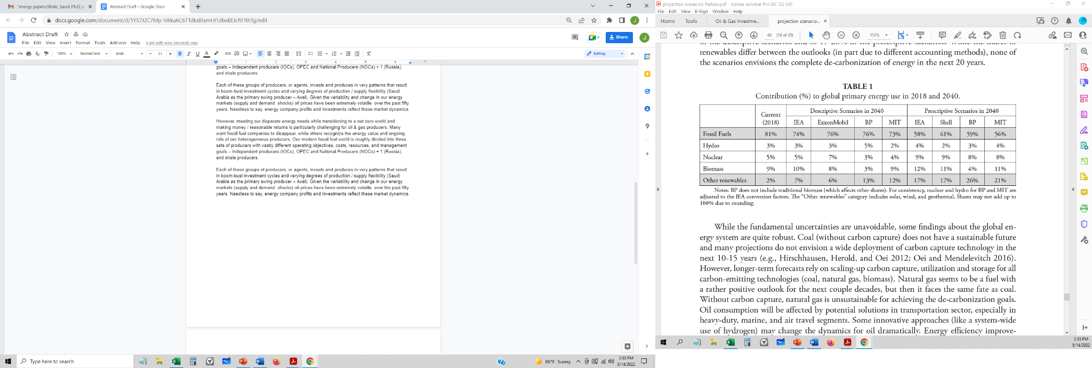 Figure 1: Scenario Comparisons from [2].
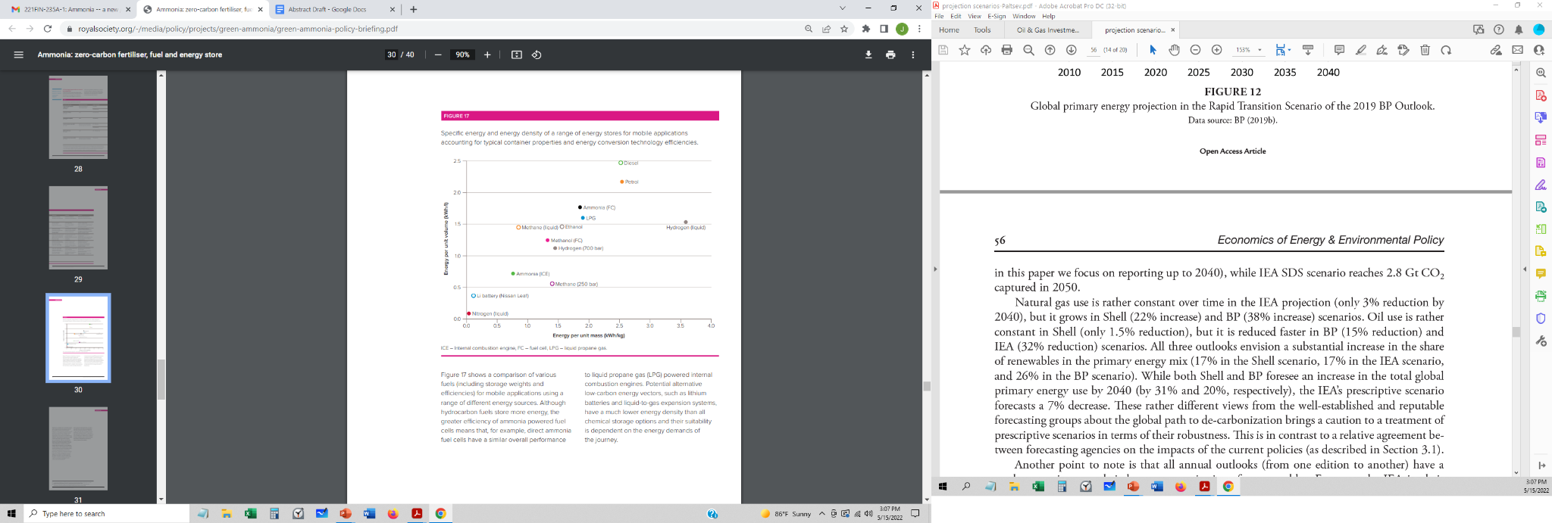 Figure 2 IF necessary, From [1]

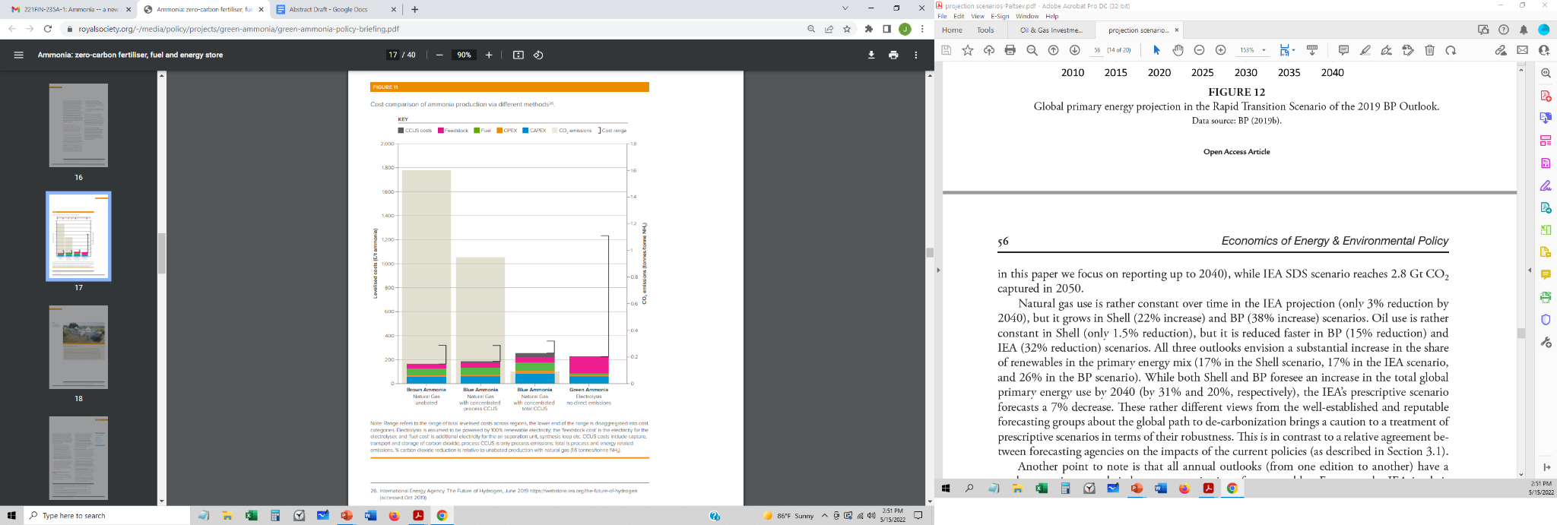 Figure 3: From [1].

