[The cost-effectiveness of physical versus financial risk mitigation for hydropower suppliers]
[Rui Shan, University of North Carolina at Chapel Hill, 9193084035, rui.shan@unc.edu]
[Rosa I. Cuppari, University of North Carolina at Chapel Hill]

Overview
Climate change imposes considerable risks in the electricity sector(Yalew et al., 2020). Higher temperature reduce the efficiency of thermal power plants and batteries(Jaguemont et al., 2014), and in many cases simultaneously increases electricity demand(Apadula et al., 2012). Both extremely high and low precipitation limit the power generation of hydropower plants(van Vliet et al., 2016). Other renewable energy sources, like solar and wind, are also affected by extreme weather events and climate change (Kozarcanin et al., 2019). Plants operators have adopted various financial instruments to hedge these risks, including temperature based derivative contracts. Previous analyses further show that insurance linked to weather-based index can indeed mitigate the risk of negative net revenues, and in particular extreme losses, for hydropower producers (Hamilton et al., 2020; Meyer et al., 2017). Such index-based financial instruments offset lost revenues from decreased electricity generation and increased costs as generators purchase electricity on the wholesale market to meet their fixed power contracts. The same functions might also be achieved with a large energy storage system that can offset lost generation with stored electricity. A key factor in considering which strategy to pursue is thus the cost of each tool. In this study, we will compare the performance of an energy storage system to that of an index-based financial instrument in terms of financial risk management. We establish a benchmark financial instrument which can successfully reduce a hydropower supplier’s financial risk and then design an energy storage system that share similar cost. We then compare the performance of both options and discuss the implications of changing technology and costs thereof. Results can inform utilities’ hedging strategies for hydrometereological risk under an uncertain climate and increasingly volatile weather conditions.

Methods

We choose the Bonneville Power Administration (BPA), the federal entity which manages the 31 federal dams in the US Pacific Northwest (PNW) as our case study. The BPA largely provides electricity to regional customers, which have long-term, fixed price contracts, but will sell surplus electricity into either the Mid-Columbia market, which spans the PNW, or the California Independent System Operator (CAISO), which serves California. In cases when there is a shortfall of hydropower, BPA purchases compensatory electricity from these markets. The Administration’s vulnerability and exposure to hydrometereological risk have made it the subject of scrutiny by credit ratings’ agencies (e.g., Moody’s, S&P, Fitch). A failure to manage its financial risk can lead to a credit downgrade, which can increase BPA’s cost of borrowing. Research suggests that BPA’s existing financial instruments leave it exposed to substantial uncovered losses(Denaro et al., 2022). That said, financial instruments have been proposed as a means to mitigate BPA’s financial risk beyond its current capacity (Cuppari et al., 2021; Hamilton et al., 2020).
To compare the cost-effectiveness of an energy storage system versus a financial instrument, we must first establish BPA’s baseline financial risk and the distribution of possible hydrometereological conditions, including extremes. To do so, we utilize the combination of CAPOW, the California and West Coast Power System model (Su et al., 2020)and a financial model of BPA(Denaro et al., 2022) .The CAPOW model is used to generate 1200 synthetic years of relevant hydrometereological conditions across the west coast power system and corresponding electricity demand, generation, and prices, which is paired with the BPA model to calculate BPA’s annual net revenues. This information is used to mimic the contract for differences financial instrument as in (Cuppari et al., 2021)
The annualized capital cost of the energy storage is assumed to be the same as the average annual cost paid for the instrument, including both the premium and negative payment based on the contract. The energy rating of the storage system is set as the maximum electricity that can be purchased given a positive payout received from the contract for a day. The operational profile is simplified to continuous charge at maximum power for a fixed duration during periods in which electricity prices are lower than a price threshold and continuous discharge when prices are higher than another threshold. The optimization model will minimize the total operation cost of the hydropower fleet plus storage by changing the threshold, power capacity and the fixed discharging/charging duration across the first 300 years of our synthetic dataset. Once determined, the storage system and corresponding operation profile will be applied on the remaining 900 years of synthetic data, and the annual net revenues of the system with and without the storage system versus the financial instrument are calculated.

Results

The net revenue distribution of BPA with and without financial instrument are shown below. The net revenue distribution with energy storage will be provided before the time of conference.

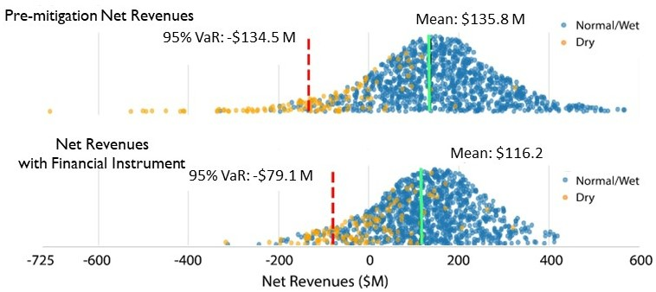

References
Apadula, F., Bassini, A., Elli, A., & Scapin, S. (2012). Relationships between meteorological variables and monthly electricity demand. Applied Energy, 98, 346–356. https://doi.org/10.1016/J.APENERGY.2012.03.053
Cuppari, R. I., Denaro, S., Su, Y., Kern, J., & Characklis, G. (2021). New financial instruments for managing hydrometereological risk for hydropower producers. AGUFM, 2021, NH14B-02. https://ui.adsabs.harvard.edu/abs/2021AGUFMNH14B..02C/abstract
Denaro, S., Cuppari, R. I., Kern, J. D., Su, Y., & Characklis, G. W. (2022). Assessing the Bonneville Power Administration’s Financial Vulnerability to Hydrologic Variability. Journal of Water Resources Planning and Management, 148(10), 05022006. https://doi.org/10.1061/(ASCE)WR.1943-5452.0001590
Hamilton, A. L., Characklis, G. W., & Reed, P. M. (2020). Managing Financial Risk Trade-Offs for Hydropower Generation Using Snowpack-Based Index Contracts. Water Resources Research, 56(10), e2020WR027212. https://doi.org/10.1029/2020WR027212
Jaguemont, J., Boulon, L., Dubé, Y., & Poudrier, D. (2014). Low temperature discharge cycle tests for a lithium ion cell. 2014 IEEE Vehicle Power and Propulsion Conference, VPPC 2014. https://doi.org/10.1109/VPPC.2014.7007097
Kozarcanin, S., Liu, H., & Andresen, G. B. (2019). 21st Century Climate Change Impacts on Key Properties of a Large-Scale Renewable-Based Electricity System. Joule, 3(4), 992–1005. https://doi.org/10.1016/J.JOULE.2019.02.001
Meyer, E. S., Characklis, G. W., & Brown, C. (2017). Evaluating financial risk management strategies under climate change for hydropower producers on the Great Lakes. Water Resources Research, 53(3), 2114–2132. https://doi.org/10.1002/2016WR019889
Su, Y., Kern, J. D., Denaro, S., Hill, J., Reed, P., Sun, Y., Cohen, J., & Characklis, G. W. (2020). An open source model for quantifying risks in bulk electric power systems from spatially and temporally correlated hydrometeorological processes. Environmental Modelling & Software, 126, 104667. https://doi.org/10.1016/J.ENVSOFT.2020.104667
van Vliet, M. T. H., Wiberg, D., Leduc, S., & Riahi, K. (2016). Power-generation system vulnerability and adaptation to changes in climate and water resources. Nature Climate Change 2016 6:4, 6(4), 375–380. https://doi.org/10.1038/nclimate2903
Yalew, S. G., van Vliet, M. T. H., Gernaat, D. E. H. J., Ludwig, F., Miara, A., Park, C., Byers, E., de Cian, E., Piontek, F., Iyer, G., Mouratiadou, I., Glynn, J., Hejazi, M., Dessens, O., Rochedo, P., Pietzcker, R., Schaeffer, R., Fujimori, S., Dasgupta, S., … van Vuuren, D. P. (2020). Impacts of climate change on energy systems in global and regional scenarios. Nature Energy 2020 5:10, 5(10), 794–802. https://doi.org/10.1038/s41560-020-0664-z

