MICRO-SPATIAL MODEL OF RIYADH DOMESTIC ELCTRICITY USE
John E. Abraham, HBA Specto Inc.
Abdel Muhsen, KAPSARC
Geraldine Fuenmayor, HBA Specto Inc.
Amila Sandaradura, KAPSARC
Kevin J. Stefan, HBA Specto Inc.

Overview
A time-series spatial-economic simulation model of the future development of Riyadh, Saudi Arabia was constructed, following the Production Exchange Consumption Allocation System (PECAS) framework. A short-term annual equilibrium spatial interaction model based on a unification of random utility theory with input-output theory works together with a real estate supply/demand model for the cadaster. The PECAS framework is commonly used to predict transportation energy use; we extended the framework to include the use of electricity by households, which is used primarily for cooling. A disaggregate residential electricity demand model was estimated based on self-reported electricity consumption, which considers demographic characteristics (household size, ethnicity, etc.) and dwelling characteristics (dwelling size, structure type, etc.). A full list of synthetic households is associated with individual buildings for each year of the simulation. For each such household, the economic spatial relationships are used to predict transportation energy use, and the dwelling and household characteristics are used to predict residential electricity use. This model will be used to predict the future use of energy by households in different scenarios, including District Cooling scenarios, to develop policies for land use, transportation, and energy that work together towards a future for Riyadh that is both economically strong and energy efficient.

Methods
A household survey from the Royal Commission of Riyadh City (RCRC) provided information on household and housing characteristics (especially dwelling type and size) which was used in a household synthesis process [1] to develop a complete representation of households in dwellings in Riyadh. This was informed by a cadaster inventory of the development in 2016 in Riyadh, also from RCRC, and labor-market occupation level statistics for Riyadh province.
A simulation model was built using the PECAS[2] framework. One of the two modules in PECAS is a short-term annual equilibrium economic interaction model called Activity Allocation (AA) based on Input-Output theory, made spatial through random-utility theory. The AA module for Riyadh was developed by adapting the national social accounting matrix to the city based on population and labor market summaries, and then further disaggregating to neighborhoods (called Hai) and transportation analysis zones, based on housing characteristics. This was used to develop a simulation of the economic flows between locations, including various economic flow relationships that are connected to household travel, such as commuting trips (labor flows), shopping trips (retail goods flows), and trips to schools (education service flows.). These spatial flows consider the transportation zone-to-zone characteristics from a travel model of Riyadh, also from the RCRC – destination choices consider supply/demand balance (resulting in spatial price maps), heterogeneity in opportunities, and travel conditions.
The RCRC household survey reported for a subset of users the monthly energy expenditure in SAR; these records were used to develop a linear regression model predicting energy expenditure by household, considering the household’s demographics, dwelling type and size, tenure and vehicle ownership. Household energy consumption was added as an additional input/output in the PECAS AA module, with demand dependent on dwelling type, dwelling size, and nationality, and supply generated by the electricity utility.
The result is a synthetic one-to-one representation of households in Riyadh, assigned to cadastral parcels based on spatial economic choices including labor market supply and housing demand. For each of these synthetic households, their household electricity use is predicted based on their housing and household characteristics. This synthetic micro-representation of energy use provides insight into energy use at a detailed level, spatially (at a fine geography), and connected to other variables in the simulation such as occupation, nationality, and dwelling size.

Results
The table below shows the coefficients in the linear regression model of 2016 energy use.

OLS Regression Results
==============================================================================
Dep. Variable: ElecExpense R-squared: 0.331
Model: OLS Adj. R-squared: 0.328
Method: Least Squares F-statistic: 97.41
Date: Wed, 01 Dec 2021 Prob (F-statistic): 3.94e-212
Time: 13:18:24 Log-Likelihood: -17501.
No. Observations: 2573 AIC: 3.503e+04
Df Residuals: 2559 BIC: 3.511e+04
Df Model: 13
Covariance Type: nonrobust
==================================================================================
coef std err t P>|t| [0.025 0.975]
----------------------------------------------------------------------------------
const 86.7881 17.066 5.085 0.000 53.323 120.254
BldgArea 0.0510 0.030 1.694 0.090 -0.008 0.110
RoomsCap 6.3509 4.099 1.549 0.121 -1.687 14.389
Rooms_VillaPal 15.3248 3.014 5.084 0.000 9.414 21.235
Rooms_Indig -4.2918 3.130 -1.371 0.170 -10.430 1.846
Is_Rent -26.7910 12.038 -2.226 0.026 -50.396 -3.185
People_EmpOth -12.0263 3.182 -3.779 0.000 -18.267 -5.786
People 15.6854 1.883 8.332 0.000 11.994 19.377
Vehicles 12.1280 3.821 3.174 0.002 4.635 19.621
Work_S 16.4926 5.219 3.160 0.002 6.260 26.726
Work_N_50 18.9166 8.646 2.188 0.029 1.963 35.870
Work_S_50 16.1031 9.415 1.710 0.087 -2.359 34.565
Saudi_NWA 14.2528 3.166 4.502 0.000 8.045 20.461
NS Kids -9.6702 3.618 -2.673 0.008 -16.764 -2.577
==============================================================================
Omnibus: 1128.677 Durbin-Watson: 1.748
Prob(Omnibus): 0.000 Jarque-Bera (JB): 7483.317
Skew: 1.958 Prob(JB): 0.00
Kurtosis: 10.380 Cond. No. 1.45e+03
==============================================================================

where:
- const – constant allocated to all units (intercept)
- BldgArea – building area, sq m
- RoomsCap – Number of rooms, capped at 10, for all structural types
- Rooms_VillaPal – Number of rooms (capped at 10), additional amount only if the unit is Villa or Palace structural type
- Rooms_Indig – Number of rooms (capped at 10), additional amount only if the unit is Indigenous housing
- Is_Rent – Household tenure is rent
- People_EmpOth – Number of people; if household tenure is Employer-paid or Other (not rent or own)
- Vehicles – Number of vehicles owned by the household
- People – Number of people in the household
- Work_S – Number of workers in the household who are Saudi citizens
- Work_N_50 – Number of workers in the household who are Non Saudi citizens, occupation group 50, 51, 52 (skilled)
- Work_S_50 – Number of workers in the household who are Saudi citizens, occupation group 50, 51, 52 (skilled)
- Saudi_NWA – Number of Saudi nonworking adults (18 years old and over)
- NS_Kids – Number of non-Saudi children

The per-person marginal contribution from each person type is summarized below:
 | Saudi | NonSaudi
Child under 18 | 15.69 | 6.02
Nonworking adult | 29.94 | 15.69
Worker, occupation 53+ (blue collar) | 32.18 | 15.69
Worker, occupation 50-52 (white collar) | 46.43 | 34.60

When this model is applied to the synthetic population, it provides an estimate of household electricity use for each household, which have each been assigned to a cadastral parcel, which can be summarized in a number of ways. For example, the zonal average of electricity energy use per household in the simulation in the calibration year is shown in the map below. 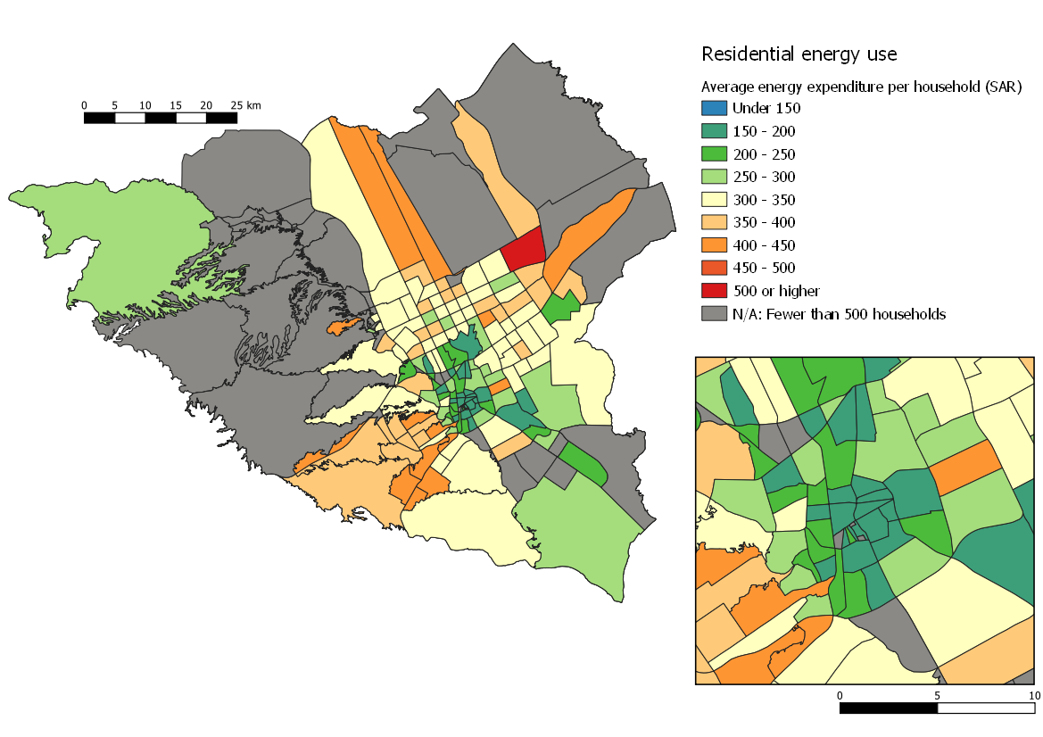

Conclusions
The use of energy in Riyadh is of great interest in national policy. This research connects household electricity use to housing characteristics and household characteristics, including nationality, occupations, dwelling structure type, and dwelling size. This is also connected to a spatial economic simulation model designed to predict the future spatial patterns and spatial interactions in Riyadh over the next decades, accounting for the demand for housing integrated into the demand and supply for all other goods and services, including labour markets and the provision of goods and services to households by businesses.
The reference year (2016) electricity consumption patterns reported here show that certain types of housing and certain types of households consume greater and lesser amounts of electricity, providing insight into the types of patterns that could lead to lower per-capita energy consumption in the future, as Riyadh continues to grow and develop.
The next step in this project is to simulate development scenarios for the future where District Cooling is applied in certain locations, with different policy regulations, incentives, and disincentives, to forecast the resulting reduced energy use in dwellings. The spatial simulation will forecast the secondary impact of District Cooling policies on spatial patterns of travel and development, as well as potential impacts on overall economic performance, and the changes in the use of energy in transportation due to the changes in spatial patterns. This future research should help fine-tune District Cooling policies and identify the most opportune locations for District Cooling projects.

References
[1] J. E. Abraham, K. J. Stefan, and J. D. Hunt, “Population Synthesis Using Combinatorial Optimization at Multiple Levels,” presented at the Transportation Research Board 91st Annual Meeting, 2012. Accessed: May 13, 2014. [Online]. Available: http://trid.trb.org/view.aspx?id=1130260
[2] J. D. Hunt and J. E. Abraham, “Design and implementation of PECAS: A generalized system for the allocation of economic production, exchange and consumption quantities,” in Integrated Land-Use and Transportation Models: Behavioural Foundations, M. Lee Gosselin and S. Doherty, Eds. Amsterdam: Elsevier, 2005, pp. 253–274.

