Closing the Investment Gap to Achieve the Paris Agreement Goals
Fatih Yilmaz, KAPSARC, 0112903059, fatih.yilmaz@kapsarc.org
Fahad Alswaina, KAPSARC, 0112903047, fahad.swaina@kapsarc.org
Fateh Belaid, KAPSARC, 0112903096, fateh.belaid@kapsarc.org
Mohamad Hejazi, KAPSARC, 0112903069, mohamad.hejazi@kapsarc.org
Mari Luomi, KAPSARC, 0112903037, mari.luomi@kapsarc.org
Salahaddine Soummane, KAPSARC, 0112903178, salaheddine.soummane@kapsarc.org

[Other Author’s Name, Affiliation, Phone, email]
[Format: single space, 10 point font, Times New Roman]

Overview

In this study, we assess whether global sustainable financial flows are in line with the transition investment necessities. To do this, we first identify investment gaps that are defined as the difference between the required annual investment to keep up with the global net NZE targets and the current investment flows. Our assessment of the investment gaps reveals that almost all countries must significantly accelerate their efforts, as their current investment levels lag behind the required levels. Secondly, investment gaps are particularly large for non-Annex I (developing) countries. Financing this massive scale investment needs continues to be a major challenge globally, where the size of global environmental, social, and governance (ESG) finance remains low. More importantly, despite their larger investment gaps, developing countries receive a minor share from global ESG funds, where access to conventional finance is already weak.

Methods

Investment gaps across countries are defined as the difference between current investment flows and the annual investment required to achieve a Paris Agreement-aligned scenario. Our assessment of this investment is based on a Global Change Analysis Model (GCAM) developed by Ou et al. (2021), which focuses on the power sector. While a significant portion of the effort to reach NZE relies on the power sector as a decarbonization lever, our analysis does not capture the full transition picture. It, nevertheless, provides data appropriate for a cross-country analysis. The current investment flows are obtained from the BloombergNEF that is available on an annual basis with significant country coverage. We then compare the investment gaps with global ESG debt flows, also obtained from BloombergNEF. The debt flows include the annual issuance of green, sustainable, and sustainability-linked bonds and loan issuances.

Results
Our results show that investment realization levels for Annex I economies are higher, relative to their required investment levels, than in the non-Annex I (developing country) group (Figure 1). Put differently, while developed countries will need 2.1 times more investment in the Paris-aligned scenario, this number is much higher for the developing nations, around 2.6. Excluding the United States (e.g., lower investment performance relative to required levels) from Annex I and China from non-Annex I groups double the investment gap between the two groups. More specifically, the gap decreases to 1.8 times the current levels for developed countries and increases to 4.8 times for developing countries.
Our analysis of financial development differences between the developed and developing world reveals similar gaps. Countries with low financial development, defined as scoring low on the IMF’s Financial Development Index, also tend to experience large investment gaps. In addition to the ongoing financial development challenges, many developing economies have not yet developed the local ESG frameworks that would help them engage with a fast-changing global investment environment, where ESG is becoming the new norm for the financing of sustainable energy transitions. The current annual share of non-Annex I countries of total ESG investments is quite low, with most of these funds concentrated in European and North American countries. One may argue that with the global ESG trend in the financial markets, lesser resources will potentially be available for developing economies if they cannot timely adapt to this new norm.

Figure 1: Sustainable energy investment gaps by country groups.
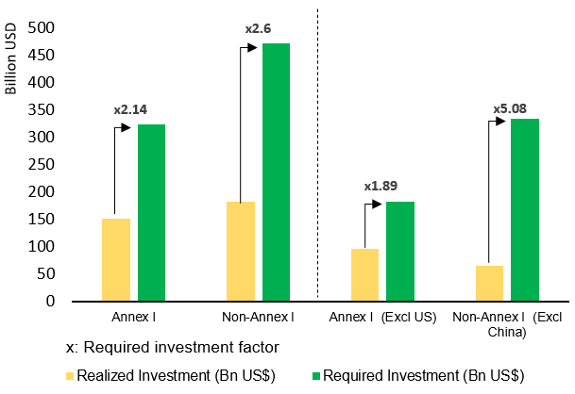
Source: Authors' calculation from Bloomberg, World Bank, and Ou et al. (2021).
Note: Realized investment is the average sustainable energy transition investment flows into the power sector between 2019 and 2021, from Bloomberg. The required investment is the average investment flow needed to achieve the Paris Agreement-compatible scenario in the model. "x" is the additional investment needed to achieve the required level. Annex classification is based on the UNFCCC. Sustainable energy transition investment numbers in the figure include hydro, geothermal, bioenergy, solar, wind, and nuclear investments. CCUS investments are not included due to data shortages.

Conclusions

Considering such bottlenecks, accelerated action and cooperation are required on many fronts to improve the financing conditions for sustainable energy transitions, especially in the case of developing economies. Firstly, globally recognized ESG guidelines have yet to be established. This has resulted in ambiguity for investors and hence, impeded scaling-up efforts. More importantly, a global ESG framework should be flexible enough conceptually to accommodate sectoral and geographic differences across the world. For instance, industry structures in many developing economies currently are much more carbon-intensive than in industrialized economies, which creates obstacles to electrification in the short to mid-run. In such cases, carbon management technologies (e.g., carbon capture, utilization, and storage, CCUS) or different clean hydrogen fuels (e.g., both green and blue hydrogen and ammonia) should be clearly and directly included in global ESG frameworks. Secondly, global cooperation on climate finance should be expanded in multiple dimensions, leveraging various tools, including increased climate finance provision and mobilization by the developed economies, knowledge sharing among countries, and more active contributions from international institutions to the process via capacity building, policy support tools, and funding.

References
Ou et al., 2021. Can updated climate pledges limit warming well below 2°C? SCIENCE, 374, 6568, 693-695, DOI: 10.1126/science.abl8976.

