IMPROVED COORDINATED PROTECTION SCHEME FOR DFIG BASED WIND TURBINES
Arshad Arshad, School of Computing, Engineering and Built Environment, Glasgow Caledonian University, +441412731486, Arshad.arshad@gcu.ac.uk
Wahab Ali Shah, Namal University, Mianwali, Pakistan, wahab@namal.edu.pk
Sali Issa, Department of Physics, Mechanical and Electrical Engineering, Hubei University of Education, Wuhan, China,
sword-lily@hotmail.com

Overview
Doubly Fed Induction Generator (DFIG) is one of the popular choices for wind generation due to its variable speed operation, low losses and relatively low cost as compared to fully rated converter-based wind turbines. However, there are many disadvantages as well of DFIG generation system such as vulnerability to grid disturbance due to direct connection between stator and grid [1]. The increased sensitivity of DFIG wind turbine to voltage sags requires additional protection scheme for Rotor Side Converter (RSC) [2], [3]. Power electronic converters protection in DFIG based system is very important to avoid any over/under voltage and overcurrent situation during faults.

Methods
The simulation setup includes a DFIG wind turbine with 690V at its terminals and is connected with step up transformer. A step-up transformer (0.69/33 kV) is used to step up the voltage for collection purposes. A step-up transformer (33/132 kV) to increase voltage suitable for transmission at long distances is used. A 50 km HVAC transmission line is utilized for power transfer to the grid. The simulations were performed in the following steps:
- Steady state simulations under no fault and without any protection scheme
- Turbine terminal, grid side, and transmission line was subjected to a three-phase short circuit fault.
- An active crowbar and DC chopper were connected to rotor windings and simulations were repeated.
- Value of crowbar resistance, fault resistance and chopper resistance were

Results
The parameters measured througout the simulations are turbine’s active and reactive power, DFIG stator current and voltage, rotor current and voltage. Per unit system was adopted for the measurement of stator current and voltage, whereas, actual values were used for the measurement of DC-link capacitor voltages, active power and reactive power. Fig. 1 shows the results of DC link voltage, reactive power and active power during fault. Overcharging of DC capacitors results in a remarkble increase of DC link voltage that reaches 2450V throughout the fault. Power electronic converters and capacitor can be damaged due to this increase in DC link voltage. These consequences show that the reliability and safety of power system operation is compromised resulting in significant damage to the turbine when the tansmission line is subjected to a the phase short circuit fault which means that a protection strategy is required to cope with the situation.
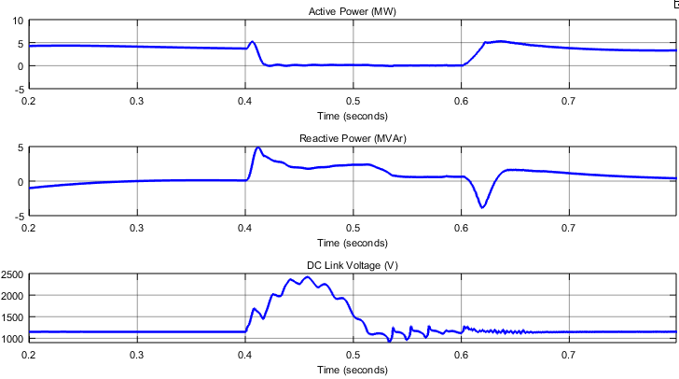
Fig. 1 Behaviour of DC-link voltage, reactive power and active power at fault

Conclusions
This paper discusses the importance of protection schemes for DFIG based wind generation system during grid disturbances. Two different types of protection schemes are designed and implement namely crowbar and DC chopper. Finally, a coordinated protection scheme consisting of both schemes is implemented which shows better results than individual crowbar and DC chopper protection. These results can strengthen our knowledge about the FRT behavior of DFIG wind turbines under different types of grid disturbance and protection scheme.

References
[1] J. Yang, J. E. Fletcher, and J. O’Reilly, “A series-dynamic-resistor-based converter protection scheme for doubly-fed induction generator during various fault conditions,” IEEE Trans. Energy Convers., vol. 25, no. 2, pp. 422–432, 2010.
[2] J. Lopez, E. Gubia, P. Sanchis, X. Roboam, and L. Marroyo, “Wind turbines based on doubly fed induction generator under asymmetrical voltage dips,” IEEE Trans. Energy Convers., vol. 23, no. 1, pp. 321–330, 2008.
[3] M. Mohseni, S. M. Islam, and M. A. Masoum, “Impacts of symmetrical and asymmetrical voltage sags on DFIG-based wind turbines considering phase-angle jump, voltage recovery, and sag parameters,” IEEE Trans. Power Electron., vol. 26, no. 5, pp. 1587–1598, 2011.

