Pricing Schemes for Solar Energy Matter in Residential Electricity Use
Hideki Shimada, National Institute of Advanced Industrial Science and Technology, +81-29-861-8375, Hideki-shimada@aist.go.jp
Tomonori Honda, National Institute of Advanced Industrial Science and Technology, +81- 90-2245-8290, tomonori-honda@aist.go.jp

Overview
The deployment of residential solar photovoltaic (PV) systems has been and will remain a key approach to realizing the energy sector’s decarbonization and curb global warming. A large body of literature has documented that pricing schemes for PV-generated electricity boost the installation of solar PV systems. Broadly, there are two pricing schemes: a gross-pricing scheme, where all generated electricity is sold to electric utilities or grid companies at a given price, and all consumed electricity is delivered using the grid; and a net-pricing scheme, where generated electricity is first consumed by a producer and the surplus, if any, is sold at a given price. These two schemes impose different incentives for electricity consumption once a PV system has been installed. Changes in electricity consumption can be primarily caused by an increase in income under the gross-pricing scheme or by a decrease in the average perceived electricity price under the net-pricing scheme, the so-called solar rebound effect. For a pricing scheme policymaker, it is critical to understand how the schemes affect post-installation electricity consumption, and how they affect welfare. Our study is the first to directly measure the difference in residential electricity usage between the gross-pricing and net-pricing schemes and evaluate how welfare changes. We focus on the Japanese feed-in tariff (FiT), which provides two advantages to this study. First, in Japan, the two pricing schemes coexist, and eligibility for the gross-pricing scheme depends on the capacity of the installed PV system, which provides a fascinating environment for measuring schemes’ causal effects on electricity use. Second, data provided by a Japanese house-building company recorded detailed electricity usage and generation information for a large number of households, enabling us to study the two pricing schemes without imputing any electricity use information, which is often observed in the literature.

Methods
We use one-hour interval electricity data of 4,880 households that installed solar PV, covering a broad range of Japanese regions. The data are from a major house-building company. The data include total electricity consumption (i.e., electricity delivered from the grid plus electricity generated and consumed at home), recorded by the company’s original electricity monitoring board, and span from 2012 to 2015. Importantly, total consumption, electricity delivered from the grid, total generated electricity, and consumption of generated electricity are separately recorded, which allows us to study actual electricity use and distinguish each household’s pricing scheme. We also had access to home and household attributes for most households, including solar PV capacity, total floor area, and average temperature.
Under the Japanese FiT, households can choose between two schemes if their PV capacity is larger than or equal to 10 kW: gross-pricing and net-pricing schemes; they have no choice but a net-pricing scheme otherwise. This study exploits the discontinuity at 10 kW to measure the difference in electricity usage between net-pricing and gross-pricing schemes. We use electricity data spanning from 2012 to 2015 containing households that purchased their homes and installed a solar PV by mid-2015. We choose this period because all households equipped with a PV system larger than or equal to 10 kW chose the gross-pricing scheme, enabling us to apply a sharp regression discontinuity (RD) design. However, a conventional RD design may not be applicable because of the manipulation of a running variable around the threshold if some households (always-gross households) installed capacity of just above 10 kW to be eligible for the gross-pricing scheme. Therefore, we also apply the partial identification approach developed by Gerard, Rokkanen, and Rothe (2020) Quant Econ., where the existence of always-gross households is allowed and their share is estimated, being utilized to bound the distribution of potential outcomes. The potential outcome of interest here is the hourly electricity consumption under the two schemes.

Results
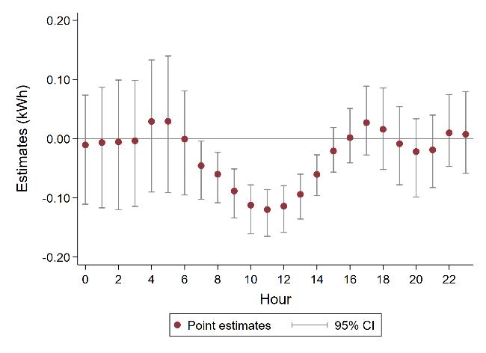
Using a simple microeconomic model, we first show that measuring the difference in electricity use between the two schemes is sufficient to determine which scheme is welfare-improving. The net-pricing scheme improves welfare if it incentivizes households to save electricity compared to the gross-pricing scheme. However, we empirically find that electricity usage under the net-pricing scheme is larger than that of the gross-pricing scheme. Point estimates obtained by the conventional sharp RD design suggest that the difference varies over time. The largest hourly difference of 0.12 kWh (11.33 % change compared to the gross-pricing scheme) is observed at 11 AM and is statistically significant at the 1% level, whereas the differences are small in early morning and late at night, and are statistically indistinguishable from zero (Figure 1). The partial identification approach confirmed these results. The estimated confidence interval (kWh) is [0.059, 0.18] at 11 AM. Thus, from the perspective of a social planner, once a solar PV has been installed, the gross-pricing scheme is welfare-improving.
Figure 1: RD estimates

Conclusions
Our study is the first to directly measure the difference in electricity use between two major pricing schemes for solar energy and empirically show that once a PV system has been installed, the gross-pricing scheme is superior to the net-pricing scheme. This study also contributes to the literature on the rebound effect of solar PV installation on electricity use, where no study has previously examined both schemes. Although we do not directly measure the rebound effects, our results imply that the effects of a decrease in the perceived electricity price under the net-pricing scheme are larger than the effects of an increase in income under the gross-pricing scheme.

References
Gerard, F., Rokkanen, M., & Rothe, C. (2020). Bounds on treatment effects in regression discontinuity designs with a manipulated running variable. Quantitative Economics, 11(3), 839-870.

