Performance investigation of two types of solar chimney
used for air conditioning

Hamod Ghorm Ali Alshomrsni
Mechanical Engineering Department, College of Engineering, University of Bisha, Bisha 61922, Saudi Arabia, tel: +966501642625, alrahal2000@hotmail.com,
Faouzi Nasri
Mechanical Engineering Department, College of Engineering, University of Bisha, Bisha 61922, Saudi Arabia, tel:+966590320696 , fnasri@ub.edu.sa, nasrifaouzi@yahoo.fr

Overview
Nearly 35 % of total worldwide energy production is consumed by the building sector. In the European Union, the overall energy consumption by buildings account for 40%, and approximately 30 % of the building energy is consumed by heating, ventilation and air-conditioning. Ventilation is the simplest, oldest, and least expensive form of passive cooling or heating. In the last years, researchers focused on the natural ventilation. Natural ventilation induced by solar chimney is an excellent passive system for air exchange that provides outdoor fresh and unpolluted air. Moreover, many current scientific researches have shown the possibility to enhance indoor natural ventilation in buildings by using solar chimneys. Shuangping Duan et al analysed the airflow in a building occpupied by solar chimney and fans. The results of this study showed that the airflow rate boosts if the height of the solar chimney and solar radiation increase. The deduced also, that using fans will decrease the natural ventilation generated by solar chimney. E.P. Sakonidou et al. Investigated the optimal angle that will provide a maximum airflow by natural ventilation in solar chimney. Developed model permitted flowing many parameters such air velocity and the temperature variation inside the chimney.

Methods
The Figures 1 and 2 illustrate a schematic diagram of the ventilated building for the two proposed types of solar chimney. The solar chimney uses the sun's heat to provide ventilation based on the pressure difference between building air inlet and air outlet. Solar radiation is used to heat up the air flow in the collector in order to enhance ventilation in the chimney. The solar chimney Type I is a conventional design with a simple vertical part while the solar chimney type II is our proposed original design with a lateral (vertical) part and an upper (horizontal) part.

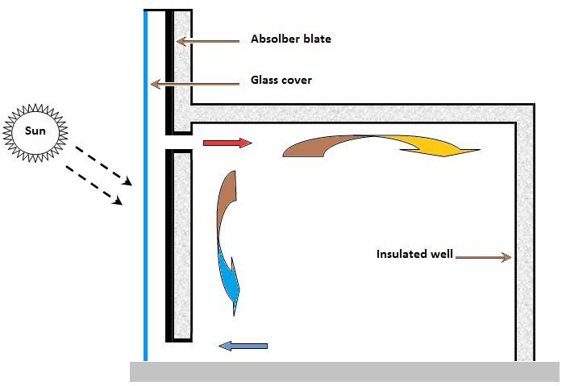 | 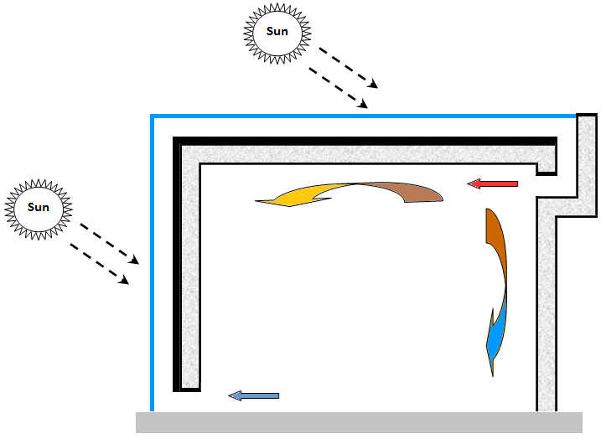
- Schematic diagram of the ventilated room: Type I. | - Schematic diagram of the ventilated room: Type II.

A solar chimney is a type of passive solar heating and cooling system composed of a glass, air and absorber. The natural air flow within the solar chimney due to the difference of the density varied with vertical direction is considered steady and with negligible resistance losses. That can be used to regulate the temperature of a building as well as providing ventilation is considered steady and with negligible resistance losses. The energy balances for each component are written as (Nasri et al., 2018):

Results

All numerical simulations are carried out for an ambient temperature Ta=15°C, solar radiation I=500W/m2, all wall temperatures are unique Tw=15°C. The chimney cross section is Ach=0.3×1m2 for the two investigated types of solar chimney. For the solar chimney Type I, the air flow velocity in the chimney is Vch=0.13 m/s and the outlet chimney temperature (inlet room temperature) is Tout,ch=27.5°C. The Figures 3 and 4 present the air temperature evolution and the air temperature contours respectively for the solar chimney Type I. This study will present the air streamlines, the air temperature evolution and the air temperature contours respectively for the solar chimney Type II.

Fig. 3. Air temperature evolution for the ventilated room: Type II. | Fig. 4. Air temperature contours for the ventilated room: Type II.

Base on the numerical results, the proposed original design of solar chimney (solar chimney Type II) provides better distribution of heated air in the ventilated room than the conventional one (solar chimney type II). We carried out numerical results of the calculated exit air velocity and the calculated air temperature respectively in function of solar heat flux.

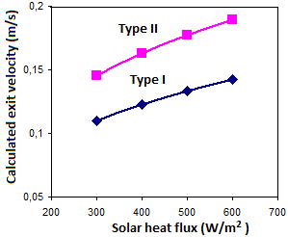 | 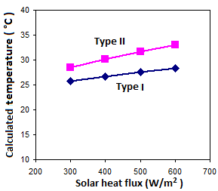
Fig. 5. Calculated exit air velocity: solar chimney Type I vs solar chimney Type II. | Fig. 6. Calculated exit air temeprature: solar chimney Type I vs solar chimney Type II.

Conclusions
An original design of solar chimney with lateral (vertical) part and upper (horizontal) part is proposed. The proposed design permits to ensure thermal comfort in a ventilated room during winter mode. A comparative numerical study between the conventional and the proposed original designs is carried out to evaluate the ability of each design to ensure indoor thermal comfort. Results show that the original design of solar chimney presents better performance than the conventional one.

