[PAPER/Poster TITLE
Technical Constraints, Cost Risks and Failure Modes of the Energy Transition
(Implications for Energy Security and Guidance for Policymakers )

Lucian Pugliaresi, et al
President, Energy Policy Research Foundation, Inc.

Overview
To achieve a global net zero outcome, a wide array of technical and resource challenges must be overcome. No single technological constraint provides a path forward, but instead, a broad and difficult set of challenges must be addressed. Drawing upon work from a two-year assessment by the Energy Policy Research Foundation, Inc. (EPRINC) analysis team, the paper examines a broad array of technical constraints, cost risks, and likely failure modes in proceeding with a worldwide energy transition over the next 30 years. Solving a long list of technical challenges across a broad range of energy systems and fuel use and then scaling the solutions worldwide presents formidable challenges largely unappreciated within the technologically advanced OECD. The technical and scale challenges are are not well understood. The net zero does not require solving a technical challenges to achieve a narrow and specific objective, but instead, broad solutions and technical breakthroughs are required across the entire energy system. The scale challenge is best described by Mark Mills in his book The Cloud Revolution; “The energy transition is not like putting a man on the moon. It is more like putting all of humanity on the moon—permanently.”

Methods
Achieving deep decarbonization requires rapid cost reductions in zero-carbon or negative-carbon technologies in all sectors of the economy. Private sector companies, NGOs, and intergovernmental organizations have presented widely different global cost estimates for transitioning to a net zero carbon emission (NZE) economy. The consulting firm McKinsery has estimated that worldwide 8 percent of GDP must be dedicated to the transition to achieve net zero worldwide by 2050. The EPRINC research indentifies regions with the most rapid requirements for energy use (including likely energy use from population growth, economic expansion,and capital formation) over the next 30 years. In the absence of massive and sustained decarbonization the developing world, even if the entire OECD achieves net zero carbon emissions, worldwide CO2 emissions in 2050 are likely to only be 20% less than in a range of reference scenarios. The research identifies the key technologies that must be developed and deployed along with their likely technical risks and cost constraints. Land use requirements and and technology limits are evaluated to determine the capacity for deployment (technology readiness level) of net zero technologies.

Results
Cost and technology risks will see the world divided along two tracks. The first group of countries will consist primarily of the existing members of the Organization for Economic Cooperation and Development (OECD), a group of 38 high-income economies. Most OECD countries will stay committed to some degree of decarbonization despite escalating costs from high fuel and commodity prices, risks of an increasingly unreliable and vulnerable grid, political challenges, and continued dependence on foreign energy supply. By 2050, much of the OECD will make some and possiblhy significant progress in diversifying their energy mix, but the high energy growth regions will will remain largely reliant on hydrocarbons. This outcome also presents a wide array of new energy security risks for the developed world as critical minerals and materials needed for the transiton will largely be sourced outside the OECD.
Conclusions
The two speeds of transition will leave the OECD countries in a disadvantaged position while strengthening the relative power position of non-OECD countries. The combined GDP of the OECD will have nearly doubled in real terms by 2050, but the non-OECD economies will have almost tripled in size during that period. The total share of the existing OECD countries will have decreased from 44% to less than a third of the global economy by 2050. In this scenario, non-OECD countries will extend their energy technology dominance to more high-value technology components while tightening their grip on conventional energy supplies. Even with unsatisfactory progress and compromised energy security systems, experience dating back to the Kyoto Protocol suggests that OECD will continue with its aspirational goals. As shown in Figure xx, future responses to future challenges are likely to be the same as before: commitments to greater ambition but little change in emissions trend.

Figure: Relative Power Positions in a Two-Speed Transition
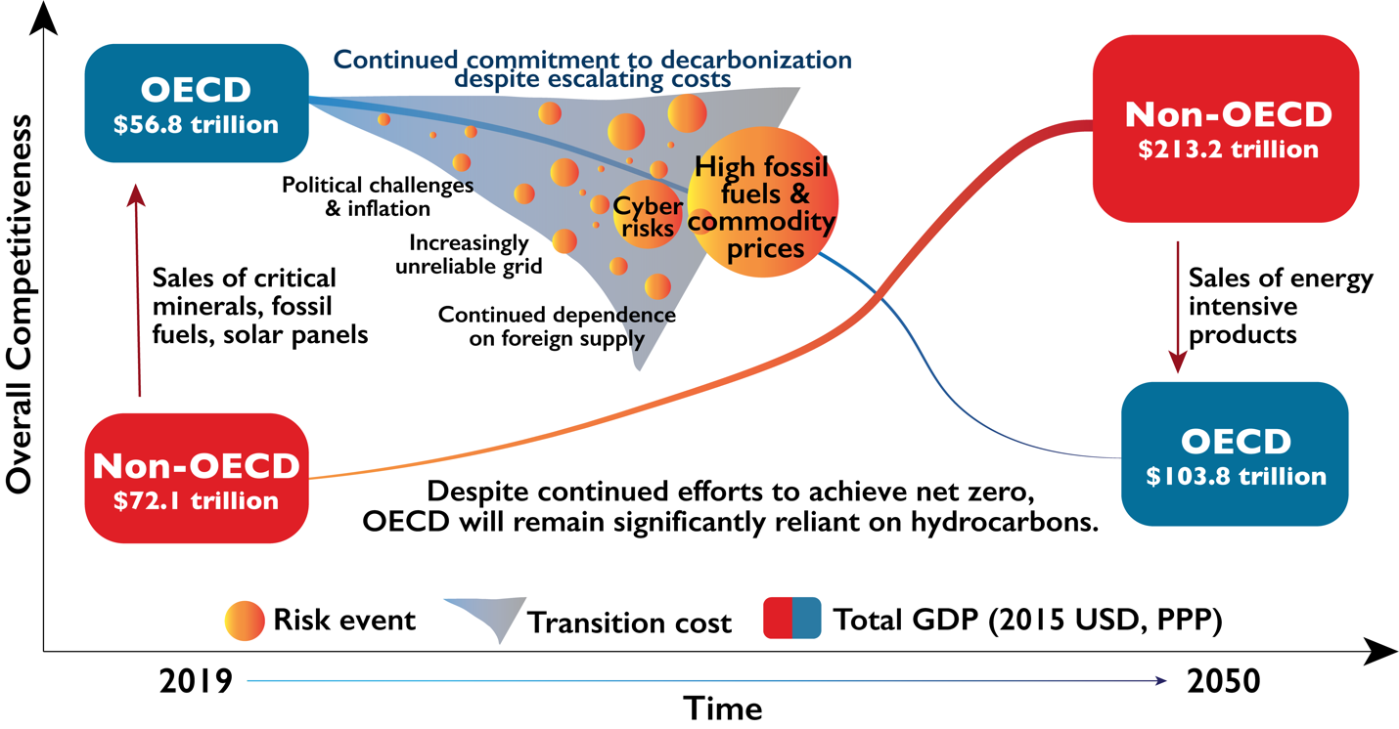
Source: EPRINC analysis
References (partial list)

APERC. APEC Outlook Annex I: Modelling Assumptions & Methodologies (2019). https://aperc.or.jp/file/2019/5/30/APEC_Outlook6th_Annex+I_Modelling+assumptions+and+methodologies.pdf

Bouckaert et al.., Net Zero by 2050 (2021). https://www.iea.org/reports/net-zero-by-2050

BP, BP Energy Outlook (2022). https://www.bp.com/en/global/corporate/energy-economics/energy-outlook.html

BP. Statistical Review of World Energy (2022). https://www.bp.com/en/global/corporate/energy-economics/statistical-review-of-world-energy.html

Broom, D., “What’s the price of a green economy? An extra $3.5 trillion a year.” World Economic Forum. https://www.weforum.org/agenda/2022/01/net-zero-cost-3-5-trillion-a-year/

Climate Action Tracker. Countries and China sections (Assessment last updated on May 19, 2022). https://climateactiontracker.org/

Earth Policy Institute Data Center. https://www.earth-policy.org/data_center/

Energy Transitions Commission. Mission Possible: Reaching net-zero carbon emissions from harder-to-abate sectors (Nov 2018). https://www.energy-transitions.org/publications/mission-possible/#download-form

Fare, R., Renewable Energy Intermittency Explained: Challenges, Solutions, and Opportunities. Mar 11, 2015. https://blogs.scientificamerican.com/plugged-in/renewable-energy-intermittency-explained-challenges-solutions-and-opportunities/

11

