A Bayesian Approach to Analyse the Nexus Between the Environmental and Financial Factors to affect Energy Efficiency in the GCC Region

Rozina Shaheen*
*Associate Professor, Finance Department, College of Business, Effat University, Saudi Arabia.
E-mail: roshaheen@effatuniversity.edu.sa

Overview
Energy, being a significant input in the production process is considered an important element in the socio-economic development of a country. In this context, global economy is concentrating on attaining financial stability through increased energy efficiency and plummeting the energy intensity. Efficient use of energy enables the countries to improve their trade balance whereas it helps to reduce operating costs at micro level. Using energy-efficient techniques can reduce the environmental risks posed by the higher level of economic activity. Similarly, development of financial sector stimulates economic efficiency through the expansion in the financial activities (Sadorsky, 2010). Financial development helps to reduce cost of borrowing and financial risk, thereby creating transparency between lenders and borrowers. In addition, financial sector development facilitates the acquisition of sophisticated energy efficiency products and technology.
However, with the rapid economic development, the environmental degradation has become a focus point for the nations across the globe. The feedback effects from environment to economic growth have stimulated the researchers to investigate the reasons for environmental dilapidation and determine the solutions for environmental conservation. Many of these research studies are encircled around the environmental Kuznets curve (EKC) hypothesis (Grossman &Krueger, 1991) which elaborates the linkages between the environmental degradation and economic growth. Middle Eastern economies are heavily reliant on the energy-based revenues and any curb on the energy production directly affects their economic growth in the region.
Furthermore, financial system in the Middle Eastern region is technologically advanced with strong regulatory frameworks related to data protection, consumer protection, cybersecurity, and anti-money laundering. These regional characteristics provide a strong base to assess the existence of environmental Kuznets curve in the region and to examine the nexus between the financial sector development, economic growth, energy efficiency and Co2 emission in the region.
The relationship between the environmental quality and economic growth is explored by various studies such as Jaeger et al. (1995), Tucker (1995), Barbier (1997), Horvath (1997), Ansuategi et al. (1998), List and Gallet (1999), Stern and Common (2001), Roca (2003), Dinda and Coondoo (2006), Coondoo and Dinda (2008) and Akbostanci et al. (2009). However, this research is unique as it is first to examine the environmental Kuznets curve hypothesis for the oil based Middle Eastern economies while using a conditionally homogenous autoregressive model for the panel of Middle Eastern economies. This model considers homogeneity across the cross-sectional units with identical structural characteristics. The panel conditionally homogenous vector autoregressive specification permits the heterogeneity in the dynamic panel data set and evaluates the relationship between the observed heterogeneity across the units and their structural characteristics.

Methods
Following Georgiadis (2012), we specify the model as follows:

$y_{}=\sum_{j=1}^{p}{A_{j}\left(z_{}\right)y_{i,t−j}+ε_{}ε_{} ^{i,i,d}}$ (i)

Where i = 1,2,….,N shows the specific cross sectional unit, t = 1,2,…., T is the time period, $y_{}$ is a K x 1 vector of endogenous variables, $z_{}$ is an M x 1 matrix of exogenous variables, $A_{j}$ is a K x M matrix of coefficients. Equation (1) is general form of panel vector autoregression but allows the heterogeneities across the units. In this case, time series are pooled and exogenous conditioning variables$z_{}$ are used to generate impulse responses. This approach presents the unit specific characteristics in observed heterogeneities and conditioning variables are key factors to affect the dynamics of the model. In PCHVAR, the coefficient matrices depend on the dynamic properties along with conditioning variables, therefore impulse responses are history dependents as well as the function of conditioning variables.
To investigate the impact of economic growth and financial sector development on the energy efficiency, this research considers a panel of five Middle eastern countries while using the annual data from 2001 -2020. Current research includes three sets of variables, the set of endogenous variables include energy intensity, carbon emission (CO2) and natural resource depletion, the set of exogenous variables contain gross domestic product (GDP) growth rate, financial technology, which is measured through number of ATMs, financial inclusion which is represented through access to credit and energy use (kg of oil equivalent per capita). These data sets are retrieved from the database of World Economic Outlook and International Financial Statistics

Results
Figure 1: Impulse Responses of the CO2 Emission/Energy Intensity/Natural Resource Depletion PCHVAR Model - Varying GDP levels ...
- at the Mean of ATMs
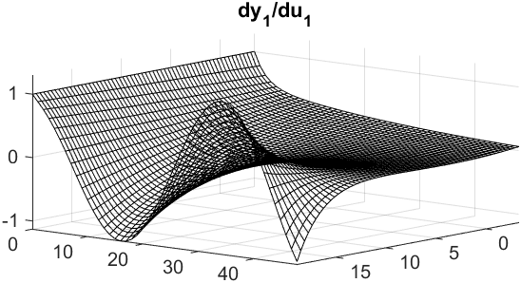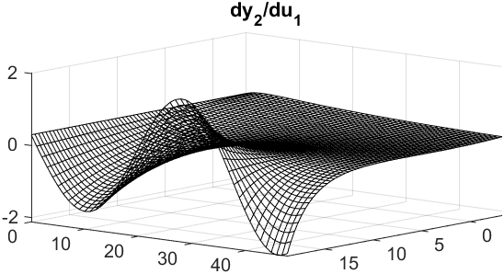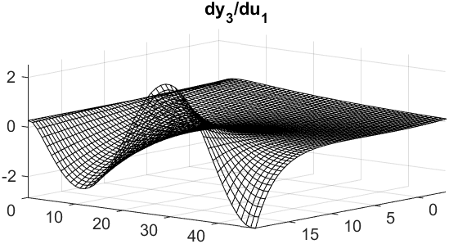
Figure 2 : Impulse Responses of the CO2 Emission/Energy Intensity/Natural Resource Depletion PCHVAR Model – Varying ATMs ...
- at the Mean of GDP
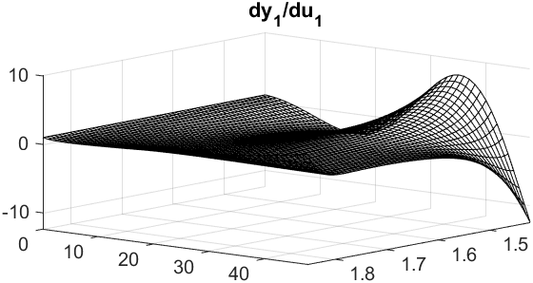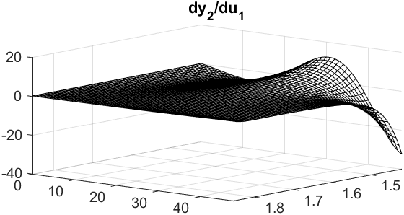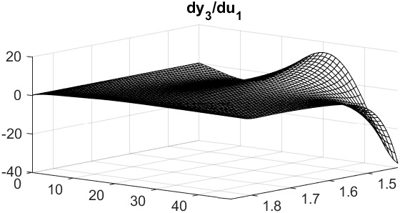

Conclusions

The analysis of impulse response functions reveals that in the short run, a one standard deviation positive shock in the GDP growth rate induces more CO2 emission in the region. However, in the long run higher GDP growth leads to reduction in the CO2 emission as countries become more economically sustainable which enables them to spend more on CO2 emission technologies. Moreover, a positive shock in GDP growth rates induces positive impacts on the energy intensity and natural resource depletion in the short run, however this relationship becomes negative over the long-time horizons.

References
A. Ansuategi, E. Barbier, C. Perrings (1998), The Environmental Kuznets Curve, in: J.C.J.M. van den Bergh, M.W. Hofkes (Eds.), Theory and Implementation of Sustainable Development Modelling, Kluwer Academic, Dordrecht.,
Dinda, S. (2004). Environmental Kuznets curve hypothesis: a survey. Ecological economics, 49(4), 431-455.
Jaeger, W., Patel, S., Pinckney, T., 1995. Smallholder wood production and population pressure in East Africa: Evidence of an Environmental Kuznets Curve? Land Economics 71, 1–21 November.
E. Barbier (1997), Introduction to the Environmental Kuznets curve special issue, Environment and Development Economics. 2 (1997) 369–381.
J.A. List, C.A. Gallet (1999), The Environmental Kuznets Curve: does one size fit all?, Ecological Economics. 31 409– 423.
D.I. Stern, M.S. Common (2001), Is there an environmental Kuznets curve for sulphur?, Journal of Environmental Economics and Management. 41 (2001) 162–178.

