Intermittent renewables versus nuclear in French electricity system? Cost sensitivity, emissions and benefits of Interconnections.

Yiling CAI, Laboratoire des Sciences du Climat et de l’Environnement, LSCE/IPSL, CEA-CNRS-UVSQ, Université Paris-Saclay, yiling.cai@lsce.ipsl.fr
François-Marie Bréon, Laboratoire des Sciences du Climat et de l’Environnement, LSCE/IPSL, CEA-CNRS-UVSQ, Université Paris-Saclay, fmbreon@cea.fr

Overview
Nuclear energy has provided close to 70% of electricity production in France during the past decade, which contributes to its power sector emission (in g/kWh) that is among the lowest, together with countries that have a high share of hydro-electricity. However, the average age of nuclear reactors in France approaches 35 years, while some claim that 40 years is the design lifetime. Even with an extension of 10 to 20 years, most of the existing reactors will be retired in 2050s. Meanwhile, wind and solar electricity production has shown a spectacular cost reduction and installation capacity surge in the last decade, and the trend is ongoing. These facts open the question on the optimal choice for the French electricity mix in the long run: nuclear, renewables or a mix between nuclear and renewables.
Yuan et al. (2020) suggested that a cost-optimized electricity system can be a mix of nuclear and renewables, while the expansion of one technology tends to drive out the other technology. Sepulveda et al. (2018) reported that firm low-carbon technologies (e.g., nuclear) can play an important role in containing the overall cost of a low-carbon mix. Cany et al. (2016) revealed that the increasing share of renewables in the French electricity system will challenge the revenues of the nuclear operators as the load factor drops significantly. Pfenninger et al. (2015) showed that a wide range combination of nuclear and renewables are equally techno-economically feasible in Great Britain, although more flexibility options such as long-term storage and electricity imports will be required for high shares of renewables (>80%).
In this context, our analysis addresses the following questions for the French electricity system: 1: What is the least-cost electricity mix and how the system cost and CO2 emissions vary for different mixes of nuclear, renewables and gas? 2: How sensible is the optimal mix to cost hypothesis? 3: What is the impact of interconnections with neighbouring countries and how is the French optimal mix influenced by these countries production and interconnection capacities?

Methods
The study uses an electricity system model to determine the least-cost portfolio of technologies in considering both investment and optimal dispatch. The optimized portfolio must balance electricity demand and supply of each hour within each country, accounting for potential exchanges between them.
We suppose a greenfield system except for existing hydro assets. Technologies considered for France includes nuclear, wind, solar PV, gas (CCGT and OCGT) and hydro. We first examine an isolated electricity grid. Secondly, interconnection is added to the system with 11 countries in Western Europe. The electricity mix for countries other than France are imposed relying on the ENTSO-E Ten Year Network Development Plan 2020 (TYNDP 2020) study. The French electricity mix is optimized with a co-optimization of electricity dispatch in France and neighbouring countries. The optimisation account for a tariff on CO2 emissions.
The following scenarios are simulated in an isolated grid: (i): the least-cost portfolio and different nuclear-renewables capacity combinations: from 0 to 80 GW with an increment of 10 GW for nuclear, and from 0 to 280 GW with a step of 40 GW for renewables; (ii) Four scenarios of both nuclear and renewable costs are considered, i.e., -25%, +25% and +50%, with respect to the reference scenario used in (i). The following scenarios are simulated in an interconnected grid: (iii): repeat (i) and (ii); (iv): Different interconnection capacities (3 scenarios) and different neighbouring countries mix (4 scenarios) are considered, repeat (i).

Results
Figure1 (left) shows the result of scenario (i). Although the optimal system is found for a mix with ≈50 GW for both nuclear and renewable, a similar (10% increase) cost of the system is found for a very wide range of nuclear and renewables, up to 0 and 100% of each. Even though the least-cost system or near-optimal system can be a mix of two, they are intrinsically competing with each other. The increasing share of nuclear will drive out the renewables or vice-versa. CO2 emissions tend to increase with an increased share of renewables without further flexibility options.
The cost sensitivity analysis shows that the optimal system is extremely sensitive to the cost assumption. Nuclear and renewables can be completely driven out of the optimal mix with realistic cost hypothesis. However, as for the reference scenario, the near-optimal decision space is rather large even in extreme cost (+50%) scenarios. To put it differently, nuclear can still have a role to play even in the highest cost scenario. In contrary, it doesn’t mean that renewables are fully sub-optimal even in the most pessimist scenario. Nevertheless, an increase of the nuclear cost from the reference scenario narrows down the nuclear capacity near-optimal range; conversely, the rise of renewables cost reduces the renewables decision zone.
Figure1 (right) shows the results of the optimization when accounting for interconnections. These contribute an important benefice to the system: the cost declines, the near-optimal decision range is further amplified, and the CO2 emission decreases. Note that the least-cost option for the whole system does not imply the least-cost choice for France. This is linked directly to the choice of France as a net electricity exporter or importer and thus impact the emissions in other countries. Both interconnection capacity and neighbouring electricity mix will impact the electricity mix in France, but far less important compared to the cost and interconnection itself (i.e., supposing that the system already has a sufficient level of interconnection). In general, the increase of interconnection capacity will further decrease the system cost and emissions both in France and in other countries. However, the impact of neighbouring electricity mix on the optimal French electricity mix is not as clear.
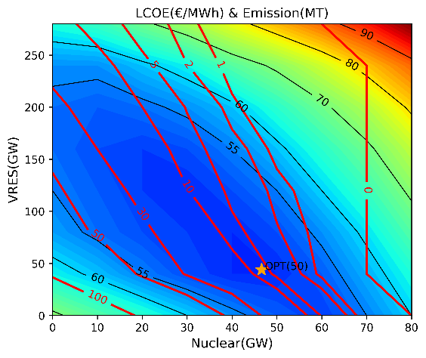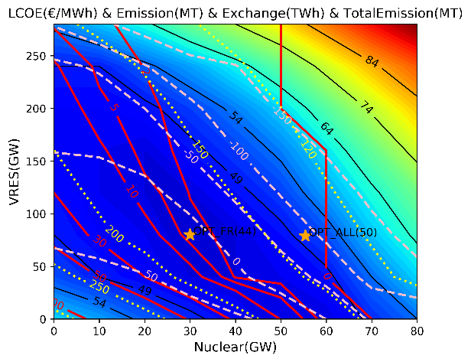
Figure 1: The contour plot of average system cost (black solid line) and emissions (red solid line) as the function of renewables and nuclear capacity in an isolated grid(left); The contour plot of average system cost (black solid line), emissions in France (red solid line), net exchange with neighbouring countries (pink dashed line) and total emissions in the whole system (yellow dotted line) in an interconnected grid (right). ‘OPT_FR’ marks the optimal mix for France, ‘OPT_ALL’ marks the optimal mix for the whole system.

Conclusions
We show that a large decision space exists at different nuclear-renewables combinations. No definitive conclusion can be drawn based on a simply cost-optimal analysis regarding the choice of nuclear and renewables. Other considerations, such as land use, public acceptance, social welfare, and financial issues must be addressed for policy decision. Interconnections have a very beneficial impact in terms of costs, emissions and decision space. However, an increase in CO2 emissions is associated to an increase share of renewables, which could be mitigated by flexibility options (e.g., storage) other than interconnections to fully decarbonize the system.

References
- Yuan, M., Tong, F., Duan, L., Dowling, J. A., Davis, S. J., Lewis, N. S., & Caldeira, K. (2020). Would firm generators facilitate or deter variable renewable energy in a carbon-free electricity system?. Applied Energy, 279, 115789.
- Sepulveda, N. A., Jenkins, J. D., de Sisternes, F. J., & Lester, R. K. (2018). The role of firm low-carbon electricity resources in deep decarbonization of power generation. Joule, 2(11), 2403-2420.
- Cany, C., Mansilla, C., Da Costa, P., Mathonnière, G., Duquesnoy, T., & Baschwitz, A. (2016). Nuclear and intermittent renewables: Two compatible supply options? The case of the French power mix. Energy Policy, 95, 135-146.
- Pfenninger, S., & Keirstead, J. (2015). Renewables, nuclear, or fossil fuels? Scenarios for Great Britain’s power system considering costs, emissions and energy security. Applied Energy, 152, 83-93.
- ENTSO-E, “TYNDP2020 -Scenario Report,” 2020. [Online]. Available: https://2020.entsos-tyndp-scenarios.eu/wp-content/uploads/2020/06/TYNDP_2020_Joint_ScenarioReport_final.pdf

