Designing a Global Energy System based on 100% Renewables for 2050
Thorsten BURANDT^{(a)}, Karlo HAINSCH ^{(a)}, Konstantin LÖFFLER^{(a)}, Pao-Yu OEI ^{(a,b,c)}
^{(a)}TU Berlin, ^{(b)}DIW Berlin, ^{(c)}SRU

Overview
Currently, around 86% of the worlds energy supply is based on fossil fuels and nuclear energy. Burning these fossil fuels emits greenhouse gases, leading to climate change and environmental warming. Hence, especially since the Paris agreement (UNFCC 2015), there is a need to take a look at the global energy system and its possible realizations towards full decarbonization. In order to do this, we develop a linear cost-optimizing model for the path from 2015 to 2050 in 10 year steps. The model is based on the existing OSeMOSYS (Open Source Energy Modeling System, http://www.osemosys.org/). We aggregated countries into ten geographic regions, calculating energy and resource flows to meet power, heat and transport demands. Final demands and demand profiles for our model stem from the 450ppm scenario of the IEA, resulting in a primary energy demand of 290 EJ in 2050. Time is disaggregated into multiple time slices, modeling seasons and day/night cycles. While being global in scope, the analysis focusses on the results for Europe.

Method
The Open Source Energy Modelling System (OSeMOSYS) is a linear optimization model for long-run energy systems (Howells et al. 2011). As a linear program, it has an easy to understand codebase, which can easily be adopted to solve several problems. OSeMOSYS is a multi-knot model using a cost minimizing objective function to calculate an energy system. Furthermore, the data used by the model has a clear structure and allows the design of multiple regions and time periods. In addition, there is an existing GAMS implementation which was written by (Noble 2012). Therefore, we decided to use this as a basis for our research on this topic. OSeMOSYS consists of multiple blocks of functionality. The current main blocks of the basic OSeMOSYS implementation include specifications of the 'Objective Function', 'Costs', 'Storage', 'Capacity adequacy', 'Energy Balance', 'Constraints' and 'Emissions'. To soften the limitations of a linear model, we had to implement an addition block of functionality. This block is called ‘Transportation’ and has been added to implement a modal split of the transportation sector in our model. A modal split models the distribution of passenger or freight kilometers to a particular type of transportation. Additionally, we improved the model by adding trade costs of imported fuels. These blocks can be changed or improved without an impact on the other blocks despite the ‘Objective’ block.
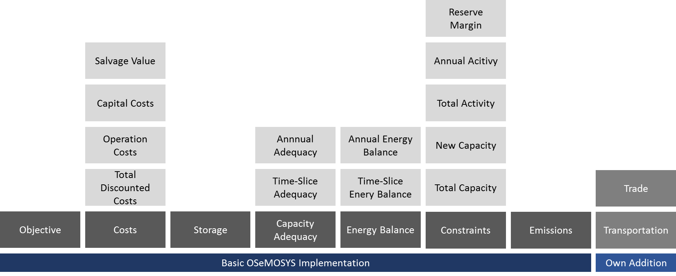
Figure 1: Layout of OSeMOSYS.
Source: Own Illustration based on (Howells et al. 2011).

Results
To analyze the energy system, we modeled 10 different regions according to geographical similarities. While some countries were aggregated to form a region, others play a role far too important in the future, requiring a separate consideration. The possibility of trading energy carriers between the regions exists while power trade is not considered in our approach. Additionally, we split the year into several time periods to simulate different seasons and daytimes and the concomitant fluctuation of renewable energy production.
Current results indicate that the share of conventional energy carriers used for power generation was still at 69% in 2020, the year 2030 indicates a strong turning point towards renewable power generation with only about 35% being produced by conventional energy carriers. Europe (and North America) both show strong tendencies towards an early adoption of widespread renewable energies with over 95% of power generation in renewables by 2030. Based on the model calculations, the global energy system towards 2050 mainly relies on wind power (58%), solar power (19%) and biomass (14%). To a smaller degree, hydro, geothermal and concentrated solar power provide energy as well. Because the other two main sources of energy, wind and solar power, produce energy in form of electricity, we observe a strong sector-coupling of the power sector with both the heat and transport sector. In the heating sector, heat pumps and direct heating with electricity convert power into heat. In the transport sector, electricity is directly used in battery electric vehicles and electric rails as well as converted into hydrogen to provide mobility where the direct use of electricity is not possible. Around 66% of the total investment costs occur in the last two modeled periods, 2040 and 2050.

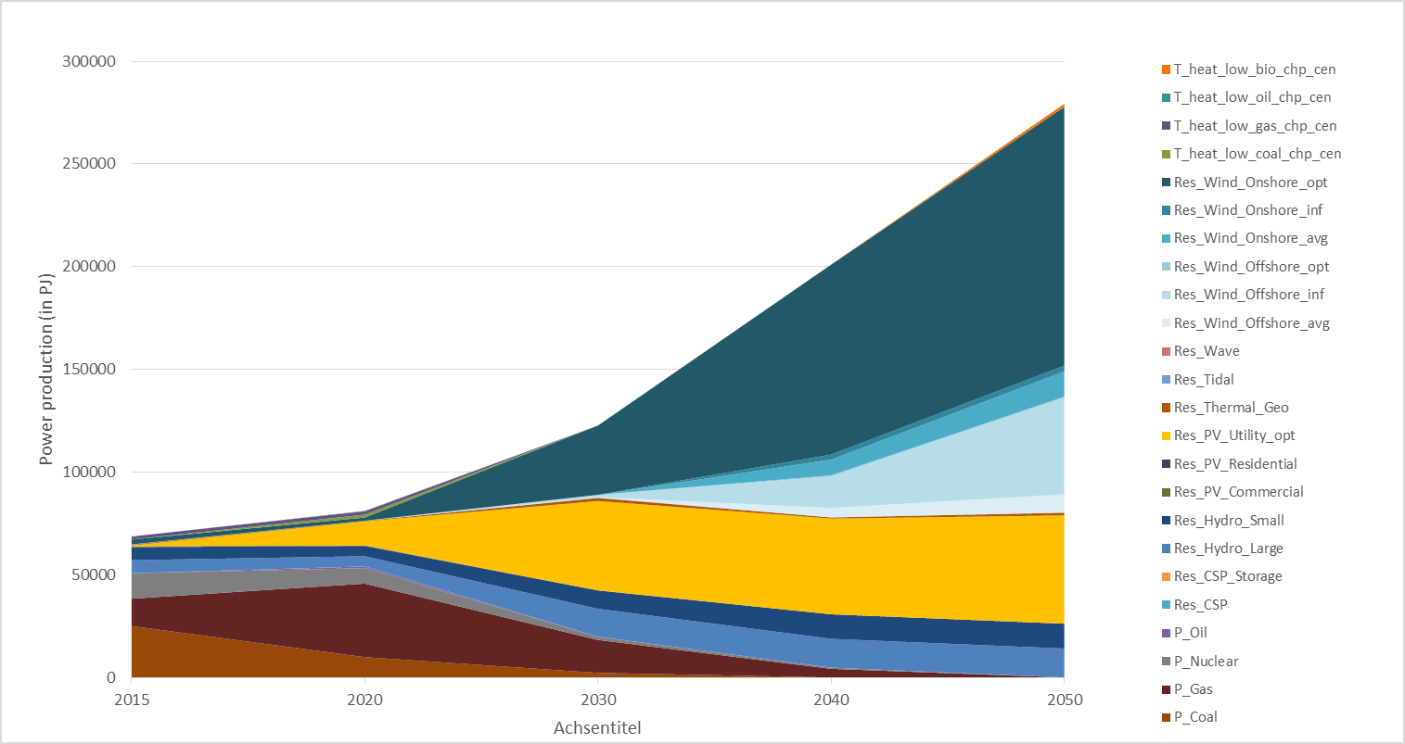
Figure 2: Electricity generation in the EU to 2050
Source: Own results with OSeMOSYS.

Literature
Howells, Mark, Holger Rogner, Neil Strachan, Charles Heaps, Hillard Huntington, Socrates Kypreos, Alison Hughes, et al. 2011. “OSeMOSYS: The Open Source Energy Modeling System: An Introduction to Its Ethos, Structure and Development.” Energy Policy, Sustainability of biofuels, 39 (10): 5850–70. doi:10.1016/j.enpol.2011.06.033.
Noble, Ken. 2012. “OSeMOSYS: The Open Source Energy Modeling System - A Translation into the General Algebraic Modeling System (GAMS).” KTH Royal Institute of Technology - Division of Energy Systems Analysis.
UNFCC. 2015. “Paris Agreement.” United Nations Framework Convention on Climate Change. http://unfccc.int/files/meetings/paris_nov_2015/application/pdf/paris_agreement_english_.pdf.

Strasse des 17. Juni 135, 10623 Berlin, +49 30 314 25377, pyo@wip.tu-berlin.de.

