DIAGNOSTIC METRICS FOR THE ADEQUATE DEVELOPMENT OF EFFICIENT-MARKET BASE-LOAD NATURAL GAS STORAGE
[Ernesto Guzman, PhD Candidate in Mineral and Energy Economics at the Colorado School of Mines, 303.517.2396, guzman.phd@gmail.com]

Overview
This paper develops four metrics to diagnose the adequate development of efficient-market base-load natural gas storage capacity. These diagnostic metrics are developed using the market equilibrium of base-load natural gas storage operations under perfect competition and monopoly environments. The market-equilibrium solutions are obtained from intertemporal choice models. The four diagnostic metrics are (1) market equilibrium of storage capacity investment, (2) price fluctuation, (3) correlation between price and consumption, and (4) correlation between price and inventories. The last two metrics complement the diagnosis from the first two metrics. These metrics are adapted to address seasonal uncertainty, which can be magnified by climate change. FERC can use these metrics to monitor potential and unintended deterrent effects of their own regulatory policies on midstream infrastructure development.

Methods
An intertemporal choice model is built taking an optimal control approach. The model solves for base-load natural gas storage operations handling seasonal demand in one year under two market environments, i.e., perfect competition and monopoly, and varying levels of binding storage capacity. The model solution captures how natural gas market prices, inventories, consumption, and storage flows, all as endogenous results, respond to these changing scenarios. Diagnostic metrics are developed using the parametric solutions from the theoretical storage operations.

Results
The formulation of the four diagnostic metrics is the main result. Nonetheless, the qualitative comparison of the shapes of the market responses predicted by my intertemporal choice model against those observed in the US market is also of interest. Figures 1 and 2 illustrate representative profile shapes for inventories and prices, respectively, originating from the parametric solutions in four stages: (A) injection, (B) binding storage capacity, (C) withdrawal, and (D) stockout. Figures 1 and 2 include profiles under perfect competiton (or social planner) and monopoly when storage capacity is binding (25% NSC) and when it is not (100% NSC). In regards to inventory, Figure 1 shows a bell shape for inventory profile under perfect competition comparable to that at the aggregate level in the US illustrated in Figure 3. The actual inventory profile in Figure 3 is tilted and stretched on the section reaching the peak due to the asymmetry of the seasonal pattern, i.e., the pace of demand change is not the same for every season. In regards to prices, the forward curves in Figure 4 show a clear growth trend and a sesonal component. After the growth trend is removed, the shape of the remaining seasonal component can be evaluated in two sections. As illustrated in Figure 4, the first section contains stages D, A, and B while the second section contains stage C. The first section resembles the first half of the price profile illustrated for a competitive environment with some degree of storage capacity constraint (25\% NSC) in Figure 2. The second section resembles the second half of the price profile illustrated for a competitive environment completely constrained (0\% NSC) in the same figure. These two sections are different not only in shape but also in length. The first section is longer than the second one. Both differences in shape and length can be explained by the actual asymmetry of the seasonal pattern. As low-demand months outnumber high-demand months, injection stage A is widespread allowing a continuous injection that modulates and flattens an otherwise natural gas price drop. On the other hand, peak-demand (or release) stage C is short and intense, which puts significant stress on the overall system capacity beyond storage. During release stage C, other system components beyond storage, i.e., transmission, could constrain the system and prevent the anticipated price modulation. The low injection and high release rates of the seasonal cycle are consistent with the magnitude of the upward and downward slopes illustrated in Figure 3, respectively.

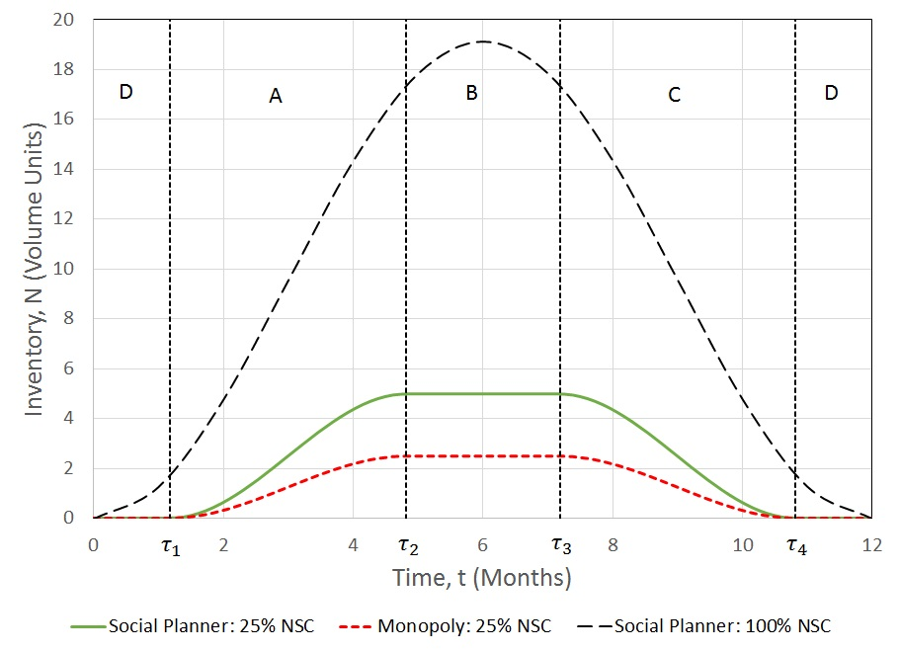 | 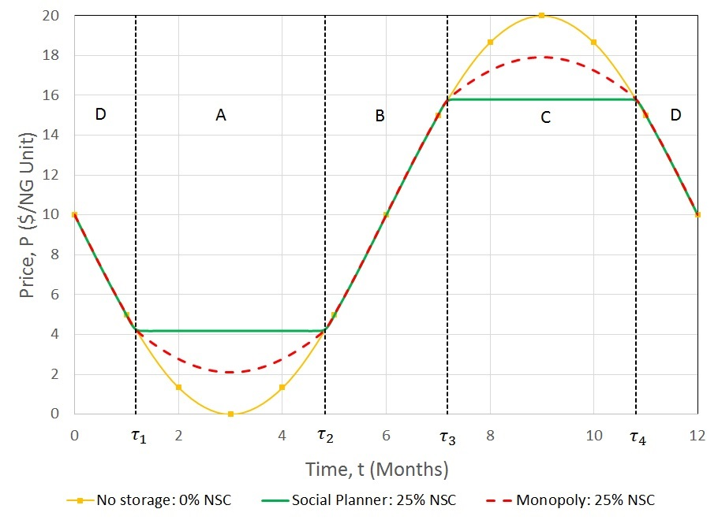
Figure 1: Representative inventory profile shapes. | Figure 2: Representative price profile shapes.
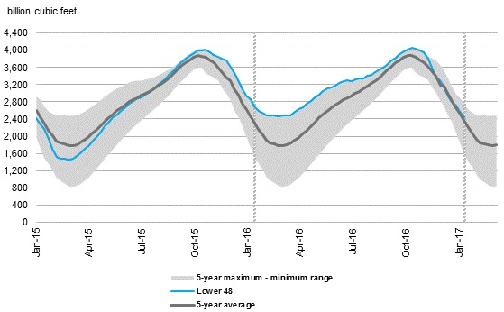 | 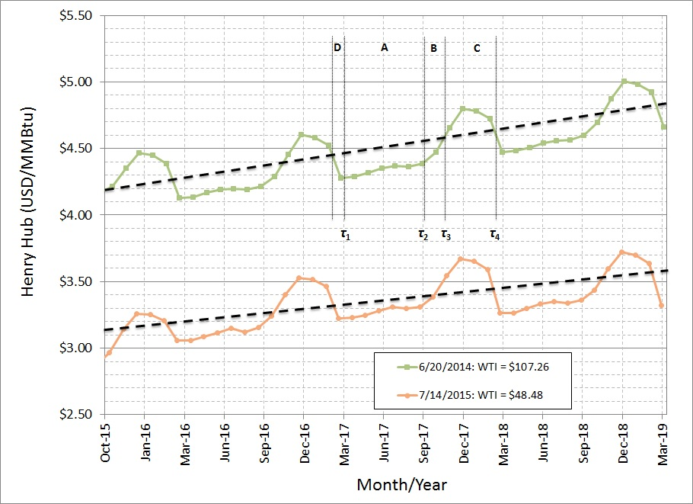
Figure 3: Working gas in underground storage (2015-2016). | Figure 4: Henry Hub forward curves at a recent peak and trough of oil price.

Back to the four diagnostic metrics, they are formulated using benchmarks that are contrasted against actual market observations. The first diagnostic metric is based on the theoretical market equilibrium of storage capacity. Assuming the investment model yields a market equilibrium storage capacity that is 25% of the non-binding level, the storage capacity benchmarks would be the maximum levels achieved by the profiles illustrated in Figure 1. The second diagnostic metric is based on price fluctuation. The benchmarks for this metric are based on the Theoritical Maximum Price Fluctuations (TMPFs) under (1) no storage operation, (2) perfect competition, and (3) monopoly. The third and fourth diagnostic metrics are used to assess the degree of market power in storage operations. The third diagnostic metric is based on the correlation in the short term (one year) between price and natural gas consumption. Thr fourth diagnostic metric is based on the correlation in the short term (one year) between price and inventories. Seasonal pattern uncertainty is introduced to the market equilibrium of the capital investment model and accordingly adjusted in the diagnostic metrics. My paper describes in detail how these four diagnostic metrics are formulated, how they can be implemented, and how they can be adjusted for seasonal pattern uncertainty.

Conclusions
This paper developed four diagnostic metrics to evaluate the adequate efficient-market development of natural gas base-load storage capacity based on economic fundamentals. Seasonal pattern uncertainty, which can be magnified by climate change, was addressed via the market equilibrium of capital investment and accordingly adjusted in the diagnostic metrics. Benchmarks were formulated for each metric using theoretical parametric solutions by market environment, i.e., perfect competition and monopoly, and varying levels of binding storage capacity. Actual values must be contrasted against these theoretical benchmarks. These diagnostic metrics can be used by FERC to monitor potential and unintended deterrent effects of their own regulatory policies on midstream infrastructure development. Based on my model insights, I posit that transmission constraints would explain the asymmetric shape of the Henry Hub forward curve. Future research can test this hypothesis by calibrating my model numerically in GAMS while accounting for storage and transmission capacities. Future research can also adjust my proposed diagnostic metrics to account for the effects of asymmetry of the seasonal patterns.
Note: References cited in my litereature review are provided in my paper.

