Correlated emission reduction measures selection under uncertainty

Jun Yuan, Energy Studies Institute, Phone +65 6516 6752, E-mail: yuanjun@nus.edu.sg

Overview
Shipping is a major contributor to global CO₂ emissions. In order to reduce shipping emissions, various operational and technical measures have been proposed. As it is often not economically feasible to implement all these emission reduction measures, it is important to select the most cost effective set of measures for emissions reduction. However, for the selection of emission reduction measures, there may exist some measures which are not independent. That is the implementation of one measure may influence the abatement and cost of implementing another measure. To provide more appropriate selection results, it is necessary to consider the correlation among these measrues. In addition, there are various uncertainties in evaluating the emission reduction measures. These uncertainties may significantly influence the selection of the emission reduction measures. In this paper, we propose a systematic way to select the correlated emission reduction measures. We further provide a selection under uncertainty method which takes into account the input factors’ uncertainties. This method can support policy makers to rank and select mitigation measures more appropriately.

The paper is organised as follows: After the introduction the model formulation is given in the second section. The third section provides the correlated measrues selection method and the fourth section gives the selection under uncertainty method. In section five a case study is given to illustrate the proposed methods. In the final section conclusions and policy implications are derived.

Methods
There are two objectives to evaluate the emission reduction measures. They are cost and abatemnt. The measure with smaller cost and larger abatement is more cost effective. The emission reduction measures selection problem can be formulated as a multi-objective selection problem.

The marginal abatement cost curve (MACC) is commonly used to rank and select emission reduction measures (Enkvist et al., 2007). However, this type of method is not appropriate for the negative cost-effectiveness (CE) measures (Kesicki and Ekins, 2012). Moreover, the correlation among the emission reduction measures is usually not considered when using the MACC methods. Yuan and Ng (2017) proposed an appropriate method to rank all emission reduction measures. This method handle the problem of inappropriate ranking of negative CE measures for MACC. However, this mehod does not consider the measures correlation. In this paper, a multi-objective selection algorithm is proposed to select the correlated emission reduction measures. This selection method balance the two objectives, cost and abatement, by incorporating the policy maker’s preference. In addition, this selection method is further extended to take into account the uncertainty of input factors. The overall algorithm is provided as follows.

- List all possible comninations of emission reduction measures;
- For each possible combination, compute the total cost and total abatement amount;
- For the combinations with the same number of measures, rank these combinations using the ranking under uncertainty method proposed in Yuan and Ng (2017);
- Select the best combination that can meet the cost and abatement requirement.

The proposed method is further applied to select the shipping emission reduction measures.

Results
The proposed method is used to rank the emission reduction measures in shipping industry. The considered measures are given in Table 1. The data sources are provided in Yuan et al. (2016).

First, all the emission reduction measures are ranked without considering their correlation. The ranking results are shown in Figure 1. However, some measures are correlated with each other which may influence the ranking results. For instance, measure 4 (propeller polishing when required) and measure 5 (propeller polishing (at regular intervals)) are two mutually exclusive measures. That is, if one measure is implemented, the simultaneous implementation of another measure will not increase the abatement amount. Hence, only one measure should be selected among the mutually exclusive measures. Simillary, measures 6 and 7 are mutually exclusive, and measures 10, 11 and 12 are mutually exclusive. Only one measure should be selected within each group. The new ranking resutls using the proposed method that excludes the correlated measures are shown in Figure 2. Compared to Figure 1, it can be found that measures 5, 6, 10 and 12 are excluded in the new ranking results. Therefore, the proposed method can provide more accurate ranking results.

Table 1: Evaluated emission reduction measures for shipping industry
Measure Number | Measure Name
1 | Speed Reduction (due to fleet increase)
2 | Weather Routing
3 | Autopilot Adjustment
4 | Propeller Polishing when Required
5 | Propeller Polishing (at regular intervals)
6 | Hull Coating I
7 | Hull Coating II
8 | Optimization Water Flow of Hull Openings (grids, scallop)
9 | Air Lubrication
10 | Integrated Propeller and Rudder Upgrade
11 | Propeller Upgrade
12 | Propeller Boss Cap with Fins
13 | Main Engine Tuning
14 | Speed Control of Pumps and Fans

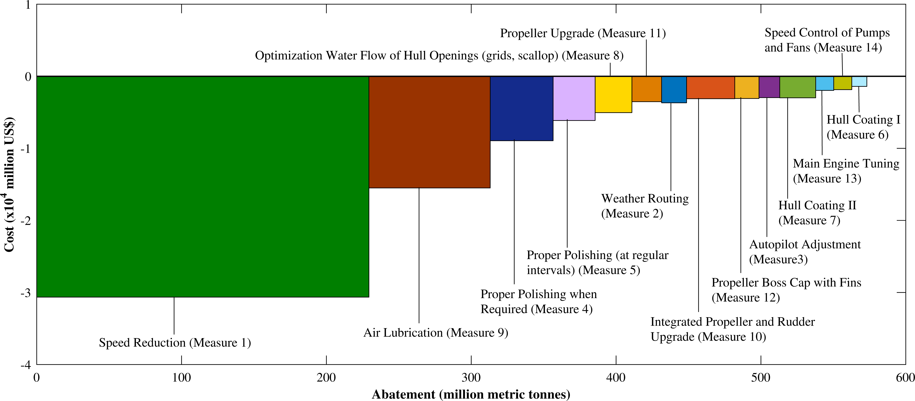

Figure 1: Emission reduction measures ranking without considering their correlation

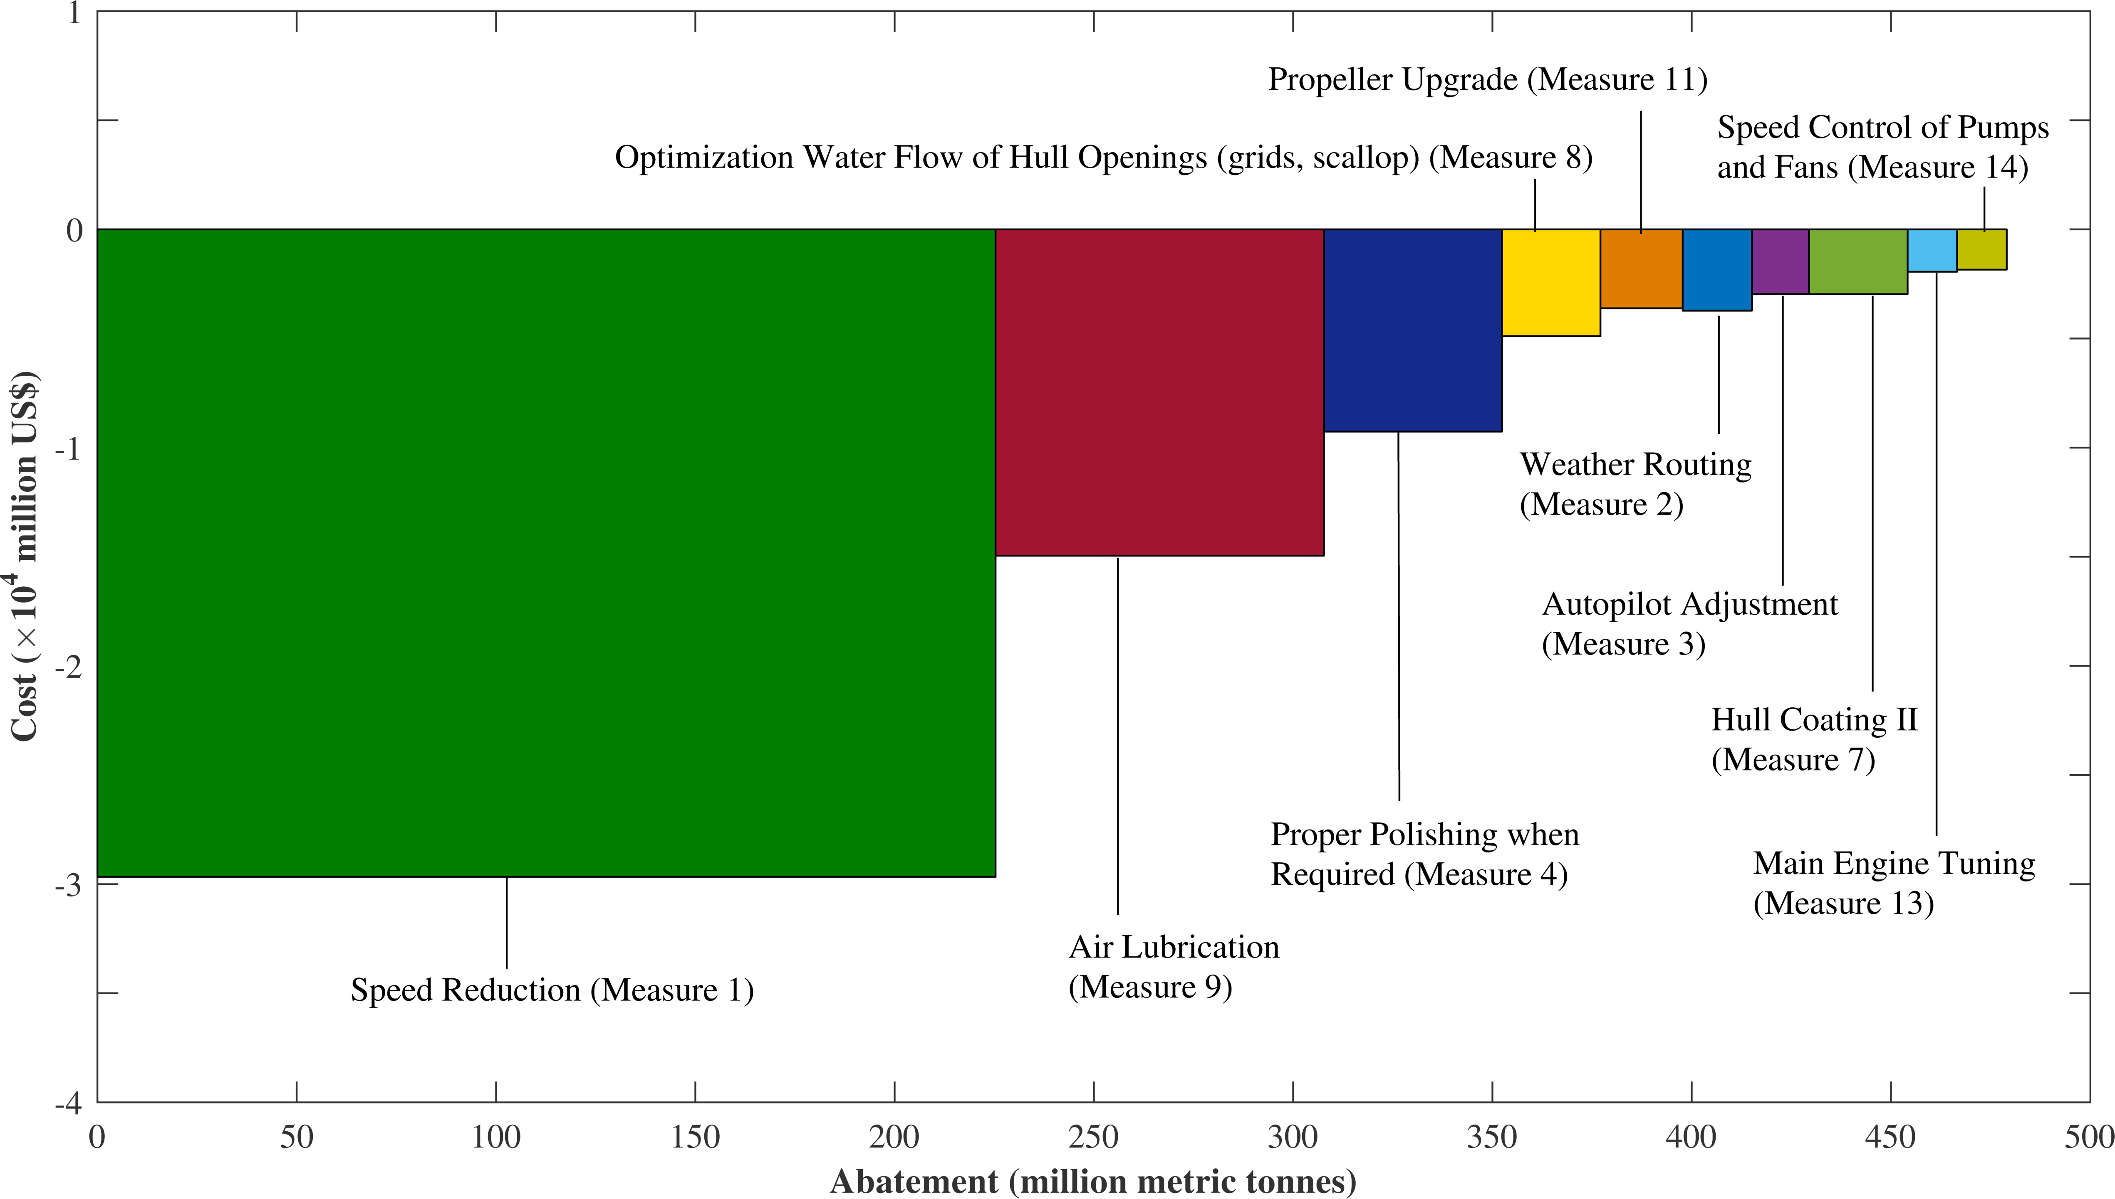
Figure 2: Emission reduction measures ranking considering their correlation

Conclusions
The correlation among emission reduction measures may significantly influence the ranking and selection of the cost effective mitigation measures. In this paper a new method is proposed to rank and select the correlated emissions reduction measures with an application to shipping industry. The resutls indicate that the new method can rank and select the emission reduction measure more appropriately by considering their correlation.

References
Enkvist, P., Nauclér, T., & Rosander, J. (2007). A cost curve for greenhouse gas reduction. McKinsey Quarterly, 1, 34.

Kesicki, F., & Ekins, P. (2012). Marginal abatement cost curves: a call for caution. Climate Policy, 12(2), 219-236.

Yuan, J., Ng, S. H., & Sou, W. S. (2016). Uncertainty quantification of CO 2 emission reduction for maritime shipping. Energy Policy, 88, 113-130.

Yuan, J., & Ng, S. H. (2017). Emission reduction measures ranking under uncertainty. Applied Energy, 188, 270-279.

