Overview

[SOCIAL AWARENESS AND Household CARBON EMISSIONs IN China]
[Jun Li, Research Institute of Economics and Management, Southwestern University of Finance and Economics, China, +86-28-87092878, 2252126100@qq.com]
[Dayong Zhang, Research Institute of Economics and Management, Southwestern University of Finance and Economics, China, +86-15881139915, dzhang@swufe.edu.cn]
As world’s biggest carbon emitter facing clear challenges of balancing its economic growth and environmental responsibility, China needs to design a comprehensive policy mix to control/reduce carbon emission in the next few decades. It has already been a very important topic to study how to reduce emissions in the production sector. However, due to unavailability of fine micro-level data, researches on consumption sector are relatively rare and the existing researches based on aggregate data cannot provide detailed information on households’ behaviour. In fact, emissions from household sector cannot be ignored. For example, Bin and Dowlatabadi (2005) find that household carbon emission accounts for more than 80% of total emission in the US, whereas Baiocchi et al. (2010) show around 74% of carbon emission in the UK is from the household sector. In China, Liu et al. (2011) find that households emission accounts for over 40% in total and this number has been increasing in recent years. Understanding the driving factors of emission from Chinese households is therefore extremely relevant for policymakers.
Existing micro-level studies such as Qu et al. (2013), use a small scale survey to study this issue. Xu et al. (2016) is perhaps the first one using large scale survey to investigate determinants of carbon emission in urban Chinese households. They introduce the idea of carbon inequality and indicate that residential consumption is the main source followed by food and recreation consumption.
This paper contributes to this line of research and aims to study determinants of household carbon emission in China using a unique micro-level dataset: China household finance survey (CHFS). It is a nationalwide survey including both urban and rural residents with very detailed consumption information. The most important contribution of our paper is to focus on subjective measures of Chinese households. It is arguable that awareness of the social/environmental problems will potentially change people’s life styles (for example, Brounen et al., 2013), and consequentially affect carbon emission. People were interviewed in the survey about how much they were aware of social welfare, whether they obeyed social norms and whether they donated to the Wenchuan earthquake. These questions together lead to a general subjective measure of social awareness, which enables us to investigate how much subjective attitude matters in terms of consumption behaviour and its associated emissions.

Methods
The key issue of this study is to measure household carbon emission in different categories. We follow Wei (2007), Qu et al. (2013) and Xu et al. (2016) to calculate direct and indirect emissions of each household. Using input-output methods, total emission from one type of consumption goods is calculated as:
Where there are N types of fossil fuel energy to produce I types of goods/services, is the quantity of energy type k for producing the i^{th} type of goods/services, is the conversion coefficient of fuel type k to tons of standard coal (tce), and is the carbon conversion coefficient for fuel type k per tce.
We follow Wei et al. (2007) to divide household consumption into direct and indirect emissions. The first part includes residential consumption including gas, electricity and other utility expenditures, whereas the second part includes food, clothing, household facilities and services, medicine and medical services, transport and communication services, education, cultural and recreation services. Our key explanatory variables include donate (whether the respondant donated to the 2008 Wenchuan Earthquake in Sichuan province), awareness (whether the respondant pays attention to social and environmental problems), welfare (how the respondant feels about social welfare system), and obey (whether the respondant obeys social norms, i.e. traffic light, wearing safty belt when riding in a car). In order to compare with other existing studies, we also include objective measures such as wealth, family structure, rural/urban residents, and other demongraphic measures.

Results
Figure 1 plots per head carbon emission for urban/rural households in China using CHFS 2011 survey. Clearly urban residents generate significantly higher levels of carbon emission than rural residents. Consistent with other previous studies, residential consumption (direct) is the biggest source of carbon emission, followed by food, education and clothes.
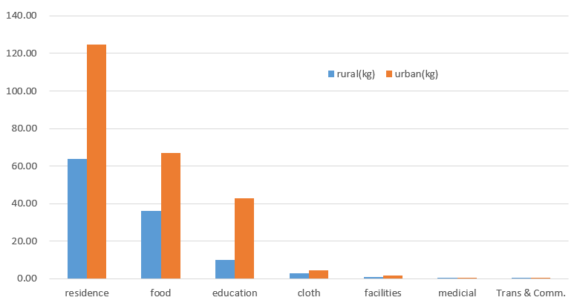
Fig. 1. Average carbon emission from differenct consumption goods/services
Our regression results show that most of the subjective measures do not reduce carbon emission. The only exception is welfare, which significantly reduces carbon emission across all specifications. Although the government has carried on promopting green/low carbon consumption life style, our results suggest that even those who care about social environment do not actually behave accordingly. One possible explanation may come from the theory of consumption smoothing. In other words, deviation from current consumption path can generate large disutility and therefore it is hard to change an individual’s consumption pattern.

Conclusions
Using a nationwide household survey, this paper studies how subjective measures affect household carbon emission patterns. Our results show that individuals, at least at the point of the survey, do not change their consumption behiavors for the purpose of reducing carbon emission. It implies that there is still a long way to go for prompting a low carbon economy/low carbon consumption life style.

References
Bin, S., Dowlatabadi, H., 2005. Consumer lifestyle approach to US energy use and the related CO2 emissions. Energy Policy 33, 197–208.
Brounen, D., Kok, N., Quigley, J.M., 2013. Energy literacy, awareness, and conservation behaviour of residential households. Energy Economics 38, 42--50.
Liu, L., Wu, G. Wang, J., Wei, Y., 2011. China's carbon emissions from urban and rural households during 1992–2007. J. Clean. Prod. 19, 1754–1762.
Qu, J.S., Zeng, J.J. et al., 2013. Household carbon dioxide emissions from peasants and herdsmen in northwestern arid-alpine regions, China. Energy Policy 57, 133–140.
Wei, Y.M., Liu, L.C., Fan, Y., Wu, G., 2007. The impact of lifestyle on energy use and CO2 emission: An empirical analysis of China’s residents. Energy Policy 35, 247–257.
Xu, X.K., Han, L.Y., Lv, X.F., 2016. Household carbon inequality in urban China, its sources and determinants. Ecological Economics 128, 77–86.

