empiricial analysis on vertical and horizontal wells in San Juan Basin
Elmira Kalhor, Department of Economics, University of New Mexico, (505)717-5568, ekalhor@unm.edu
Katie Zemlick, Department of Civil Engineering, University of New Mexico, (505)577-4203, czemlick@unm.edu
Janie Chermak, Department of Economics, University of New Mexico, (505)331-5514, jchermak@unm.edu

Overview
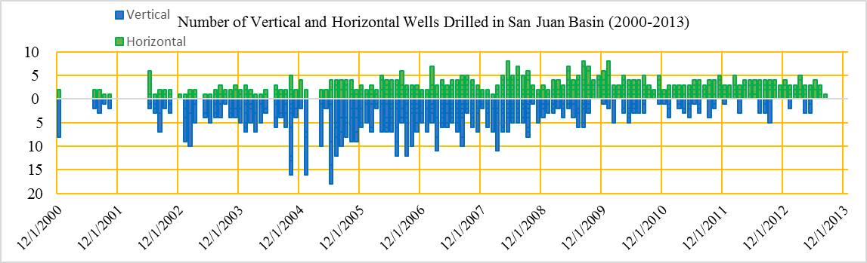
Evidentally, since 1996, there has been an increase in horizontal well drilling in San Juan Basin (SJB), whereas, the vertical well drilling has been on the decline. If this shift in drilling type for recovery from unconventional resources sustains, it will affect the nexus between energy, water, and the economic system in SJB. Two goals are sought in this paper; First, to draw comparisons between the two types of wells in terms of production costs and recovery rate. Second, to use empirical models to estimate the time to undertake recompletion on producing wells. Together, the two objectives improve our state of understanding of future trends in energy production, water use, and economics in SJB.

Methods
Data used in this study are collected from a variety of sources including but not limited to Oil Conservation Division (OCD) of New Mexico, Environmental Protection Agency (EPA), the US Energy Information Administration (EPA), and New Mexcio Energy, Minerals, and Natural Resources Department (EMNRD). The first objective is sought through a statistical analysis of available drilling and production costs along with the production amount at the location of wells. For the second part of this research, an Ordinatry Least Squares (OLS) model is utilized to estimate the time to recompletion. Peak production rate before recompletion, well age, reserve’s type, vertical depth of the well, perforation intervals, estimates of potentially recoverable reserves, recompletion costs, selling price of productin, and the number of wells the operator has in the area are used to estimate the time to undertake recompletion.

Results
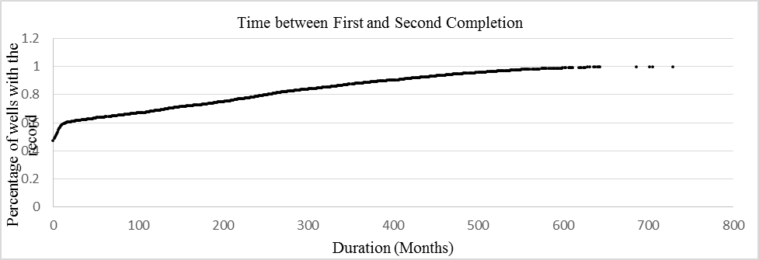
Our preliminary results shows that although the horizontal wells are more expensive to drill, the production rate is higher in the initial years after completion. However, horizontal wells’ production faces a larger draw down in the following years compared to their vertical counterparts.We also expect a tradeoff between the number of existing wells in the basin and the number of new horizontal wells, due to less disturbance to the surface. Regarding the second objective, almost all the horizontal wells undertook at least one re-completion within the first year of their completion wherease over 50% of the vertical wells didn’t have a recompletion until after the first year of production. Among parameters named in the methods section, total vertical depth of the vertical wells was shown to be negatively attributed to the length of time between compeltions. In other words, deeper wells undertook recompletion relatively earlier than the shallower wells. In addition, the longer the perforation interval, the shorter is the time to undertake the recompletion. Selling price of the gas and oil was shown to be a positive driver for recompletion. Our initial results show that other factors are not significant in the estimation of time to recompletion.

Conclusions
We investigate two strategic factors in the nexus between energy and economics in San Juan basin. Our results show that with an increase in horizontal well drilling in San Juan Basin, a boost in oil and gas production can be expected. In this case, the energy will be recoverd at higher rates and in shorter time. Without a recompletion in place, however, the energy production can decline deeply which justifies the costs of recompletion.
Funding for this research was provided by the NSF Award #1345169 and New Mexico’s Experimental Program to Stimulate Competitive Research (EPSCoR).

