The influence of spatial setting and socioeconomic profile in urban areas in the diffusion of residential PV systems.
[Marcello Graziano, Central Michigan University, +1989-774-1627, grazi1m@cmich.edu]
[Maurizio Fiaschetti, SOAS-University of London, +44-0-2078984754, mf51@soas.ac.uk]
[Carol Atkinson-Palombo, University of Connecticut, +1 860-486-3023, carol.atkinson-palombo@uconn.edu ]

Overview

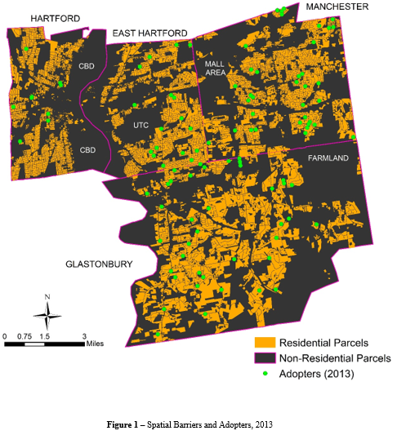
In recent years Connecticut (CT) has been one of the most active states to support the adoption of PV systems, achieving outstanding results in less than a decade. Despite this success, the distribution of PV is still quite uneven across the state because of the combination of metering policies and current incentive design, and the progressive role of peer effects (Graziano and Gillingham, 2015). Within higher-density urban areas such as the CT capital region (Figure 1), the interaction between spatial barriers, and differences across reference peers can distinctively change the patterns of diffusion for PV systems, even with a uniform endowment of solar radiation.

In the present work, we focus on the different profiles of adopters within four towns in CT capital region: East Hartford, Glastonbury, Hartford and Manchester (4-Ts). We draw upon previous studies of Graziano and Gillingham (2015) and Bollinger and Gillingham (2012) to investigate how jurisdictional and built environment characteristics shape the adoption of PV systems, and how their interaction influence spatial peer effects. Additionally, we seek to understand what degree of generalization can be reached by analysts when studying social and spatial drivers to adoption of PV systems.

Methods
Methodologically, we employed three connected methodologies for investigating the social and spatial determinants of PV adoption in the 4-Ts. First, we built the most comprehensive parcels dataset available for CT, and utilize spatial inference to investigate the distribution of PV systems relative to spatial barriers (Figure 1). Secondly, we employ hierarchical cluster analysis (HCA) (Bridges, 1966; Blashfield, 1976) to identify the major determinants of adopters’ profile in each of the 4-Ts based on the original set of variables used by Graziano and Gillingham (2015). Our specifications can be parsimoniously stated as:
PVcount _{i},t = α + Ni,t β + Bi,t γ + Di,t θ + μi + ψt + εi,t
where PVcount_{i,t} is the number of new adoptions in block group i at time t; Ni,t is the vector of spatiotemporal variables built by Graziano and Gillingham; B_{i,t} is the vector of built environment variables; D_{i,t} is a vector of socioeconomic and demographic variables; μi are block group fixed effects; ψ_{t} are time dummy variables; and ε_{i,t} is a mean-zero error term. Compared to the work of Graziano and Gillingham, we expect the maximum spatiotemporal variables to be significant within a shorter distance. This expectation accounts for the relative size of the study area: four miles would equal the diameter of the largest of the towns (Glastonbury), thus extending the neighborhood effects to the whole town. This approach is consistent with the previous findings (e.g. Graziano and Gillingham, 2015).

Results
The pattern of PV diffusion is clearly clusterized within historic neighborhoods, and cross-neighborhood influence appears limited within each town because of the effect of spatial barriers (Figure 1). These influences mean that policymakers can craft peer-based policies (e.g. Solarize) upon historic neighborhoods boarders as well as residential continuity.
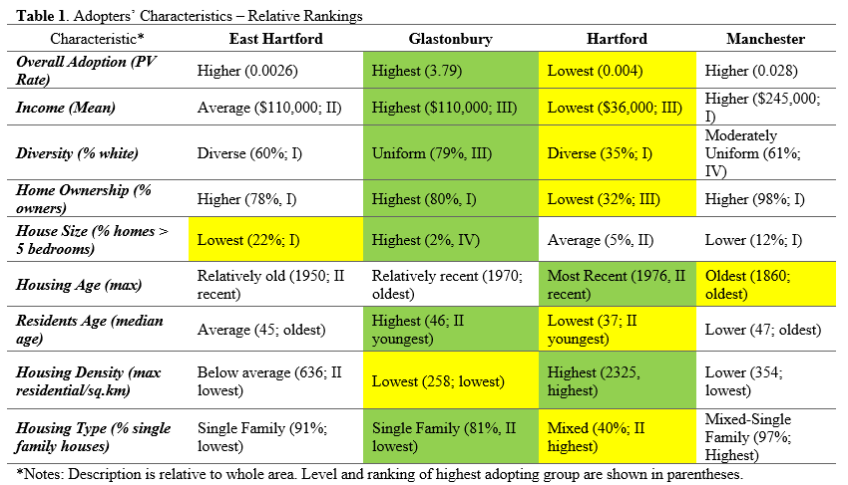
The profile of the potential adopters’ changes between towns, with Hartford and Glastonbury providing two quite interesting contrasting profiles in terms of area geography and socioeconomic status, independently of the degree of market penetration (i.e. adoption rate relative to the diffusion curve) of the PVs (Table 1).

The effective distance of spatial peer effects is further reduced compared to previous works, owing to the higher population and housing density within the 4-Ts region compared to CT as a whole (Table 2). While peer effects still operate at shorter distances, share of minority usually associated with lower adoption patterns only affect adoption when interacted with proximity itself. Further, no significant influence is exercised by the built environment within these models, which suggest further research might be needed, through the application of spatial models. Note: Static models use a standardized value of new PV as d.v.

Conclusions
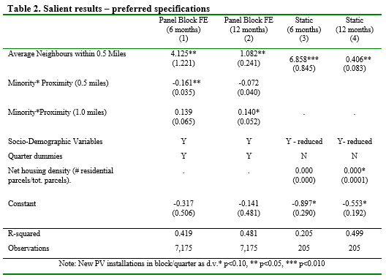
Policy-relevant findings based on current results, and future research include:
- Social-demographic diversity in inner-city areas and metro areas, which poses challenges for implementing equitable outreach policies to support diffusion of PVs;
- Spatial peer-effects still operate within heavily built, inner-city areas, although it becomes difficult to identify these effects due to emergence of social interactions at lower distances;
- Spatial and network research need to interact more at a methodological level, implementing transdisciplinary, mixed-methods approaches for carefully isolating each effect, and support more efficient support policies;
- Ongoing research, which will be included in an expanded version of the present work, will include employing SAR/SEM/SAC models for improving the understanding of the spatial elements (e.g. built environment) affecting the diffusion processe of PV systems.
References
Blashfield, R.K. (1976) Mixture Model Tests of Cluster Analysis: Accuracy of Four Agglomerative Hierarchical Methods. Psychological Bulletin, 83(3): 377-388.
Bollinger, B., Gillingham, K. (2012) Peer Effects in the Diffusion of Solar Photovoltaic Panels. Marketing Science, 31(6): 900-912.
Bridges Jr., C.C. (1966) Hierarchical Cluster. Psychological Reports, 18: 851-854.
Graziano, M., Gillingham, K. (2015) Spatial Patterns of Solar Photovoltaic System Adoption: The Influence of Neighbors and the Built Environment. Journal of Economic Geography, 15(4): 815-839.

