Policy Uncertainty and Real Options in Switching of Peak Generators

Stein-Erik Fleten, Norwegian University of Science and Technology, +4746694793, stein-erik.fleten@iot.ntnu.no
Marius Johansen, Norwegian University of Science and Technology, +4799369926, johans.mar@gmail.com
Alois Pichler, Norwegian University of Science and Technology, +4746164828, alois.pichler@iot.ntnu.no
Carl J. Ullrich, James Madison University, +1 (540) 553-1907, ullriccj@jmu.edu

Overview

This paper examines empirically how economic factors, government policy, and strategic interactions affect managers decisions to switch between operating and stand-by states for peaking electric power generators. We model the switching decisions using a structural model of a dynamic decision game. We focus on the power markets in the Northeastern United States, where annual observations of such decisions are available. The results indicate that regulatory uncertainty significantly increases firms’ perception of switching costs, and that large power producers are noticeably more influenced by their economic environment during their decision-making than small firms.
We consider that a peak generator is always in one of three operating states: 1) Operating state (OP), where the generator has the ability to initiate production on short notice, but is not required to actually produce electricity. It holds the option to shut down to the stand-by state. 2) Stand-by state (SB), where the generator saves on maintenance costs but foregoes revenues as it cannot initiate production. It holds the options to enter the operating or retirement state for an irreversible, one-time investment cost. 3) Retired state (RE), where the generator is abandoned and cannot become operational again. Thus, switching options include starting up (SB→OP), shutting down (OP→SB) and retiring (SB→RE).
Understanding switching dynamics in peak power plants is important because these kinds of plants ensure reliability in the power market. Knowledge about switching and maintenance costs is useful in the design of capacity markets that aim to entice these kinds of generators to be ready to supply power. And estimating these costs is challenging given that switches can happen less than once per year. Regulators sense the urgency of such mechanisms when increased renewable generation capacity erodes profitability of fossil fuelled plants such as peak generators.
We contribute to the literature by uncovering the links between economic factors (profitability per unit of capacity, level of uncertainty of the spark spread, projected reserve margin, a measure of local competition, and a measure of regulatory uncertainty) and the costs of switching. Further, we investigate whether or not generators take into account the switching actions of their competitors when making their own switching decisions. Finally, we evaluate whether or not payments from the young capacity markets affect the generators’ susceptibility to these economic factors using temporal sample splits. Firm size effects are similarly addressed.

Methods

Our primary data source is the annual filing of form 860 to the U.S. Energy Information Administration. This form contains information about operating status, and we focus on peak generators in the Northeastern United States from 2001 to 2011. Projected reserve margin is from North Americand Electricity Reliability Council’s Electricity Supply and Demand database. Commodity prices are collected from NYMEX and the wholesale electricity market operators’ websites; PJM, ISO-NE and NYISO. Data comprises 21 U.S. states, and there are 13,078 generator-year observations of switching decisions – where not switching operating state is also counted. See fig. 1.
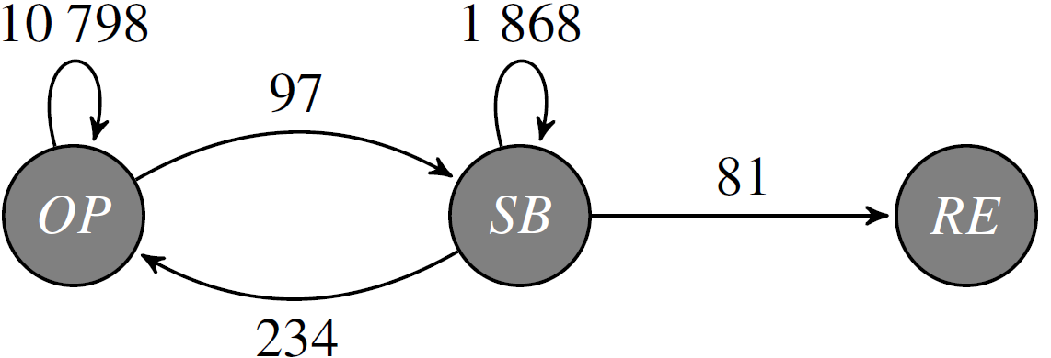
Fig. 1: Switching decisions observed in our dataset.
Our most interesting state variable affecting switching decisions is the level of regulatory uncertainty. When building this (binary) variable we study the retail deregulation process, if any, in each state over time. This builds on qualitative data published by the EIA. The idea is that uncertainty on whether, and how, retail competition will be implemented in a state, affects decisions on power plants, which will be subject to competition rather than rate-based remuneration. We consider the regulatory uncertainty to be high if there is a political investigation into retail market restructuring, or if such restructuring is recommended. The latter case still has uncertainty regarding the rules of the game, that is, exactly how the market will be organized in the state. See also Fleten, Haugom and Ullrich (2012).
We employ structural estimation, building on Fleten, Haugom, Pichler and Ullrich (2016), which aims at estimating parameters that are hidden within a dynamic decision model. We assume the 332 owners make switching decisions according to a Brennan-Schwartz (1985) type real options model in discrete time.

Results

The results indicated that the decision-making of power producers is greatly influenced by real option waiting effects. Regulatory uncertainty increases the perceived switching costs. Uncertainty of the profit of a peak generator has a similar impact.
Several capacity markets have been established in the United States post 2008. We find few effects of these markets, however, the projected reserve margin ceases to be a significant influence on the switching costs after the introduction of capacity markets.
Large utilities are found to be far more responsive to economic factors than smaller firms. Our results indicate that large firms consider the strategic interaction with nearby competitors when making switching decisions, particularly for shutdown decisions. The same utilities are found to be influenced by projections of next year’s reserve margin when deciding to shut-down or retire its generators. None of these effects are found for small firms.

Conclusions

This paper examines empirically how economic factors, government policy and strategic interactions affect thermal peak generator’s decisions to switch between operating and stand-by states. Specifically, it shows that the economic environment influence a plant manager’s perception of the costs associated with such switching decisions. There are notable real options waiting effects from policy uncertainty.
On the other hand, a significant portion of the generating capacity in the market is controlled by smaller firms that might not necessarily supply peak capacity from financial incentives. This is relevant for regulators who want to create incentives for supply of such capacity.

References

Brennan MJ, Schwartz ES. Evaluating natural resource investments. Journal of Business. 1985 Apr 1:135-57.
Fleten SE, Haugom E, Ullrich CJ. Keeping the Lights On Until the Regulator Makes Up His Mind! Midwest Finance Association 2012 Annual Meetings Paper.
Fleten SE, Haugom E, Pichler A, Ullrich CJ. Nonparametric Structural Estimation of Operational Switching Options. Working Paper, Norwegian University of Science and Technology, 2016.

