FRAMEWORK FOR DECISION-MAKING PROCESS IN GRANTING RIGHTS TO USE HYDROPOWER IN THE EUROPEAN CONTEXT
Gaudard Ludovic, University of Geneva and Imperial College London, ludovic.gaudard@unige.ch
Hediger Werner, HTW Chur, werner.hediger@htwchur.ch
Romerio Franco, University of Geneva, franco.romerio@unige.ch
Voegeli Guillaume, HTW Chur and University of Geneva, guillaume.voegeli@htwchur.ch

Overview
As highlighted by Glachant et al. [2014], Europe represents a manifold panorama of granting rights to use hydropower. The contract type as well as the constraints and conditions significantly vary from country to country, while the same market rules govern all the electricity suppliers in Europe. To avoid any infringement of the competition laws, the granting of water rights should be equivalent and comparable between entities having access to the market. Finally, the attribution process has to give priority to the most sustainable projects. Indeed, sustainable development has become an underlying target and key political principle for a large amount of decision makers worldwide (Rametsteiner, Pülzl, Alkan-Olsson, & Frederiksen, 2011).
This paper proposes a process to select the best project following the requirements stated above (equivalence in water rights access and highest sustainability of projects). The new European Union directive 2014/25, which enters into force in April 2016, provides a general framework (European Parliament and Council, 2014). However, it does not address the rights to use hydropower specifically. This paper aims to bridge the gap between the directive and the concrete case of attributing water rights to use hydropower.

Method
The proposed process is based on decision-making methods that involves successive steps. It allows the decision makers to discard the suboptimal projects that do not fulfil the requirements of the different specific steps. The procedure of each step requires specific financial and time means. In those conditions, the decision-making process must find a compromise between effectiveness and efficiency, as required by the directive 2014/25 itself. The core principle of the proposed process is to bring first the least time and financial costly steps, in order to reduce the valid projects that will be finally assessed, and therefore relatively reduce the mentioned costs.
While each assessment step needs distinct methods, two of them require an in-depth development; the estimation of the water resource rent (Banfi and Filippini, 2009; Amundsen et al., 1992) and the sustainability assessment of the projects (Bond et al., 2012). The state of the art is firstly provided, since the most suitable method may depend on the institutional context and data available, which vary between European countries.
The price of the water rights to use hydropower must theoretically equal the water resource rent. An inadequate estimation leads to a suboptimal allocation of resources and challenges a fair access to the electricity market. The rent being site and plant-design specific (IEA, 2015), generic assessment methods are challenging. We suggest considering a real option approach since the water right can be considered as an option (Gaudard, 2015; Dixit and Pindyck,1994). However, the main challenge remains in addressing the related risk and uncertainty.
New energy projects have to be ensured to be sustainable (Hugé, Waas, Eggermont, & Verbruggen, 2011) and, in order to evaluate the progress toward sustainability transition, goals have to be assessed (Ness, Urbel-Piirsalu, Anderberg, & Olsson, 2007). There are many definitions and methods for assessing sustainability (Bond et al., 2012). While all of them afford specific and various outcomes, data available will affect the methodology. We suggest proceeding to an iteration process between project-concerned stakeholders and analysts, but also between the stakeholders themselves. We believe integration of stakeholders is essential in several steps of the decision making process. It allows us to confirm, remove or adapt the indicators to the specificities of the project or area concerned (Shortall, Davidsdottir, & Axelsson, 2015), as those indicators will form the basis of the assessment. Moreover, the stakeholders are essential to assess the weighting of indicators, in order to investigate trade-offs between miscellaneous aspects of hydropower projects. This step, if based on a comparative basis, aims to identify the most optimal project that can be implemented. From a more global perspective, the proposed method has to be flexible enough to address site-specific issues, while still providing a reliable tool that ensures an equivalent process in each different case.
Finally, the process must prevent any strategic behaviour. The robustness of our proposal is tested regarding this specific aspect. We consider a mixed method, using both quantitative and qualitative data. The method used will be designed with the aim to prevent such behaviour (Creswell and Plano Clark, 2011).

Results
This paper will present a process to grant rights to use hydropower. The preliminary general process is presented in Figure 1. Our research focuses mostly on steps 6 and 9, respectively rent value and sustainability assessment. We make the hypothesis that the penultimate step is the most costly, both in terms of time and financial means. This embodies the reason why it is last in the process, as we try to eliminate sub-optimal projects previously to this step. A case study in Switzerland will be used in order to discuss our results.
Figure 1: Preliminary proposal for decision makers in attribution to grant water rights to a third party
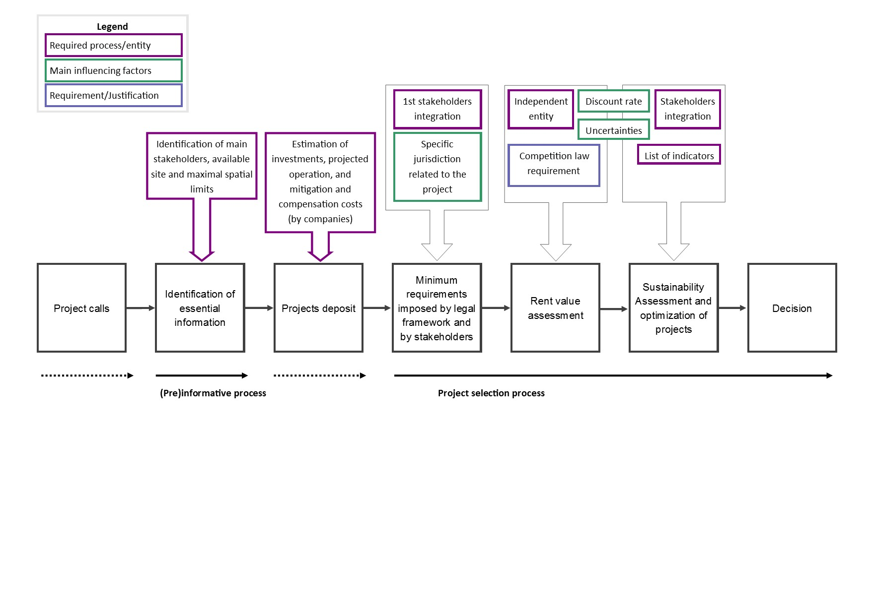

Conclusion

The granting of rights to use hydropower is becoming topical in several European countries. An inadequate granting process can indirectly distort access to the electricity market, thus leading to inefficiency of resource allocation. The sustainability of the project must also be assessed and ensured, in order to be in line with energy transition policies. Those two specific goals form the basis of our framework, and therefore are ensured to be considered as essential objectives. This framework is compared on a case study in Switzerland, in order to verify its applicability.

References
Amundsen E.S., Andersen C. and Sannarnes J.G. (1992), Rent Taxes on Norwegian Hydropower Generation, The Energy Journal 13(1), 97-116.
Banfi S. and Filippini M. (2009), Resource Rent Taxation and Benchmarking – A New Perspective for the Swiss Hydropower Sector, CEPE working paper No. 67,
https://www1.ethz.ch/cepe/publications/workingPapers/CEPE_WP67.pdf (site accessed on January 6th).
Bond, A., Morrison-Saunders, A. and Pope, J. (2012). Sustainability assessment: the state of the art. Impact Assessment and Project Appraisal 30(1), 53–62. doi:10.1080/14615517.2012.661974
Dixit, A. and Pindyck, R. (1994). Investment under uncertainty. Princeton University Press.
Creswell, J. and Plano Clark, V. (2011). Designing and conducting mixed methods research (2nd edition). SAGE Publications.
European Parliament and Council (2014), Directive 2014/25/eu of the European Parliament and of the Council of 26 February 2014 on procurement by entities operating in the water, energy, transport and postal services sectors and repealing directive 2004/17/ec, http://eur-lex.europa.eu/legal-content/FR/TXT/?uri=celex%3A32014L0025 (site accessed on January 6, 2016).
Gaudard L. (2015). Pumped-storage project: A short to long term investment analysis including climate change, Renewable and Sustainable Energy Reviews 49, 91-99.
Glachant, J.-M., Saguan, M., Rious, V., Douguet, S. and Gentzoglanis, E. (2014), Regimes for granting rights to use hydropower in Europe, European University Institute, Florence. Hugé, J., Waas, T., Eggermont, G., & Verbruggen, A. (2011). Impact assessment for a sustainable energy future-Reflections and practical experiences. Energy Policy 39(10), 6243–6253. doi:10.1016/j.enpol.2011.07.023
Ness, B., Urbel-Piirsalu, E., Anderberg, S., & Olsson, L. (2007). Categorising tools for sustainability assessment. Ecological Economics 60(3), 498–508. doi:10.1016/j.ecolecon.2006.07.023
Rametsteiner, E., Pülzl, H., Alkan-Olsson, J., & Frederiksen, P. (2011). Sustainability indicator development-science or political negotiation? Ecological Indicators 11(1), 61–70. doi:10.1016/j.ecolind.2009.06.009
Shortall, R., Davidsdottir, B., & Axelsson, G. (2015). Development of a sustainability assessment framework for geothermal energy projects. Energy for Sustainable Development 27, 28–45. doi:10.1016/j.esd.2015.02.004

