optimal portfolios for risk-averse generators
Vitali Avagyan, Imperial College Business School & Department of Computing, +447742071653, v.avagyan12@imperial.ac.uk
Richard Green, Imperial College Business School, +442074952611, r.green@imperial.ac.uk

Overview
Techniques for finding the profit-maximising set of generating plants in a competitive electricity industry that does not face uncertainty are well known, and equivalent to the social planner’s cost-minimising combination. We ask whether this equivalence also exists in the face of uncertain fuel prices and demand, or whether companies will systematically under-expose themselves to a particular technology (such as nuclear power). Green (2008) constructed optimal company-level portfolios of coal, gas and nuclear stations but against a fixed capacity mix. In this paper we seek to find an industry-wide capacity mix that can be broken down into optimal portfolios for risk-averse companies, and to show how this varies with the level of risk aversion and uncertainty.
We look at the generating companies with symmetric marginal-cost supply function and the same level of risk aversion. It is important to note that since no firm has market power, marginal changes in capacity levels are assumed not to affect the profitability and risk levels of technologies or the correlations among them.
Firstly, this paper reviews some relevant literature in the area to put it onto the theoretical grounds. Secondly, the modelling of generating profit risk and optimal portfolio selection is presented. Finally, the paper concludes with the discussion of received results and potential future directions.

Methods

Recent approaches on optimisation of electricity generation mix have focused on portfolio optimisation theory since many investment decisions in the electricity industry are made mostly by large existing generating companies (in Great Britain, the so-called Big Six: British Gas, EDF Energy, E.ON UK, npower, Scottish Power, SSE), that wish to maximise some combination of their expected profits for a given risk level across their entire portfolio of plants given uncertain future conditions. Though it would seem counter-intuitive, including more expensive renewables in the portfolio may actually decrease the cost of the entire portfolio since that cost depends not only on individual costs of technologies but the cost correlations among them (Awerbuch, 2006). The more the investor is risk averse, the more the investor gives weight to minimising risk vis-a-vis maximising profit/return. Generators’ risk preferences create various optimal portfolios with different plant mixes, and hence it is in line with the government’s aim in the context of Capacity Mechanism to encourage all types of technologies to be present in the industry’s generating mix (DECC, 2011).
Using a merit order stack model, it is straightforward to show optimal plant mix without uncertainty. We let demand and fuel prices vary to calculate profit distributions for a range of portfolios. Palisade's @Risk Excel add-in does simulation optimisation to find optima for mean-variance utililty function.
During an optimization a number of trial solutions are generated and a genetic algorithm is used to continually improve the results of each trial. For each trial solution, 10,000 Monte Carlo simulations are run, sampling probability distribution functions and generating a new mean-variance utility value for the portfolio - it is run continously unless the optimal portfolio is found within an error tolerance (see Figure 1).
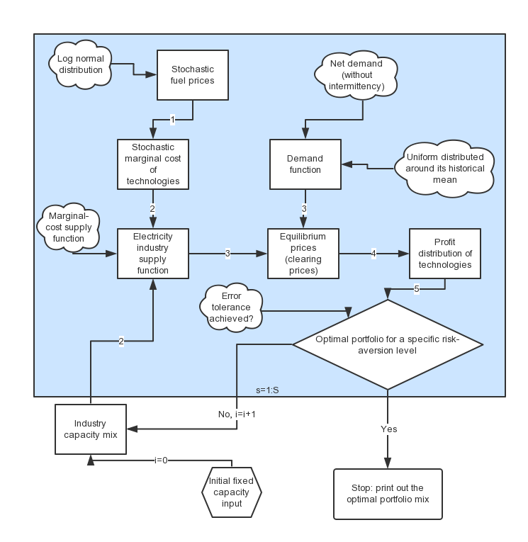

Figure 1

Results
This is work-in-progress and we do not have all the results to report yet. However, we expect gas-fired stations to be the most profitable option for the investors whenever there is no carbon constraint. Their costs are correlated with the prices of electricity yielding less variable profits than other technologies. The impact of carbon prices would raise the profits gained from nuclear power plants but would not reduce the volatility of their profits as long as the prices of electricity are positively correlated with the prices of gas. Firstly, we will gain firm-level optimisation results and, secondly, social-level optimisation results and we will carry out sensitivity analysis for optimal portfolios for the range of risk-aversion levels and carbon costs .

We expect to find that profit-maximising companies will under-invest in nuclear power compared to gas-fired stations in the presence of uncertainty and risk aversion. This result was foreshadowed by Roques et al (2006), but on the basis of assumed correlations between fuel and electricity prices: we will reinforce their work by showing the extent of the under-investment when power prices are endogenous and as uncertainty and risk-aversion vary.

Conclusions
We have created a simple modelling technique that can be used for easy simulation of an electricity market, also allowing large numbers of Monte Carlo trials, to capture the effects of uncertainty. We hope that the results on optimal portfolios will be of use to policy-makers as well as to the energy industry experts in general.
Fuel price and demand uncertainties have a huge impact on industry portfolio mix. This gives a policy maker an understanding of what risk-aversion levels for generators’ we should have to make sure all generating technologies are present in 2020 – a significant milestone in UK decarbonisation policy. Moreover, we also analyse carbon price levels that all technologies are present in the industry.

References
Awerbuch, S. (2006). Portfolio-based electricity generation planning: policy implications for renewables
and energy security. Mitigation and adaptation strategies for Global Change, 11(3):693–710.

Department of Energy and Climate Change (DECC) (2011). Planning our electric future: a white paper
for secure, affordable and low carbon electricity.

Department of Energy and Climate Change (DECC) (2013). DECC fossil fuel price projections.

Green, R. (2008). Carbon tax or carbon permits: the impact on generators’ risks. The Energy Journal,
pages 67–89.

Roques, F. A., Nuttall, W. J., Newbery, D. M., de Neufville, R., & Connors, S. (2006). Nuclear power: a hedge against uncertain gas and carbon prices?. The Energy Journal, 1-23.

