Overview

HISTORICAL CONSTRUCTION COSTS OF GLOBAL NUCLEAR POWER

Arthur Yip, Breakthrough Institute, 857 600 2288, arthurhy@andrew.cmu.edu
Jessica Lovering, Breakthrough Institute, 510 550 8800 x300, jessica@thebreakthrough.org
Ted Nordhaus, Breakthrough Institute, 510 550 8800 x305, ted@thebreakthrough.org
The construction cost of nuclear power reactors is of vital importance to the future of the nuclear industry and to climate change mitigation efforts at large. Cost estimates for future nuclear power are among the most important inputs to energy system models and climate mitigation scenarios (Leibowicz et al, 2013; Bosetti et al, 2015; Barron & McJeon, 2015). Analyzing the historical experience has been a common approach to help understand the prospects and challenges on nuclear power. Past studies (Thomas, 1988; Mackerron, 1992; Koomey & Hultman, 2007; Escobar-Rangel & Lévêque, 2015) have documented dramatic cost escalation and have even identified the presence of “negative learning-by-doing”, suggesting an “intrinsic” or inevitable increase in costs (Grubler, 2010). These results have played a role in informing integrated assessment modellers and policy makers (Neij, 2008; Junginger et al, 2010; Harris et al, 2013; Azevedo et al, 2013).
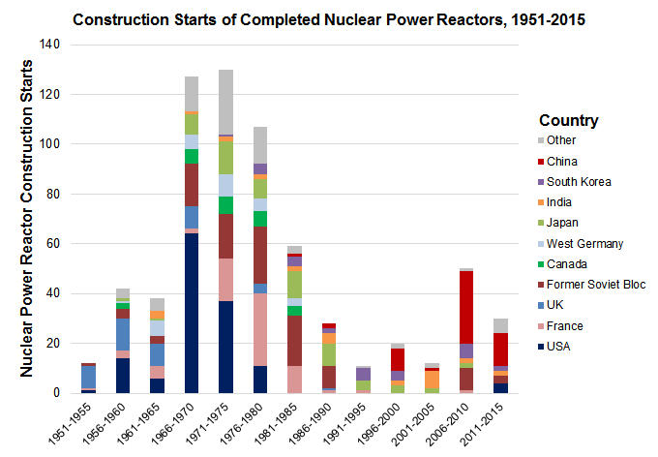
We find that the existing literature focuses narrowly on specific time periods or countries, specifically the US and France in the 1970-80’s. The 157 reactors studied by Koomey & Hultman (2007) and Escobar-Rangel & Lévêque (2015) in these two countries (out of the 31 countries with nuclear power today) only represent 26% of the total number of completed reactors. This provides an incomplete picture of the economic evolution of nuclear power construction. We introduce new data that broadens the scope of study, covering earlier, recent, and international experience in nuclear reactor construction. We present a more comprehensive and complicated picture of cost trends that describe more variation and uncertainty in nuclear power construction cost trends than has been previously claimed.

Methods
This study rigourously curates historical reactor-specific overnight construction cost (OCC) data, especially those that have been neglected in the literature. We provide a comprehensive and up-to-date review, analysis, and comparison of the full cost history in the US, France, Canada, West Germany, Japan, India, and South Korea, using data from the IAEA and other sources by country. We re-assess the apparent lack of learning-by-doing in nuclear power construction. We also investigate the role of the Three Mile Island and Chernobyl accidents on OCC and construction durations.

Results
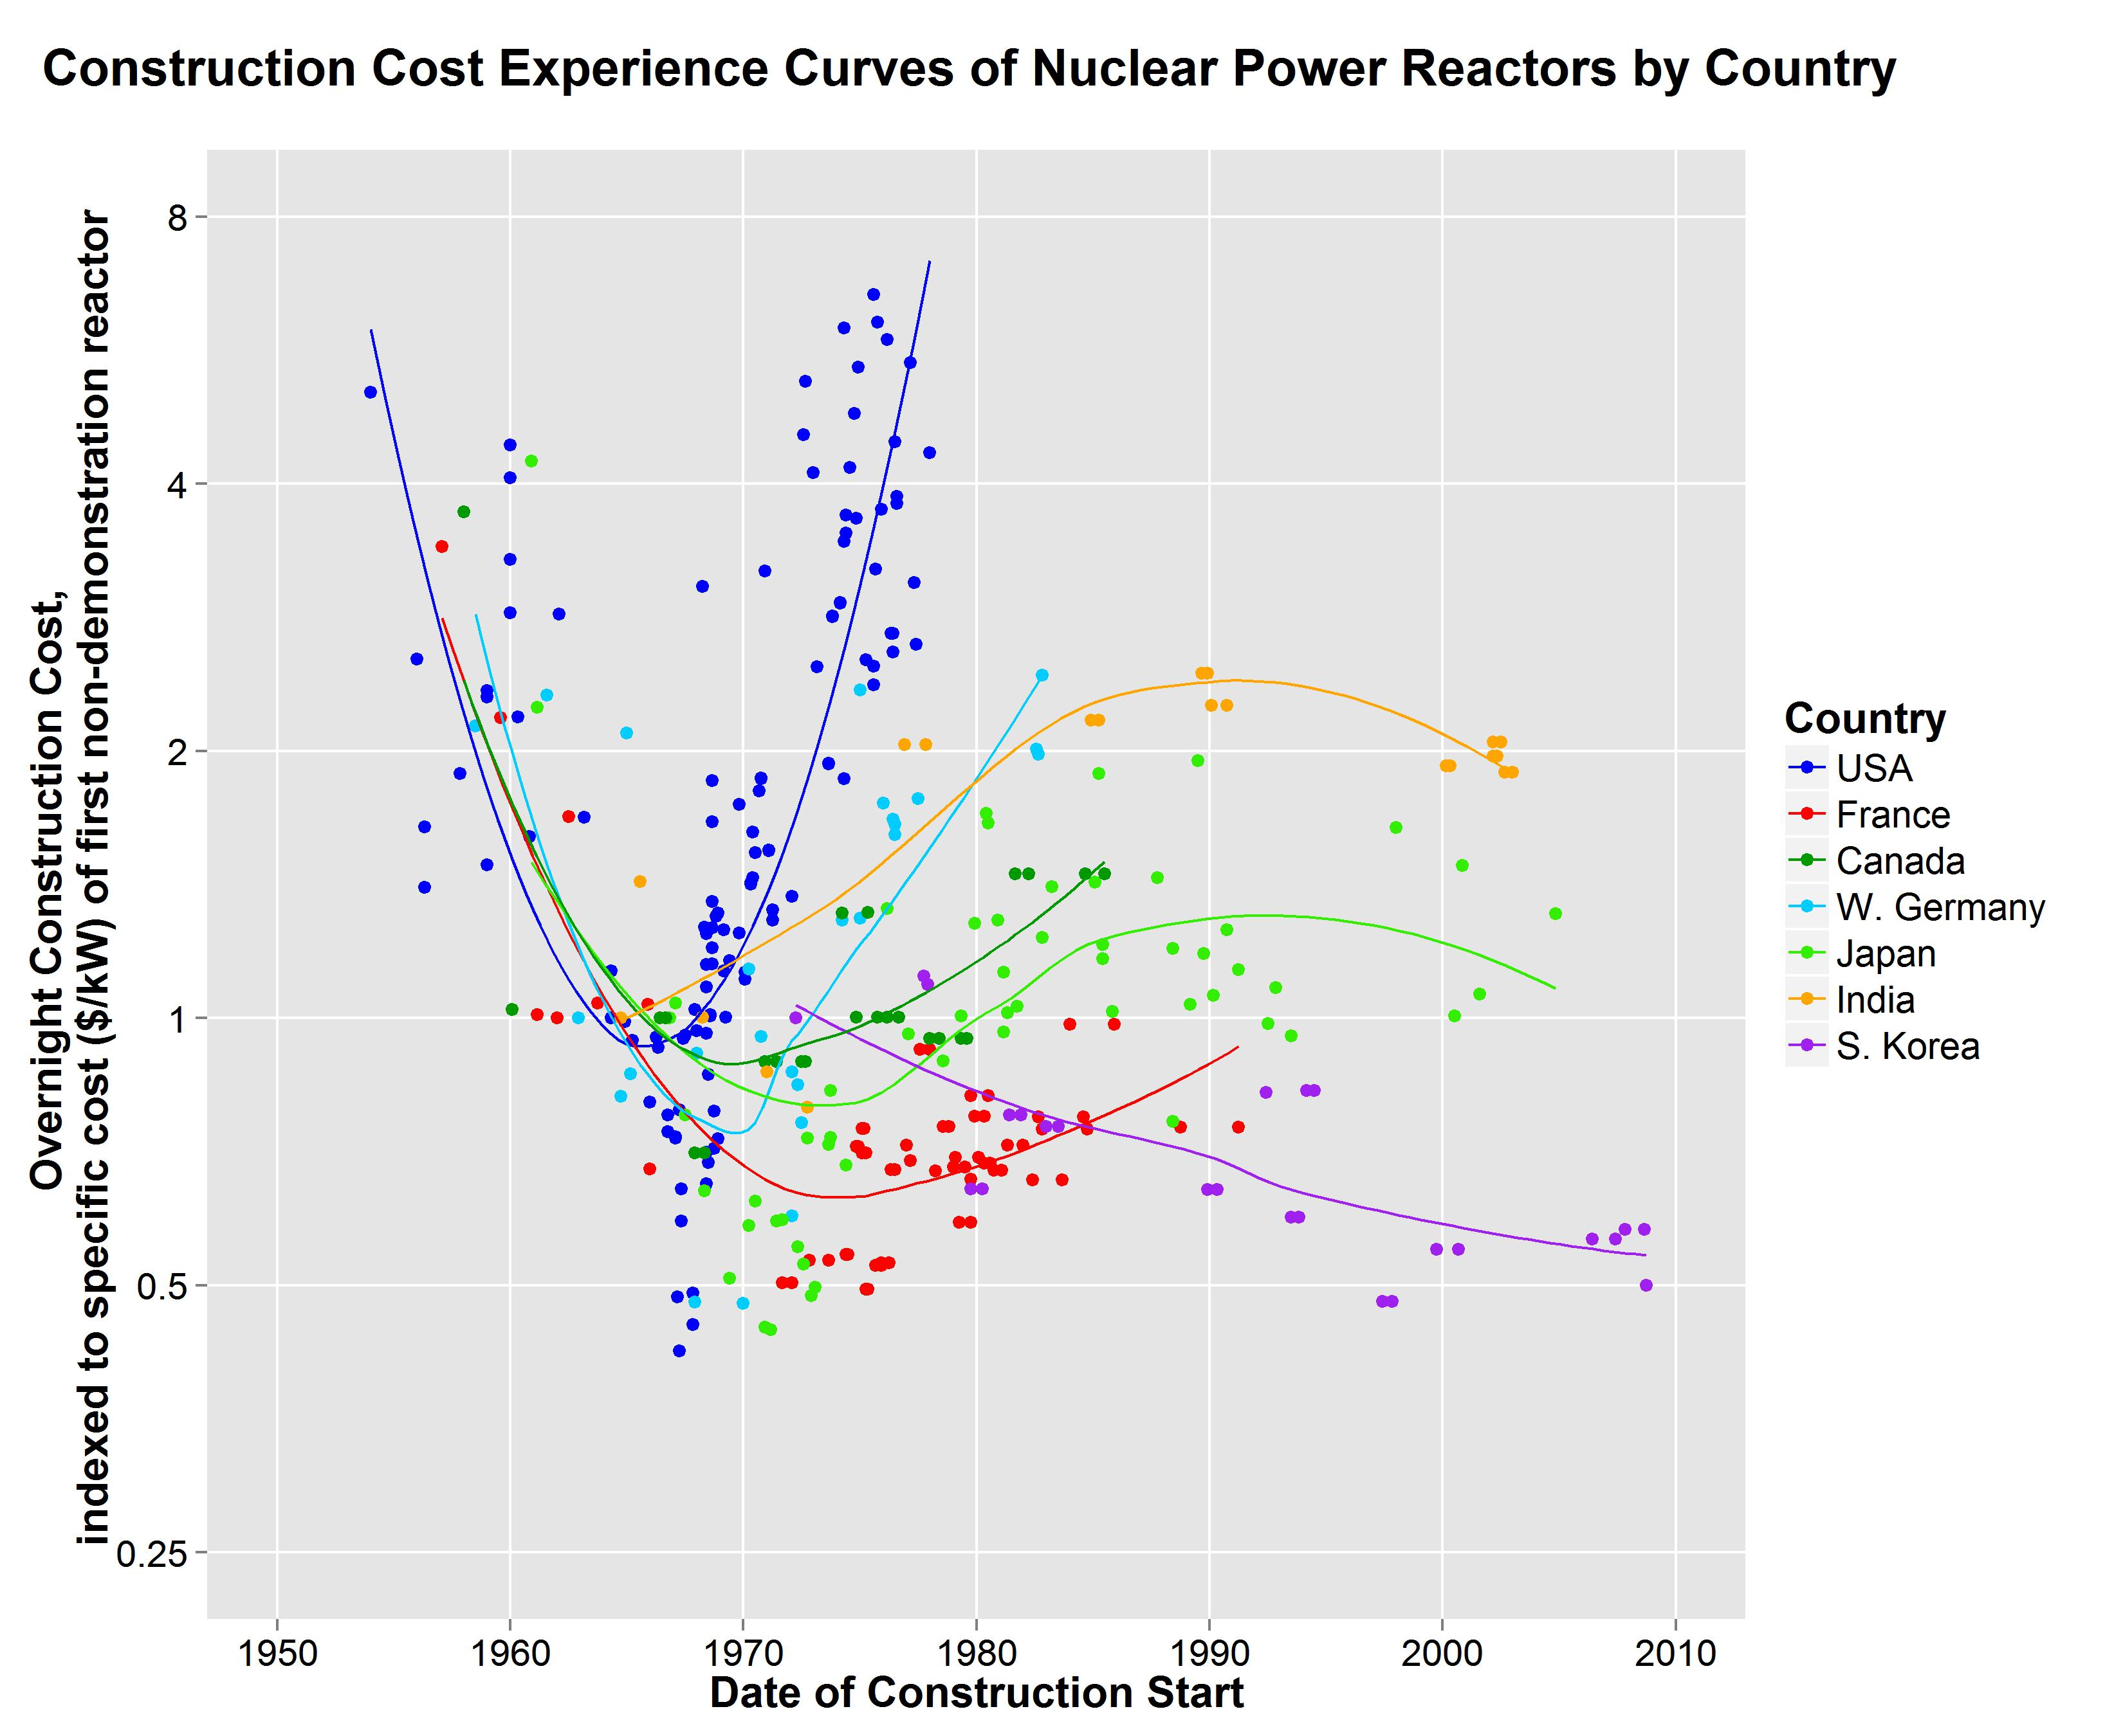
Data for 349 reactors from 7 major countries with nuclear power reactors yield new insight to the historical costs of nuclear power. We find that trends in costs have varied significantly in magnitude and in structure, by era, country, and experience. In addition to cost escalation in several countries, there is evidence of much milder cost escalation and also cost declines in nuclear construction costs in early and recent construction history. The empirical comparison of global experiences raises new methodological and practical questions regarding the analysis and application of learning rates and the role of drivers behind technological change other than traditional learning-by-doing, such as RD&D, operational experience, changing requirements, economies of unit scale, economies of production scale, technology transfer, and international spillover.

Conclusions
This analysis of historical experience for global nuclear power construction offers a more comprehensive perspective on cost trends than in the literature. The variation in trends dispels the single story of cost escalation. This study has significant implications for modelling assumptions and energy scenarios, and invites researchers, modellers, and policy makers to reconsider the costs of nuclear power construction.

