The Private and Social Value of Blackout Risk Reduction

Anand Govindarajan, Pennsylvania State University, Phone +1 814 865 3437, E-mail: axg5179@psu.edu
Seth Blumsack, Pennsylvania State University, Phone +1 814 863 7597, E-mail: sethb@psu.edu

Overview

Distributed generation (DG) systems provide a mechanism for individual electricity customers to generate energy locally rather than drawing from the power grid. During periods of normal operation this provides an energy savings benefit to DG-enabled electricity customers, which has been well-discussed in the existing literature (e.g., Siler-Evans et al., 2012). We focus on another important source of benefits, namely those related to decreasing or avoiding the costs associated with power blackouts. These system benefits have both a “private” component that accrues to the DG owner/operator and a “social” component that accrues to all other grid-connected customers. When blackouts do occur, DG-enabled customers will be able to continue to receive electric service from local generation, provided that fuel supplies are not interrupted. This is the private benefit accruing to the DG owner/operator. If DG units are deployed at scale and operated in such a way as to decrease stress on power grids during times of peak demand, these DG units provide a risk-reduction service to the grid as a whole (the “social” benefit) by reducing the probability of blackouts occurring. Using the Mid-Atlantic power grid as a case study, we use historical blackout data to estimate season-specific blackout risk as a function of total demand for grid-provided power and estimate the risk reduction associated with a modest deployment of DG, in the form of Combined Heat and Power (CHP) installations throughout the Mid-Atlantic commercial building sector. Our analysis suggests that deployment of 1,000 building-integrated CHP units in the Mid-Atlantic would confer benefits of $2 million to $2.5 million per year to CHP owners. We estimate social benefits, in the form of blackout risk reduction, amount to $14 million to $40 million per year. The magnitude of these benefits is most sensitive to how building-integrated CHP units are operated.

Methods
Our approach integrates four separate modelling components: An econometric model of blackout risk in the Mid-Atlantic region (the PJM transmission grid); an econometric model of locational electricity prices within PJM; a simulation model of building-integrated CHP operation; and building energy models that generate electricity demands for commercial buildings with and without integrated CHP. Each of these modelling elements is described briefly below:

- Our econometric model for blackout risk is estimated using a rare-events logit approach, using data on reported blackouts within the PJM region reported to the U.S. Department of Energy (excluding those related to extreme weather) and data from PJM on historical hourly system loads. We estimate a rare-events logit model that estimates the likelihood of a blackout being initiated in each hour as a function of electric loads in PJM and temporal characteristics such as seasons and time of day. (We compare our results from the rare-events logit model with those of a conventional logit model and find few differences in estimated blackout probabilities.) We also estimate an econometric model for blackout duration as a function of blackout size (customers affected) and temporal variables.
- Locational electricity prices within PJM are estimated using the econometric approach developed in Sahraei-Ardakani and Blumsack (2014), which estimates locational supply curves within regional power grids that accounts for spatial differences in fuels utilization and congestion on the electric transmission grid. This model utilizes hourly demand and pricing data from PJM, as well as fuel prices from the U.S. Energy Information Administration.
- CHP usage profiles are developed for specific commercial building types using the BCHP tool available from the U.S. Department of Energy.
- Building energy profiles with and without CHP are developed using the BCHP tool and a building-integrated CHP assessment approach from the Berkeley National Laboratory.

Our overall modelling approach is to estimate baseline hourly blackout risk and locational electricity price profiles for the PJM region. We then simulate hourly energy profiles for up to 1,000 commercial buildings in PJM with and without integrated CHP systems. As more buildings add CHP systems, these customers save on electricity costs and the building energy loads removed from the grid will lower wholesale power prices. These two effects together constitute the private benefit of CHP adoption by commercial buildings. Removing loads from the grid and placing them on CHP also reduces the risk of blackouts, which amounts to the social value in our study. This social value of blackout risk reduction is monetized using an approach suggested by Sullivan, et al. (2010).

Results
Our econometric model for blackout risk suggests that electric loads and temporal variables are all statistically significant predictors of the hourly probability of a blackout being triggered. All estimated coefficients have the expected signs – blackouts other than those instigated by extreme weather events are more likely to be triggered during high-demand periods in the winter and the summer. Blackout durations can be expected to be longer when a larger number of customers are affected.

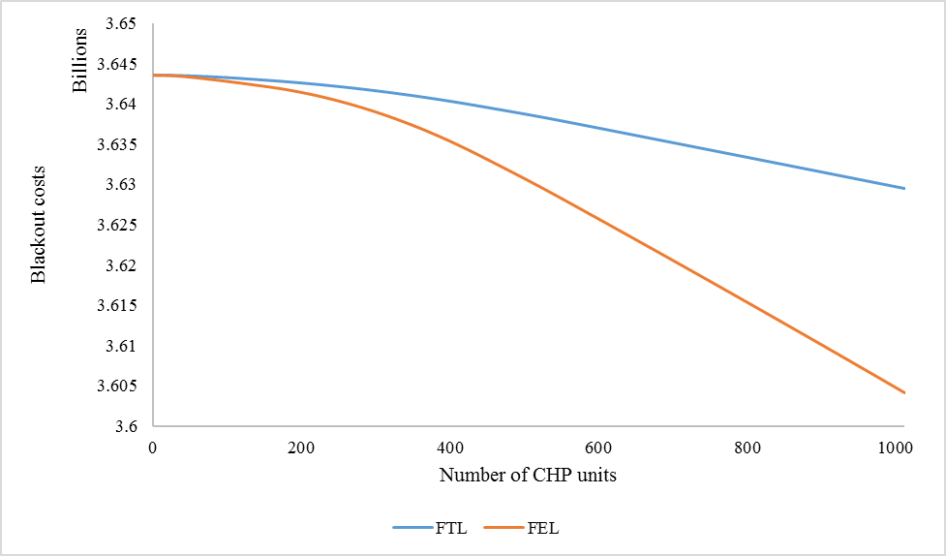

Conclusions
CHP units operated to ameliorate peak demand can benefit electricity consumers in two ways. First, CHP-enabled customers can continue to receive electricity service even when power-grid interruptions occur, as long as fuel supplies are not interrupted. This “private reliability benefit” would amount to between $2 and $2.5 million per year with a deployment level of 1,000 CHP units throughout the Mid-Atlantic region. The average private benefit would thus amount to $2,000 to $2,500 per year. The energy-savings benefit is generally larger than the private reliability benefit, suggesting that building-integrated CHP units have little private incentive to operate in a way that maximizes blackout risk reduction for the grid as a whole. We estimate that the social benefits of blackout risk reduction amount to $39 million annually (or $39,000 per CHP unit) when CHP is operated in a way to follow electrical load during peak periods. Our estimated social benefits are lower - $14 million annually for deployment of 1,000 CHP units ($14,000 per unit) when CHP is operated to follow thermal load.

References
Lawrence Berkeley National Lab, 1991. 481 Prototypical Commercial Buildings for 20 Urban Market Areas (Technical Documentation of Building Loads Database Developed for the GRI Cogeneration Market Assessment Project). Report No. LBL-29798. Online at <http://gundog.lbl.gov/dirpubs/29798.pdf.>
Sahraei-Ardakani, M. and S. Blumsack, 2014. Estimating Supply Curves in Transmission-Constrained Electricity Markets. Energy 80:1, pp. 10-19.
Siler-Evans, Kyle, M. Granger Morgan, and Inês Lima Azevedo, 2012. Distributed Cogeneration for Commercial Buildings: Can We Make the Economics Work? Energy Policy 42, pp. 580–590.
Sullivan, M.J., M.G. Mercurio, J.A. Schellenberg, and J.H. Eto. 2010. “How to Estimate the Value of Service Reliability Improvements.” Power and Energy Society General Meeting, 2010 IEEE (July 25): 1–5.

