Overview

SHORT-TERM ENERGY STORAGE FOR STABILIZING THE HIGH VOLTAGE TRANSMISSION GRID: A REAL OPTIONS ANALYSIS
Kathrin Illian, RWTH Aachen University, +49 9131 7-0, katrin.illian@rwth-aachen.de
Reinhard Madlener, RWTH Aachen University/FCN, +49 241 80 49 820, RMadlener@eonerc.rwth-aachen.de

Ensuring a high quality of electrical power supply requires a stable transmission system operation by means of constant frequency and voltage. Even after disturbances or load variations the transmission grid must operate in a stable manner and must remain within the specified voltage and frequency ranges according to the transmission grid codes in order to prevent blackouts causing potentially huge economic damage. A main contribution to the frequency stability is the inertia of the synchronous power generators of conventional power plants due to their rotating masses. The increasing shares of renewables with fluctuating power generation, combined with the decreasing amount of conventional power plants with rotating machines, reduce the system inertia and hence threaten grid stability. However, use of renewables is typically based on non-synchronous power generation, with a limited contribution to system inertia due to the electronic converter-based power injection. To ensure power quality, systems are required that provide voltage- and frequency-control by means of injecting both reactive and active power into the grid for up to several minutes. Additional active power is required during the first seconds until operating reserves are activated. A contemporary, technically feasible solution is the use of super-capacitors (SC) or battery storage (BS) devices that are connected to the high voltage transmission grid via insulated gate bipolar transistor (IGBT) multilevel converters (SVC PLUS, SVC PLUS ES). The stored energy enables the emulation of the required system inertia. In this paper, we analyse the integration of such short-term energy storage devices in the high voltage system. The economic benefit of the storage device – reducing the risk of non-compliance to the grid codes and for potential blackouts and providing additional services to the system – is identified by means of real options analysis (ROA) and compared to other alternative solutions.

Methods
We apply ROA (Dixit and Pindyck 1994), which, in contrast to simple net present value (NPV) analysis, enables to consider the management reactions to a broad range of risky scenarios over time, and thus to capture the value of flexibility and future opportunities (Triantis, 2003). Whereas Pindyck (1991) focused on irreversible investments under uncertainty and the optimal timing to invest, other options exist that can be used: e.g., the option to delay the investment was studied by McDonald and Siegel (1986), whereas Kulatilaka and Trigeorgis (1994) invested the option to switch between different modes of operations, including the eventuality of switching costs. In our study, we apply a binomial tree approach to investigate the optimal timing to invest in a storage device.

Results

The NPV and real option values (ROV) of different options investigated are calculated at a step size of one year, with a time horizon of five years, and with truncating the underlying tree and always allowing delay. The NPV is always smaller than the ROV, which results from the option value arising due to the possibility of deciding between options (Figure 1). Figure 1 shows the CAPEX, overall profits, NPV and ROV of different options of the SVC PLUS ES, and SynCon with Z=0% and Z=30% (Z denotes the rated power share). With Z=0%, only profits due to provided reactive power and losses are considered for the overall profit (orange). When additionally considering the CAPEX (red), then the NPV (blue) is negative for every option. The ROV (green) is always positive, because in cases where an investment is not profitable, there is always the option to abandon and realize a profit of zero. Although the SynCon has four times higher losses than the SVC PLUS ES at a similar rated power, its value at Z=0% is slightly higher than the value of the SVC PLUS ES, because the CAPEX difference is € 15 million. The advantage of the SVC PLUS ES is that it can provide primary response for Z = 30% of its rated power. Therefore, positive NPVs with this model can just be gained with a SVC PLUS ES, providing primary response.
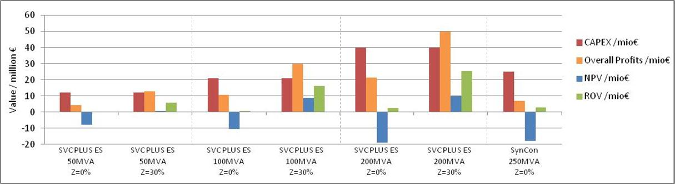
Figure 1: CAPEX, overall profits, NPV and ROV of different options

In Table 2 the performance and CAPEX of the SVC PLUS ES and SynCon are compared. Concerning the supply of reactive power, the 200 MVA SVC PLUS ES and the 250 MVA SynCon are equivalent. The inertia constant is much higher for SVC PLUS ES. If the amount of inertia is compared, the 50 MVA SVC PLUS ES and the 250 MVA SynCon are similar. The CAPEX are similar for a 100 MVA SVC PLUS ES and a 250 MVA SynCon. Thus for purchasing the same amount of inertia, the SynCon is nearly double expensive compared to the SCV PLUS ES. These values are calculated at a step size of one year and with a time horizon of five years and with truncating the underlying tree and always allowing delay. The NPV is always smaller than the ROV, which results from the option value, which is available due to the possibility of deciding between options.
Table 2: Comparison of SVC PLUS ES and SynCon
 | SVC PLUS ES |  |  | SynCon
Rated power / MVA | 50 | 100 | 200 | 250
Inertia constant H / s | 8.3 | 8.3 | 8.3 | 1.8
Inertia / GWs | 0.406 | 0.812 | 1.624 | 0.450
CAPEX / million € | 12.2 | 21.0 | 40.0 | 25.0

References
Black, F., Scholes, M. (1973), The pricing of options on corporate liabilities, Journal of Political Economy, 81(3), 637–659.
IEC – International Electrotechnical Commission (2014), Microgrids for disaster preparedness and recovery - With electricity continuity plans and systems, White paper, Geneva, Switzerland.
Kulatilaka, N., Trigeorgis, L. (1994), The general flexibility to switch, Real options revisited, International Journal of Finance 6(2), 778-798.
McDonald, R., Siegel, D. (1986), The value of waiting to invest, Quarterly Journal of Economics, 101, 707–728.
Myers, S.C. (1977), Determinants of Corporate Borrowing, Journal of Financial Economics, 147-175.
Pindyck, R.S. (1991), Irreversibility, uncertainty and investment, Journal of Economic Literature, 29(3): 1110-1148.
Triantis, A.J. (2003), Real Options, Handbook of Modern Finance, ed. D. Logue and J. Seward, Research Institute of America, New York.

