THE ENERGY WATER NEXUS: A DYNAMIC SPATIAL CASE STUDY OF THE SAN JUAN BASIN, NM
Katie Zemlick, University of New Mexico, 505-577-4203, czemlick@unm.edu
Elmira Kalhor, University of New Mexico, 505-717-5568, ekalhor@unm.edu
Janie Chermak, University of New Mexico, 505-277-4906, jchermak@unm.edu
Bruce M. Thomson, University of New Mexico, 505-277-4729, bthomson@unm.edu
Vincent C. Tidwell, Sandia National Laboratories, 505-844-6025, vctidwe@sandia.gov

Overview
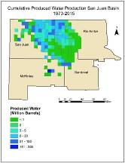
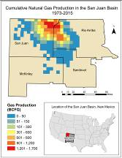
The connections between energy production and water resources is of increasing interest as both energy demands and demand for limited water supplies increase. Non-renewable fuels have long comprised the majority of of energy production and consumption in the U.S., and water is required at nearly every step, including resource extraction, refining, transportation, and electricity generation. Furthermore, technological advancements in resource recovery often rely on water to enhance production. The San Juan Basin in northwestern New Mexico has long been characterized by an abundance and diversity of energy resources, including coal, uranium, oil, and natural gas. Coal mined in the region supplies more than 50% of the state’s energy needs (Mercier, 2010) and until the early 1980’s the region supplied nearly half of the nation’s uranium demand (McLemore & Chenoweth, 2003). More recently, the oil and natural gas reserves in the basin have gained renewed attention. It is estimated that 20 million barrels of oil and more than 50 trillion cubic feet of natural gas reserves are present in the basin. (USGS, 2013) Water is tied to this production, in the completion of wells and injection, as well as with produced water, as shown in Figure 1. However, the San Juan Basin is located in a very arid environment in which evaporation exceeds precipitation and groundwater is the sole source of water supply except along its northern boundary.(Kernodle, 1996) As such, an understanding of economic factors that drive energy development and the consequent impacts of that development on water resources is a key component in developing the state’s energy future plans an may inform energy development in other arid regions. A systems dynamic model was developed to quantify the hydrologic and economic relationships between energy and water resources in the basin. An annual time-step was used over a 30 year range, coinciding with U.S. Energy Information Administration (EIA) projections. Variable options for economic fluctuations, energy demand, technological advancement, and climate change factors are included.
Figure 1:San Juan Basin Natural Gas Production and
Produced Water, 1973-2015
This paper is arranged as follows: The first section presents an overview of the basin and recent modeling efforts, the second section provides a summary of subsurface data including water and energy (oil, natural gas, and uranium) resources as well as economic assumptions applied in the modeling effort. The third section describes model structure and logic as well as the interaction between the three areas of interest. The results are described in section four, where we discuss model outputs, scenario development, and sensitivity analysis. The implications of this analysis and areas of future work are discussed in the conclusion.

Methods
Two modelling methods are coupled in order to ascertain the interactions and tradeoffs between energy production and water in the San Juan Basin of New Mexico: a compartmental geospatial model of the subsurface and a system dynamics model. Specifically, we focus on natural gas and water. The compartmental model divides the basin land surface as well as the twelve distinct subsurface geological layers into 419, approximately 36 square mile subbasins in order to capture spatial variability within the basin and the distribution of energy and water resources. Subbasins were delineated according to Township and Range boundaries which are the basis of oil and gas pool demarcation in the state. Similar to the approach taken by Roach and Tidwell (2009), the impacts of resource recovery on water availability is dictated by the spatial connectivity between subbasins and geologic formations. Natural gas and water production functions were generated using regression analysis of existing well data. This paper describes modeling research that was focused on oil and gas development in the Basin. Work on the relationship between uranium development and water resources has been described elsewhere.(Zemlick and Thomson, 2014) Production data was obtained from the New Mexico Oil Conservation Division which has maintained monthly production and injection data and well characteristics for 26,275 gas wells in the basin since 1973. This is augmented by FracFocus data, compliled by the EPA. This model considers water in three stages: water used for well completion, injected water for enhanced recovery, and produced water. Economic data including historic and projected spot prices, well drilling, completion, and operating costs were obtained from the EIA. Economic drivers include price and production costs, allowing for technological changes, as well as for different price paths. The interactions between energy production and water use are developed from historical data as well as EIA projections.

Results
Initial results indicate:
First, geologic variability such as formation thickness and depth play an important role in resource recovery, water use, and have the potential to influence adjacent areas.
Second, we our regression results suggest variables that are statistically significant for natural gas production include the age of the well, the depth to production, the number of production days, and the pool.
Third, the impacts on water, especially produced water, as a result of extraction vary (see Figure 2) in accordance with demand, field, and age of production, and method of extraction.
Fourth, technological advancements such as horizontal drilling and hydraulic fracturing play a role in total quantity of recoverable resources as well as the viability of repurposing produced water.
Fifth, the price of natural gas is significant in the number of wells drilled, as shown by Figure 3.

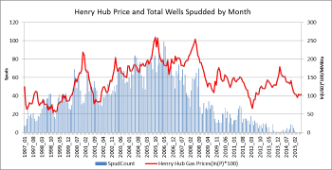
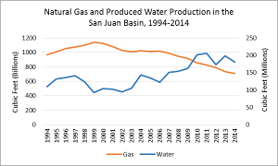
Figure 2: San Juan Basin, Aggregate Natural Gas and Water Production (left) and Figure 3: San Juan Basin: Henry Hub Price and Total Wells Spudded by Month (right)

Conclusions
Conventional wisdom dictates tradeoffs exist between water and energy development. However, these relationships are complex:
First, quantification of recoverable energy resources is dependent upon economic factors including market price, total cost, and technological advancement.
Second, these advancements in turn influence total water use as well as methods of conserving or reusing wastewater are implemented.
Third, the interactions between resource recovery and water use are strongly influenced by geologic factors which, in turn, impact both laterally connected subbasins and overlying formations.

Future work will incorporate uranium and oil resource availability within the basin into the model in order to anticipate the tradeoffs among them. These tradeoffs will be influenced by economic drivers, water availability and demand, technologic advancements, and policy scenarios.

Funding for this research was provided by the UNM Center for Water and the Environment, an NSF funded Center for Research Excellence in Science and Technology (CREST), NSF Award #1345169 and New Mexico’s Experimental Program to Stimulate Competitive Research (EPSCoR), NSF Award #IIA1301346

