The Economics of Commercial Demand Response for Spinning Reserve

Michael Fisher, Dept of Engineering & Public Policy, Carnegie Mellon Univ, 914-844-2062, mjfisher@cmu.edu
Jay Apt, Dept of Engineering & Public Policy, Tepper School of Business, Carnegie Mellon Univ, 412-268-3003, apt@cmu.edu
Fallaw Sowell, Tepper School of Business, Carnegie Mellon Univ, 412-268-3769, fs0v@andrew.cmu.edu

Overview
Demand response (DR) for spinning reserve may be appropriate for customers whose operational constraints preclude participation in energy and capacity DR programs. We investigate the private business case of an aggregator providing spinning reserve in California. Average costs to enable quick-response capability, obtained from California’s Automated Demand Response programs and the literature, were $230/kW of controlled load. Revenues are calculated using end use level hourly load profiles. With average annual revenue of ~$35/kW, steady end uses (e.g., lighting) are more than twice as profitable as seasonal end uses (e.g., cooling) because spinning reserve is needed year-round. Business segments with longer operating hours, such as groceries or lodging, have more revenue potential. However, average payback periods are longer than 5 years and thus do not present a compelling business case for an aggregator. Avoided carbon emission damages from using DR instead of fossil fuel generation for spinning reserve could justify incentives for DR resources.

Methods

In calculating the costs and revenues of commercial DR in the California spinning reserve market, we adopt the perspective of a DR aggregator. We consider three cost categories for an aggregator participating in demand response markets – (1) event communication and automated response, (2) telemetry, and (3) incentives paid to individual facilities. In order for DR to provide spinning reserve within the required 10 minutes, automated response is necessary. Automated response can be enabled by pre-programming DR strategies into control equipment so that the response is implemented without the need for human intervention. We obtain information on the costs of such a system from PG&E and SCE incentive programs designed for automated DR. The mean cost is approximately $180/kW. Telemetry is required by system operators for ancillary service providers to ensure services are delivered as promised. Recent work out of Lawrence Berkeley National Labs has shown that telemetry equipment for commercial buildings can be produced for approximately $50/kW. Finally, we explore a range of incentives that would need to be provided by an aggregator to individual end users to entice them to participate in spinning reserve.
Potential revenue from DR participation in spinning reserve markets was calculated from hourly commercial load profiles that had been standardized to typical weather conditions. These profiles were disaggregated by geographic zone, business segment, and end use in the 2006 California Commercial End-Use Survey (CEUS). Models of these profiles were created so that new profiles could be developed specifically for the period 2011-2013. Non-weather dependent end-uses were modelled with simple day-matching methods while weather-dependent end-uses were modelled with econometric techniques.

Results
End uses which are relatively constant throughout the year, such as lighting or refrigeration, are better suited for spinning reserve than seasonal end-uses like cooling and heating (Fig. 1). This is counter to the intuition behind traditional capacity-based demand response programs that focus on seasonal end-uses because they are highly correlated with system peak. Spinning reserve, however, is needed at all times and is therefore best served by resources which are available at all times. However, we find that median payback periods in the range of 5-10 years do not make a compelling business case for an aggregator (Fig. 2).
We then examine the policy case for incentivizing DR to participate in spinning reserve markets by avoiding carbon emissions from fossil-fuel generation. In this first-order analysis, we focus on the emissions and associated damages from CO2 and not from criteria pollutants (e.g., sulfur dioxide, nitrogen oxide, particulate matter) as the social damages from CO2 are orders of magnitude larger than damages from criteria pollutants for natural gas plants (the majority of generation in California). Using the emissions profile of a typical combined-cycle unit, we find that the value of CO2 emissions avoided is of the same order of magnitude as the cost of telemetry (Fig. 3).
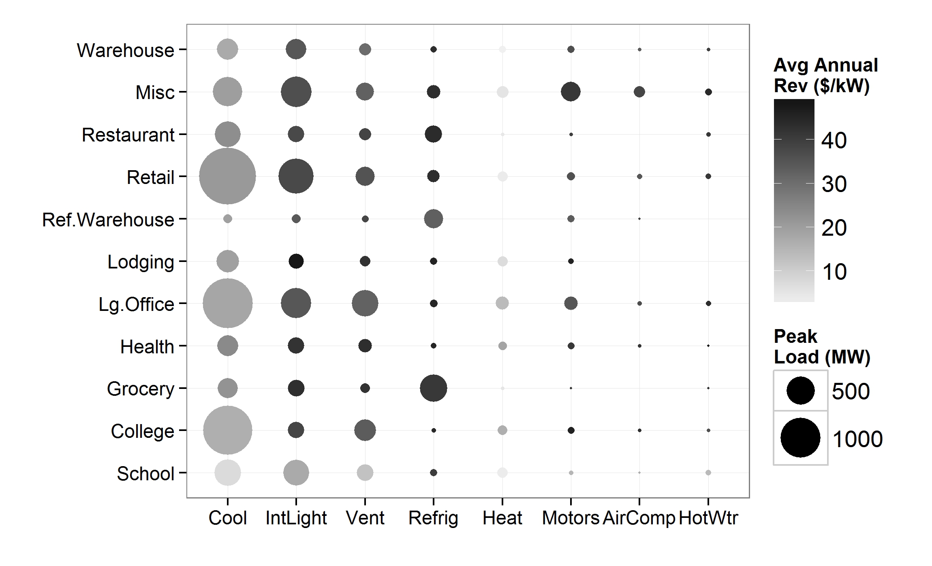
Fig. 1. Average annual revenue for end use / building segment combinations. The area of the dot represents the total peak load for that combination across all forecasting zones. The shading of the dot corresponds to the average annual revenue potential. Average annual revenue is calculated as a weighted average across all zones, weighted by peak load.

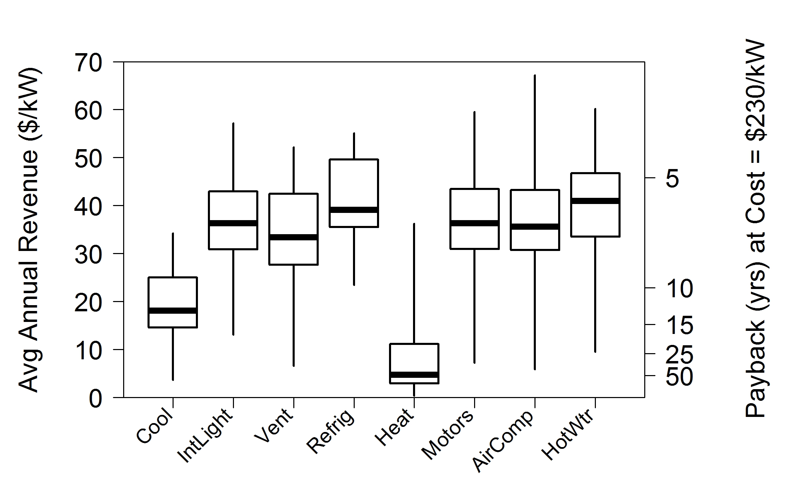
Fig. 2. Average annual revenue and years until payback at a fixed cost of $230/kW (excludes customer incentives). Each zone-segment combination represents a single point within each end use distribution. The heavy horizontal line in the middle of each box marks the median. The range of the box represents the interquartile range. The whiskers extend to the extremes of the distribution.

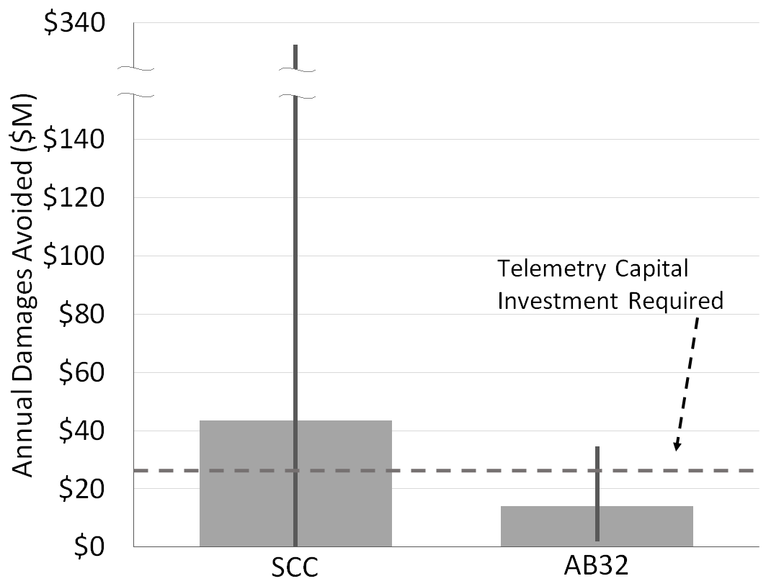

Fig. 3. Damages avoided from carbon emission savings due to DR procurement in spinning reserve market. Uncertainty bars reflect 90% confidence interval for uncertainty in the value of damages per metric ton and the uncertainty in the estimated magnitude of carbon savings.

Conclusions
We find that niche applications of DR could present an attractive business opportunity – certain business segments in southern California can achieve nearly $60/kW-year in revenue from interior lighting. Avoided carbon emissions from using demand response instead of fossil fuel generation for spinning reserve could justify the provision of incentives for the cost of installing telemetry (~$50/kW) for demand response resources. Avoided emissions may be larger for grid operators with higher proportions of coal-fired resources.

