La Tonya N. Walker, Sandia National Laboratories, (505) 844-3265, lnwalke@sandia.gov

Shale Gas Production in the U.S.: Projecting Investment, Technology and Cost Impacts on Reserves
Peter H. Kobos, Sandia National Laboratories
Leonard A. Malczynski, Sandia National Laboratories

Overview

Shale gas production due to the more wide spread application of hydraulic fracturing technology in the United States is changing the makeup and timeline for natural gas production supplies throughout the economy. Additionally, a potentially large shift in demand from coal to natural gas-based electric power, or even potential use of these new supplies for exports, may further increase the incentive to manage production appropriately. The analysis focuses on the dynamics between new technologies, production of supplies, and the changing incentive structure to produce natural gas. A suite of scenarios calculate the level of research and development (R&D) and capital investments required to maintain a sustainable business model. Specifically, three scenarios explore the role of technology, investment and environmental considerations. The scenarios highlight the incentives and feedback structure that will likely govern the annual production of U.S. natural gas in the coming decades.

Methods

System Dynamics, Monte Carlo Simulation, Data Forecasting
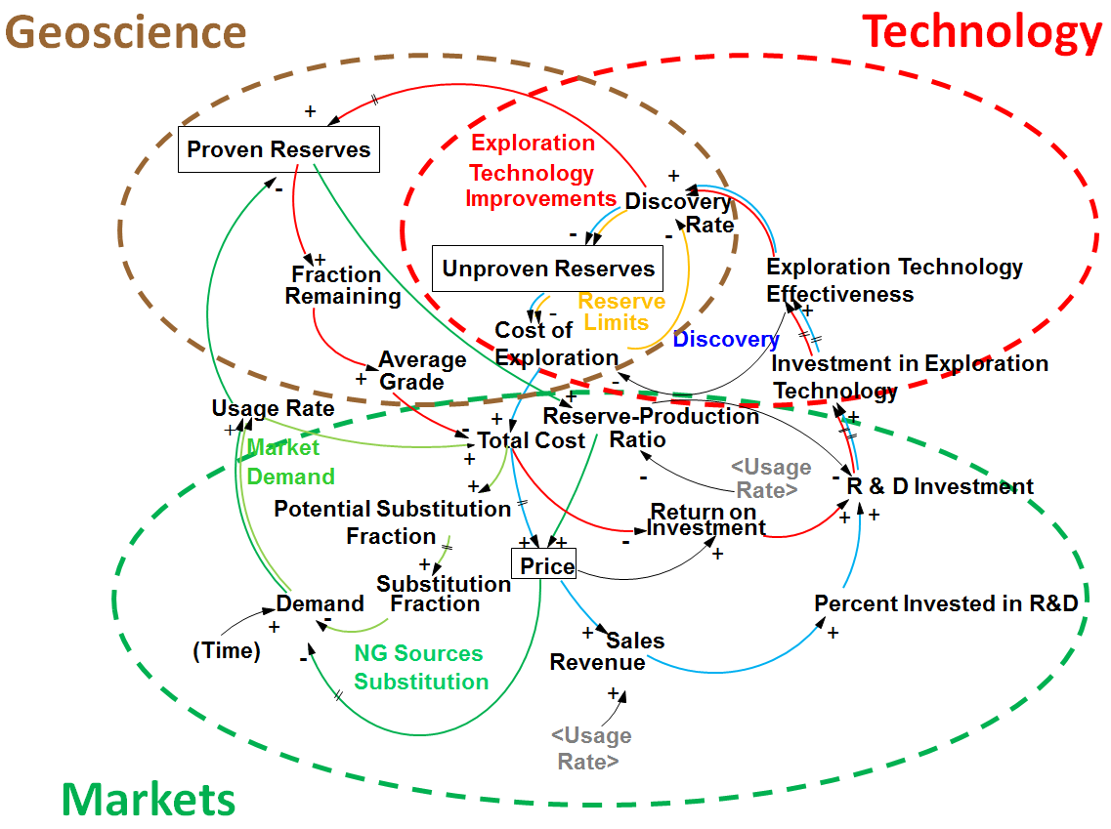
Figure 1. The assessment methodology and causal loop diagram. Note: materials adapted from Naill (1973), Behrens (1973), Kobos (2015), and Walker et al. (2014; 2015).

Results

The main findings indicate that the system dynamics (SD) model accurately simulates past investment impacts on shale gas production in the United States. Further, the model forecasts the impacts of an endogenously developed price that drives the level of quantity demanded (usage) and the level of proven reserves. These calculations may help the shale gas industry decide to incorporate price pressures as it relates to the desired reserve to production ratio and relatively conservative growth in natural gas demand. The model also forecasts the proven reserves, quantity demanded and endogenously-develop price for 2013 – 2025 and beyond..

Figure 2. Total natural gas (conventional, shale gas and coalbed methane) and shale gas proven reserves working estimation. Note: Historical data based on the Annual Energy Outlook (AEO), 2013.

Additional externality and regulatory scenarios may alter the speed of change for each of these three main model outputs. Increasing demand changes the level of proven reserves in the forecast beyond historical data, varying by the length of the forecast period. Similarly, in one scenario, adding a carbon tax to the cost of natural gas generally decreases the amount of demand. Decreasing demand may then decrease the return on investment that in turn reduces the amount of proven reserves through decreases in exploration.

Conclusions

Shale gas production has several key, governing variables including the market price, level of quantity demanded, and the level of regulatory (and often resulting cost increase) constraints. Using a series of differential equations within the System Dynamics architecture, this model accurately recreates the recent shale gas production rise. Future efforts could investigate the possibility of increased market demand, possibly by sector and with additional technology and regulatory constraints.

References

Energy Information Administration, 2013, Annual Energy Outlook (AEO).
Kobos, P.H., 2015, Shale Gas: Modeling the Economic Factors and Quantifying Uncertainty, Korea-U.S. Shale Gas Technology Cooperation Symposium, Seoul, Korea.

Naill, Roger F. “The Discovery Life Cycle of a Finite Resource: A Case Study of U.S. Natural Gas.” Toward Global Equilibrium: Collected Papers. By Dennis L. Meadows and Donella H. Meadows. Cambridge, MA: Wright-Allen, 1973, pp. 213-56.
Walker, L.T.N., Malczynski, L.A., Kobos, P.H. and G. Barter, 2014, The Shale Gas Phenomenon: Utilizing the Power of System Dynamics to Quantify Uncertainty, International Conference on System Dynamics Proceedings, Delft, Netherlands.
Walker, L.T.N., Kobos, P.H., and L.A. Malczynski, 2015, Shale Gas Production in the U.S.: Projecting Technology and Cost Impacts on Reserves, Shales at All Scales Workshop Presentation, Santa Fe, NM.

