Overview

Exploring Energy-Water Issues across the United States

Peter H. Kobos, (505) 845-7086, phkobos@sandia.gov
Vince Tidwell, Sandia National Laboratories
Barbie Moreland, Sandia National Laboratories
Haibo Zhai, Carnegie Mellon University
Edward S. Rubin, Carnegie Mellon University
Hari Mantripragada, Carnegie Mellon University
The collaborative project with Sandia National Laboratories and Carnegie Mellon University is developing a type of Water Atlas for the Eastern United States, to help understand what water may be available for new and existing changes in water use for thermoelectric power generation. Sandia National Laboratories is collecting water availability, cost data, and future projected use for four sources of water including surface water, groundwater, municipal wastewater, and shallow brackish groundwater. To date, the SNL team contacted all 31 states of interest to begin collecting water data for the Water Atlas with 88% of the states responding thus far and the project is now into the data vetting stage. Previous work for the Western Electricity Coordinating Council (WECC) identified areas of the United States that may exhibit water stress to the point that supplies may not meet demand for thermoelectric cooling requirements in the face of ongoing drought, turnover of the power plant fleet, and in view of potential CO2 capture requirements on fossil fuel-based electricity systems. The latter may increase the water required for power plants by more than 30% unless water-efficient cooling technologies are employed in the appropriate regions of the country.

The enhanced Integrated Environmental Control Model developed by Carnegie Mellon University will be applied in conjunction with data developed by Sandia National Laboratories to model alternative technologies affecting power plant water use and management and provide an integrated analysis of low-carbon electricity generation, alternative water technologies, and regional water resource impacts.
Methods
Energy-Water Nexus modelling, Integrated Environental Control Model (IECM)

Results
We illustrate a set of stylized scenarios that indicate water for power plant cooling may become a challenge in the Eastern United States over time. These results compliment previously-completed efforts for the Western United States in an effort to develop a complete, U.S.-focused ‘Water Atlas’ to identify potential sources of additional cooling water for power plants.

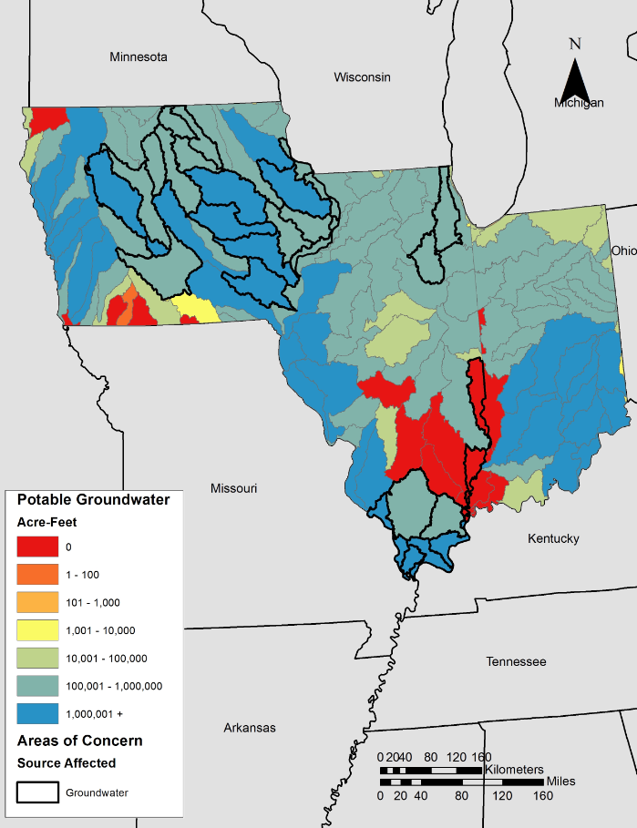
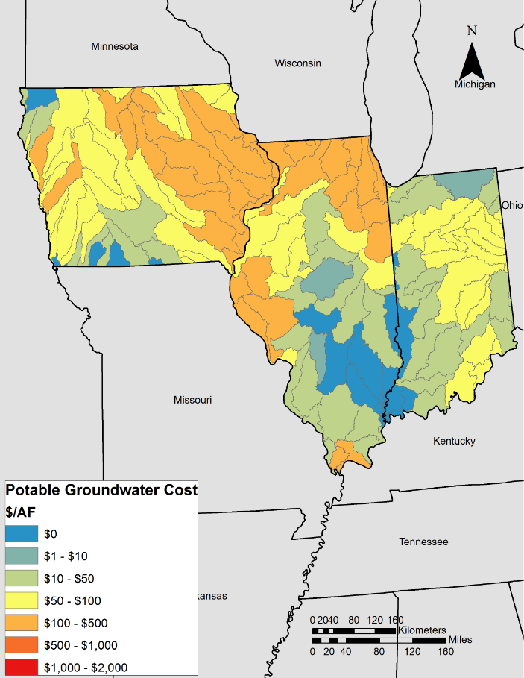
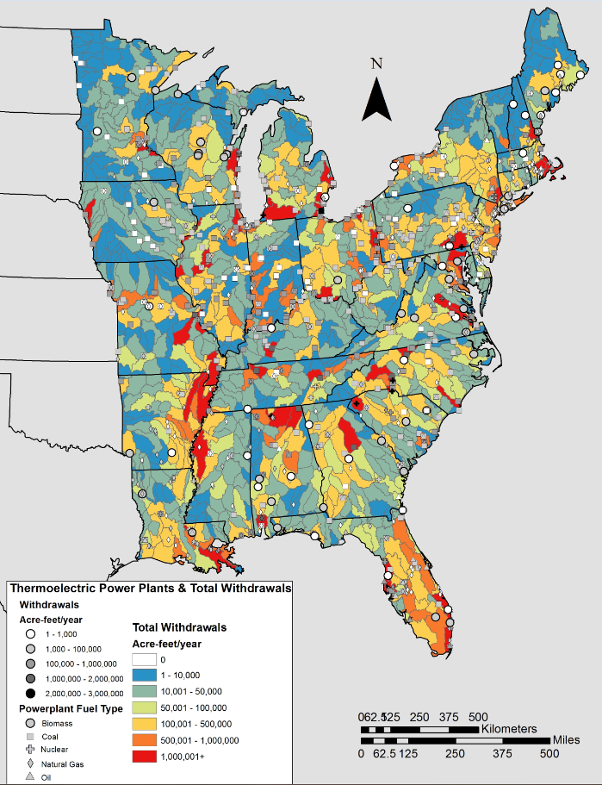

Figure 1: Current Thermoelectric Water Use & Illustrative Data Water Metrics (as of 7/2015).

Additionally, the IECM offers several power plant configurations that may work within a more constrained water and CO2 environment.

Conclusions
Developing a Water Atlas for the Eastern United States compliments previous work completed for the Western United States. Having this information will only serve to inform and leverage other, existing planning and process models such as IECM to identify the impact of constraints on water for cooling and CO2 management scenarios throughout the United States as demand and the types of power supply change to include less coal and more natural gas.

References
Tidwell, V., Kobos, P.H., Zhai, H. and E. Rubin, 2015, “Exploring Energy-Water Issues in the United States,” Poster presentation at the DOE Crosscutting Technology Research Program Review, Pittsburgh, PA, April 27-30.

Acknowledgements
This work was funded by the National Energy Technology Laboratory (NETL), and the authors thank Jessica Mullen for her insights.

