Construction and Simulation of Robust Electric Power futures

Donald A. Hanson, Argonne National Laboratory, 630-252-5061, dhanson@anl.gov
David K. Schmalzer, Argonne National Laboratory, 703-622-2431, schmalzer@anl.gov
Christopher Nichols, National Energy Technology Laboratory, Christopher.Nichols@NETL.DOE.GOV
Peter Balash, National Energy Technology Laboratory, Peter.Balash @NETL.DOE.GOV

Overview

Electric power generation is a large sector of the U.S. economy and key to continuing innovation, economy growth, and basic household services. The sector is also exposed to a variety of risks such as tighter environmental regulations, technological risks, and public concerns. In this work we construct a Robust Electric Generation investment path and compare the incremental cost with a Reference case with known parameters (i.e., without risks).

Methods
Argonne’s Electricity Supply and Investment Model (ESIM) calculates least-cost generating capacity additions and unit dispatch paths under alternative scenario specifications. The ESIM model represents 25 different new technology investments, and includes an inventory of existing Coal-Fired Power Plants (CFPPs). Scenarios are described by alternative supply functions for fuels and technologies, as briefly described below:

Shale gas supply in the U.S.: The ESIM gas supply model offers high, medium, and low dynamic gas supply functions calibrated to different EIA AEO runs.

Nuclear energy supply: Nuclear generation scenarios combine alternative assumptions about existing plant retirements, development of new nuclear technology, and regional public acceptance.

Non-hydro renewable generation: Wind and solar resources vary greatly by region and site-specific location giving rise to upward sloping supply curves for wind and solar generation.

Retirement scenarios for existing CFPPs: Argonne has been researching the effects of aging and low-utilization cycling damages on exiting CFPPs due to factors such as low gas prices, CO₂ limits, and intermittency of renewable generation. A best estimate, higher estimate, and lower estimate of endogenous CFPP retirement rates from cycling damages have been developed.

In the Reference case, ESIM calculates a least-cost investment path given expected supply functions for gas production, nuclear and non-hydro renewable generation, and cycling damages. Then we construct a Risk case in which the set of supply functions are assumed to shift up, raising costs of gas, nuclear power, renewable generation, and increasing existing CFPP retirements. The result is a need for significant investment in new State-of-the-Art (SOA) CCS retrofit-ready CFPPs and advanced coal-based technology.

We then construct a Robust investment path for SOA and advanced coal-based technologies that initially follows closely the investment path that emerges from the Risk case (i.e., advancing the development and the deployment of new baseload technology) but allowing for an upward adjustment if risk outcomes were to occur in the future. CO₂ emission reductions are held the same in each case.

Results

Many results are presented in the paper. As an example, Figure 1 shows a preliminary robust simulation for electric power generation. Figure 2 shows the sensitivity of gas demand to alternative risks of CFPP cycling and retirements.

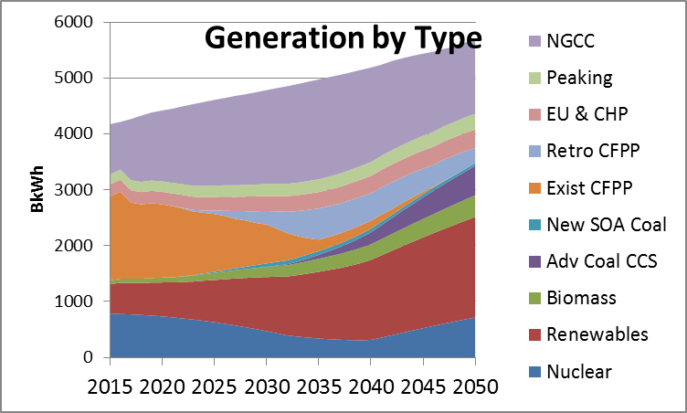

Figure 1. Preliminary electric generation scenario

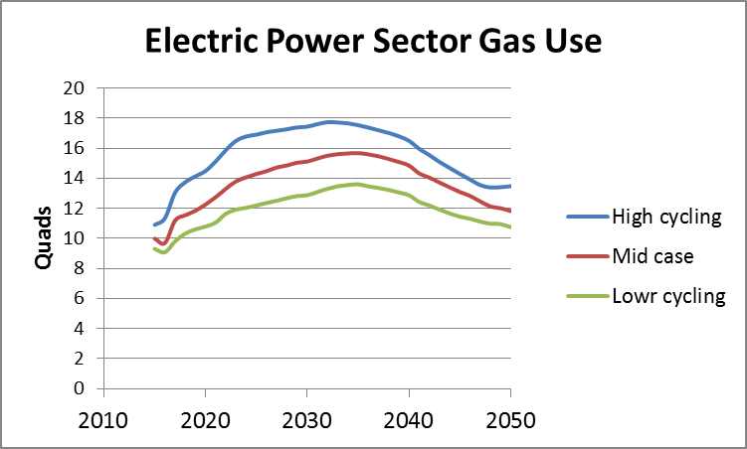

Figure 2. Gas use sensitivity to higher, medium, and lower CFPP damage and retirements due to cycling

Conclusions
We are able to construct an investment strategy that keeps deployment options open for advanced baseload generation technologies. By comparing total system costs between our Robust Electric Generation case and the Reference case, we find that the expected incremental cost of a robust electricity future is relatively small.

References
D.K.Schmalzer, D.A.Hanson, P.C.Balash, C.Nichols, Economic Scenarios for Aging in Coal-Fired Power Plants (CFPP), Argonne National Laboratory, 14th Annual Conference on Carbon Capture Utilization & Storage, Pittsburgh, April 28 – May 1, 2015.

