MODELLING BIOENERGY TECHNOLOGIES IN MALAYSIA'S POWER SECTOR - LONG TERM PLANNING STRATEGIES
Dayang Ratnasari Abu Bakar, Phone: +44(0)7479338111, E-mail: dayang.bakar.13@ucl.ac.uk
Gabrial Anandarajah, Phone: +44 (0) 203 1085 993, E-mail: g.anandarajah@ucl.ac.uk

Overview
Bioenergy represents one of the key elements in Malaysia's renewable energy policy, which aims to enhance utilisation of indigenous renewable energy sources that contributes towards energy security and sustainable socio-economic development. Bioenergy is also important in Malaysia's future energy mix as it supports the commitment in promoting GHG mitigation. Malaysia's target is, by 2020, to deliver 5% of the country's primary energy demand from bioenergy. This paper assess the role of bioenergy in the power sector for long term planning strategies under the scope of energy system framework analysis using TIMES (The Integrated MARKAL EFOM System) Model. A new TIMES-Malaysia model has been built to develop long-term energy scenarios to analyse the energy, economic and environmental implications of different energy and climate policies. Five scenarios have been constructed: a reference scenario, a policy scenario (assumes policy implementation of biogas capture facility installments in 250 palm oil mills to generate (renewable) electricity) and three CO₂ emission reduction scenarios. The preliminary results show that this policy alone is not capable of delivering the 5% of the country's primary energy demand target and specific policy interventions to accelerate deployment of bioenergy technologies are still needed.

Methodology
To generate future energy demand and energy supply scenarios for Malaysia, the model generator TIMES is used. TIMES model is an optimisation energy-economic tool developed as part of the Energy Technology Systems Analysis Program (IEA-ETSAP). TIMES model aims to supply energy services at minimum global cost (more accurately at minimum loss of surplus) by simultaneously making equipment investment and operating, primary energy supply, and energy trade decisions, by region [1]. A simple representation of Malaysia's Reference Energy System which interconnects energy resources, conversion technologies and end use demand is illustrated below. In this modelling exercise however, focus is given to the power sector and the details related to the end-use technologies (or application stage) have been merged as a single gross electricity demand.

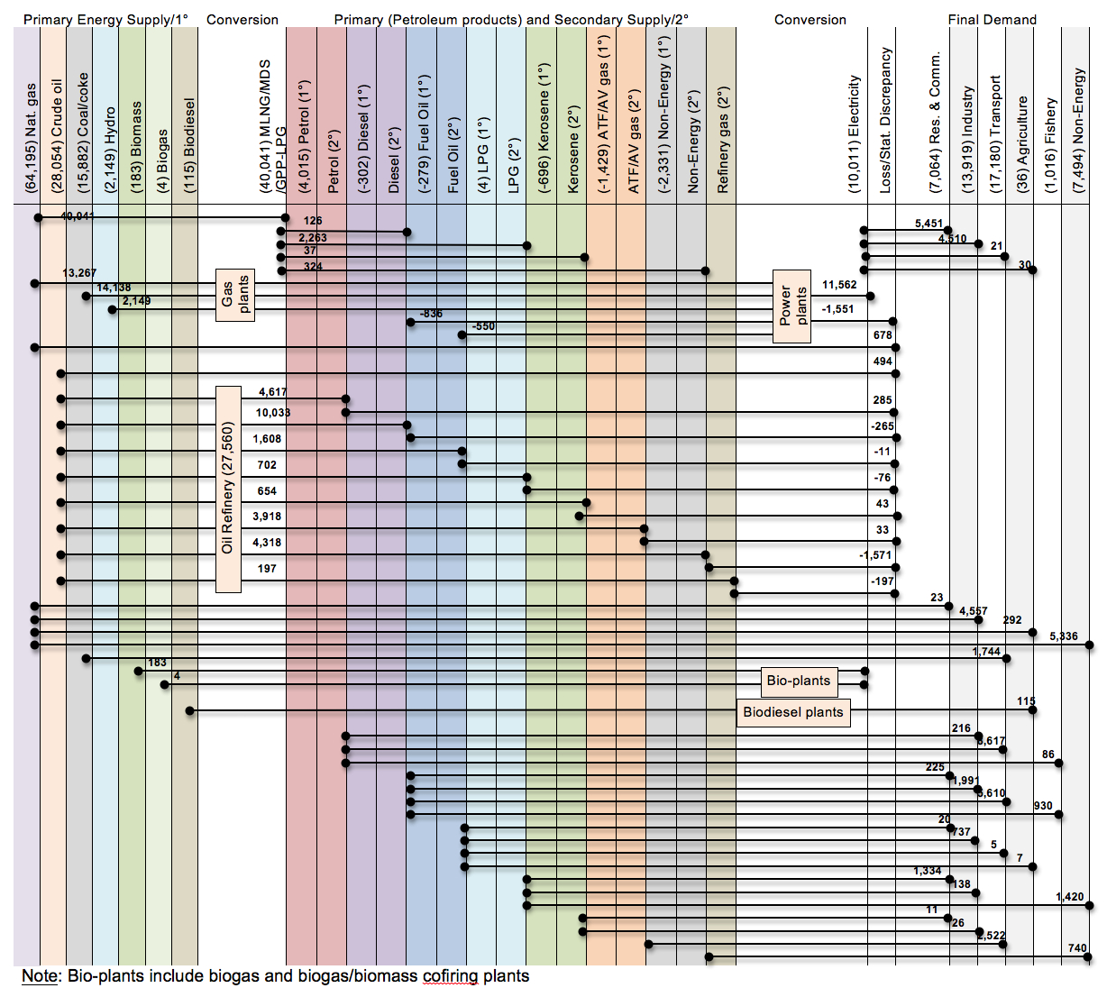

Other parameters/assumptions in this model include (i) base year: the year 2012 is indicated as the base year; (ii) time horizon: 2012-2050; (iii) only centralised grid is covered in the model; (iv) the current GDP growth rate will not deviate from the trend in the last decades; (v) interannual timeslices are considered in the model based on seasonal load fluctuations (Northeast (wet season) and Southwest (dry season) monsoons); and (vi) it is assumed that all the existing power plants of the base year will continue to work throughout the whole analysis period, with assumptions regarding retirement and new generation development plans in accord with the national plan.

Five scenarios are developed in this work:
1: Reference Scenario: This scenario presumes a continuation of current energy and economic dynamics. It provides a reference for comparing impacts of policies or future scenario in the power sector. The year 2012 is set as the base year.
2: EPP5 Scenario: This policy is contained in the National Key Economic Area (NKEA) for Palm Oil Sector under the Economic Transformation Programme (ETP5). The policy target is to install biogas (methane) capture facility in 250 palm oil mills in order to generate electricity for supply to the national grid by 2020 [2]. The estimated potential energy generated from biogas is 1.88 million MWhr of electricity which is equivalent to 261 MW of potential power (calculation is based on 21% efficiency in a steam plant and the production of oil palm fresh fruit bunch in 2009) [3].
3: 10% CO₂ emission reduction Scenario: Emission reduction scenarios are cumulative reduction from 2012 to 2050.
4: 20% CO₂ emission reduction Scenario.
5: 30% CO₂ emission reduction Scenario.

Results
The preliminary results indicate:
- Electricity generation in the baseline scenario for Malaysia's future electricity demand will almost be solely covered by natural gas fueled power plants from 2020 onwards and coal/oil power plants will be phased out.
- Renewable electricity from EPP5 represents about 1.4 to about 3% of the generation mix, thus depending on this policy implementation alone is not capable of delivering the 5% of the country's primary energy demand target from bioenergy.
- EPP5 Scenario also shows that only 1-2% CO₂ emission reduction is achievable from 2020 onwards.
- Scenarios with 10%, 20% and 30% CO₂ emission reduction led to an increase in the total system cost of 11.4%, 21.6% and 29.7% respectively.

Conclusions
In most developing countries where availability of biomass is abundant to generate (renewable) electricity, government policy is required to promote sustainable bioenergy systems which in the long run mitigates GHG emissions. The current policy in place; EPP5, can deliver only up to 3% of Malaysia's target to meet 5% primary energy demand from bioenergy. Thus, Malaysia's long term strategy should include increasing investments on bioenergy technologies.

References
[1] Loulou, R., U. Remme, A. Lehtilä, A. Kanudia and G. Goldstein. 2005. Documentation for the TIMES model.
[2] Deepening Malaysia’s palm oil advantage, in Economic Transformation Programme, A Roadmap for Malaysia, Performance Management and Delivery Unit (PEMANDU), Prime Minister’s Department, Malaysia, 2010, Chapter 9, pp. 281–314. (Accessed on 1 August 2015: http://www.mpob.gov.my/images/stories/pdf/NKEA__ Chapter_9 _Palm_Oil.pdf).
[3] National Key Economic Areas, National Biogas Implementation (EPP5), PEMANDU), Prime Minister’s Department, Malaysia, p.6. (Accessed on 1 August 2015: http://www.mpob.gov.my/images/stories/pdf/2014 /2014_ nkea.pdf).

Acknowledgement
The paper is a part of the first author’s research project, and the author is most grateful to the Commonwealth Scholarship Commission in the UK for the financial support for her PhD study.

