ELECTRICTY GENERATION MISSING MARKETS WITH CO2 EMISSION CONSTRAINTS
Donald A. Hanson, Argonne National Laboratory, 630-252-5061, dhanson@anl.gov
David K. Schmalzer, Argonne National Laboratory, 703-622-2431, schmalzer@anl.gov
Christopher Nichols, National Energy Technology Laboratory, Christopher.Nichols@NETL.DOE.GOV
Peter Balash, National Energy Technology Laboratory, Peter.Balash @NETL.DOE.GOV

Overview
Expanding renewable generation and use of natural gas combined cycle (NGCC) are projected to push existing coal-fired power plants (CFPPs) into the intermediate or shoulder mode of operation with low coal unit capacity factors and cycling damages. An explicit or implicit price on carbon emissions would further drive this process, since a carbon tax relatively favors gas over coal generation. NGCC utilization would be lower if the NGCC units were required to internalize the cycling damage costs to CFPPs. Market-based approaches to mitigate this situation will be discussed and simulated using Argonne’s Electricity Supply and Investment Model (ESIM).
This presentation will also discuss and simulate a market design for CO₂ capture and sequestration, beyond the EOR market, to incentivize CCS adoption to help meet a carbon reduction target.

Methods

In a recent paper, D. Schmalzer reviewed the literature on cycling damages, that is, the damages that are incurred by CFPPs which are pushed down the dispatch loading order and operated in an intermediate or shoulder mode. As cycling is prolonged and capacity factors decline further over time, the unit will eventually retire. As a result, costs are incurred within the power system. The capacity that retired will have to be replaced, likely mostly with gas-fired capacity, in order to meet peak load power flows and reserve margins. Since the phenomena are wide spread, market gas prices will rise, making electricity more expensive.

The retirement of older CFPPs and the replacement with new capacity, likely mostly gas units, will cause the entire dispatch order to re-adjust making it difficult to assess the total system cost of cycling damages other than through a simulation of the power system as a whole. This is what we do here in order to assess the cost incurred on the power system by expanding gas capacity, high gas utilization, lower CFPP utilization, and more retirements.

If the electric power system in a service territory had a single owner, i.e., a regulated franchise, the owner could minimize its costs, including cycling damage, by operating its existing CFPP in baseload and intentionally operating gas units in the intermediate and peaking mode. However with the rise of competition, wholesale merchant plants, independent system operators and resulting electricity markets, units are dispatched in order of variable costs, independent of external cycling damages to CFPPs which end up low in the loading order.

A classical solution in the economic literature to correct an externality and to achieve economic efficiency is to impose a Pigouvian tax on the agents causing the damages to others. The method that we employ here is to add a charge to the variable cost of NGCC units to re-arrange their position in the dispatch loading order. We adjust the Pigouvian tax to minimize total system costs.

In terms of institutional implementation, the rules of electricity and capacity markets could be adjusted to include estimated external costs that some types of generating units impose on other types of units.

Results

Figure 1 shows a plot of the capacity factors over time for marker units that we selected to represent units that retire soon or in several decades due to cycling damages. In a least-system-cost scenario, the better CFPPs are operated at higher utilization, cycled less and have longer lives. Carbon capture and sequestration (CCS) provides a technology to greatly lower the CO₂ emissions from high-utilization CFPPs.

The presence of a carbon reduction goal implies a value on capturing and sequestering CO₂. Markets can also play a role here to improve efficiency. Firms with a capability to sequester CO₂ emissions could offer a price to do it. In turn these firms would need to purchase CO₂ from powerplants that capture it, incentivizing the capture process.

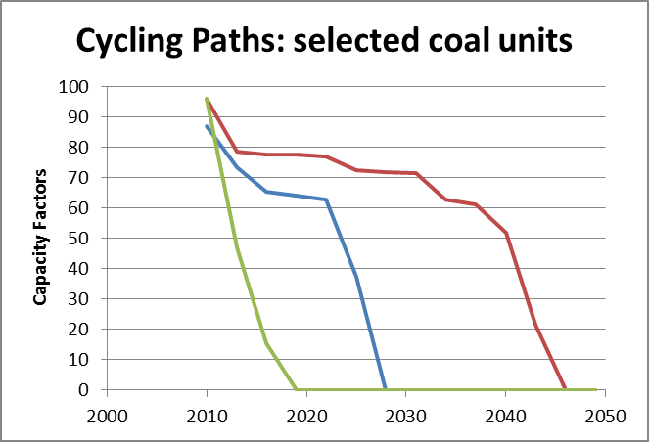

Figure 1. Capacity factors for three selected marker CFPPs that show near-term, intermediate-term, and long-term retirements due to eventual cycling.

Conclusions

The electric power world is being turned upside down. Older baseload units may be pushed down the loading order with higher variable costs and low capacity factors, while gas units, which can operate fine at low capacity factors, are being asked to run at or near baseload utilization. This is least cost operation for any given hour of the day, but over a longer planning horizon it raises the total cost of providing electricity. In this paper we simulate lower cost solutions that achieve the same CO₂ reductions.

There are significant implications for the design of electrical energy power markets and likely also for capacity markets.

References
D.K.Schmalzer, D.A.Hanson, P.C.Balash, C.Nichols, Economic Scenarios for Aging in Coal-Fired Power Plants (CFPP), Argonne National Laboratory, 14th Annual Conference on Carbon Capture Utilization & Storage, Pittsburgh, April 28 – May 1, 2015.

